# http://web.viu.ca/nethertoa/Alex_VIU_Home_Page/images/VIUlogo_1.jpgVIU Sustainability Project Endorsement Request

***Apply to have your sustainability project endorsed by the Sustainability Advisory Committee***

|  |  |
| --- | --- |
| **Why?** **Everyone has great ideas to make VIU a more sustainable place. The Sustainability Advisory Committee can help you implement your idea by getting it formally approved, advising on possible funding sources, and connecting you with key internal players. An endorsed green project be ‘fast-tracked’ for implementation, and could be reviewed multiple times a year.** | |
| **What are sustainability project goals?** | **What does an endorsement look like?** |
| Sustainability projects/ideas/events are intended to foster sustainable action across the diverse VIU community. Your sustainable project should:   * Offer unique opportunities for students to make our campuses and/or Western Student Housing (WSH), more sustainable * Encourage the VIU community to actively participate in social, environmental and economic sustainability * Connect sustainability to a diverse range of disciplines and interests * Not duplicate with existing initiatives * Have measurable outcomes | As well as providing advice, internal approval and connections, some events/ideas/projects may require support from departments or areas. This support may include, but is not limited to such assistance as:   * Copying/image reproduction * Classroom booking * Equipment booking (tent tops/tables/extension cords e.g.) * Videoconferencing * Website development aid * Connection with mentors * Promotion |
| **Is there funding available?** An endorsement should not be centered only on funding. | |
| If funds are necessary, funding ***may*** be considered for project-specific activities such as:   * supplies * materials * advertising * behaviour change programs * contests and challenges * offsetting speaker/trainer fees and their travel expenses * educational events * bicycle clinics * conference attendance | |

Creativity and collaboration between students, staff, and faculty is encouraged. Projects should incorporate bias-balanced approaches and collaboration. They should also lead to positive changes on our campuses. Strong applications will demonstrate how they help VIU be a more sustainable university community.

# Eligibility

* Registered undergraduate and graduate students (part and full-time)
* VIU employee
* Representative of a campus group

# Applying

Applications are invited throughout the year; however, the Sustainability Advisory Committee meets two times per year to determine which applications to support. Application deadlines are posted on the application website and are typically in October and February. Applicants will be notified of the status of their application in the week following the application deadline.

Student applications not associated with a registered student organization may require a faculty sponsor. Faculty/staff applications may require a sponsor at the director or departmental chair level (or higher).

Download the application here (or fill out online), and submit it to [sustainability@viu.ca](mailto:sustainability@viu.ca) .

# Process

1. The Sustainability Advisory Committee will provide constructive feedback as appropriate. Applicants are encouraged to address feedback received and reapply where appropriate.
2. Applicants will be notified by email Decisions on endorsements are final and cannot be appealed.
3. Successful applicants will be required to produce a short report and pictures related to their project upon completion. *Applicants may also be requested to participate in the creation of a story profiling their project.*

# Adjudication

Applications that clearly show a strong alignment to the following objectives are more likely to be successful.

* Realistic timeline
* Provide unique opportunities for students to make our campuses or wider community more sustainable.
* Enhance sustainability on any campus, WSH, and/or enhance sustainability in the local community.
* Encourage active participation in social, environmental and economic sustainability.
* Connect sustainability to a diverse range of disciplines and interests

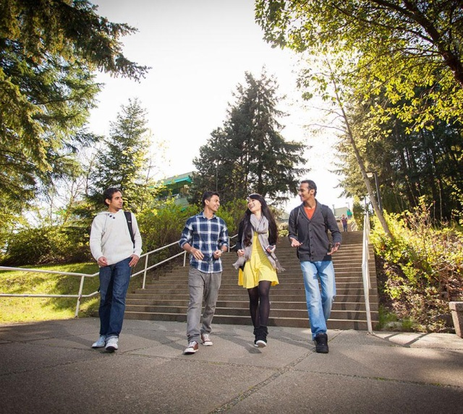

*VIU would like to acknowledge that this program has borrowed heavily from SFU, UVic, and UofA.*

**APPLICATION**

CONTACT INFORMATION

Primary contact person

Related club/department/organization (if applicable)

Year of study (if applicable)

Email address

Affiliation  CUPE  BCGEU  VIUFA €ADMIN Student

**PROPOSED ACTIVITY OR PROJECT DESCRIPTION**

Project name

Project description (max 500 words)*

Project timeline

*Consider these points in writing your description

***IMPACT AND LEGACY***

How does your project align with these objectives?

* Offer unique opportunities for students to make our campus and/or Western Student Housing (WSH), more sustainable.
* Encourage the VIU community to actively participate in social, environmental and economic sustainability.
* Connect sustainability to a diverse range of disciplines and interests
* Not duplicate with existing initiatives
* Have measurable outcomes

***SUCCESS METRICS/EVALUATION***

What are your quantifiable goals and how will you know they have been attained?

e.g.

* 300 students/staff/faculty will participate in this project
* All users of the lower cafeteria compost with 85% accuracy
* Consider the following when answering this question
* Who is the target audience for your project?
* As a result of your project, what knowledge, values, skills, attitudes, behaviours or sustainable practices will change in your audience?
* How will your initiative itself be sustainable into the future?

What improvements to sustainability will occur as a result of your project?

e.g.

• 40 L of water/day will be saved throughout the campaign

**OUTCOMES**

In what areas will your project advance sustainability at Vancouver Island University?

My project will help VIU make progress on sustainability by (click one or more as applicable):

Integrating sustainability into teaching and learning.

Integrating sustainability into facilities, operations and services.

Integrating sustainability into campus, community outreach and university life.

**IN KIND RESOURCES ANTICIPATED**

What kind of assistance do you anticipate needing to implement your project? Not applicable

Please explain:

**PROJECT BUDGET**

What funding do you anticipate needing to implement your project? Not applicable

Please list expenses (add rows if required)

|  |  |  |
| --- | --- | --- |
| Expense | Amount | Explanation |
|  |  |  |
|  |  |  |
|  |  |  |
|  |  |  |
| Total Costs |  |  |
| **REVENUE** |  |  |
| Funds from other VIU sources |  |  |
| Other funds |  |  |
| Total requested |  |  |

**OTHER INFORMATION**

How did you hear about VIU’s Sustainability Project Endorsement?

Friend/Colleague  Poster  Advertisement  Website  Our Newsletter

Twitter  Facebook  Student Guidebook

Other, please specify:______________________________

**ACKNOWLEDGEMENTS**

If your application is successful, and depending on the type of project, you may be asked to provide some or all of the following. Please indicate your agreement by checking each of the following items:

Provide the Sustainability Advisory Committee with a brief story (approx. 300 words) including at least one quote from a participant or organizer for use in print and online publications. This story may be edited by the VIU.

Acknowledge that VIU endorsed the project at the event, in presentations, publications, reports or outreach associated with your project, with the following statement: “Supported (in part) by the Sustainability Advisory Committee’s Sustainability Project Endorsement Program at Vancouver Island University.”

If applicable, provide the Sustainability Advisory Committee with a brief financial report (with receipts) that verifies funds were expended solely for this project. You will contact the Sustainability Advisory Committee for approval if there are any changes to the project before they occur. Any unspent funds associated with this application will be returned to the funding authority.

If applicable, provide the Sustainability Advisory Committee with a final report containing:

* testimonials from program participants/organizers,
* details about the idea/events/tool,
* number of participants,
* what was learned, and
* any associated evaluation results outlined in your proposal.

The report will include up to 6 pictures capturing your event. Photo releases must be provided with all pictures giving the Sustainability Advisory Committee permission to use them in print and online media in perpetuity.

**EVALUATION (a minimum score of 35 is needed for further consideration)**

|  |  |  |  |  |  |
| --- | --- | --- | --- | --- | --- |
| **Criteria** | **0-2** | **3-5** | **6-8** | **9-10** | **Score** |
| Offer unique opportunities for students to make our campuses or wider community more sustainable. | Limited opportunity to make a campus/wider community more sustainable and/or conventional. | Some opportunities that engage the community and/or a number of unique elements presented. | A selection of opportunities that engage the community and/or a variety of unique elements presented. | Many opportunities that engage the community and/or a wide range of unique elements presented. |  |
| Enhance sustainability on campuses, WSH, and/or enhance sustainability in the local community. | Limited enhancement outlined. | Some enhancement is outlined. | Considerable enhancement is clearly outlined. | Significant enhancement is outlined. |  |
| Have measurable outcomes | Outcomes are poorly defined and/or unrealistic. | Outcomes are somewhat defined but qualitative/quantitative measures have some gaps. | Well defined outcomes have clear quantitative/qualitative measurement processes. | Strongly defined outcomes have clear and achievable quantitative/qualitative processes. |  |
| Encourage the VIU community to actively participate in social, and/or environmental and/or economic sustainability. | Passive participation only--opportunity to actively participate is limited. | Some active participation opportunities are available and/or passive participation is likely to lead to more active involvement. | Active participation opportunities are well defined and likely to be engaging, but there may be some barriers to participation. | Active participation opportunities are well defined, and highly engaging with few or no barriers. |  |
| Connect sustainability to a diverse range of disciplines and interests | Narrow audience focus. | A few connections between a few departments/areas have been identified. | Clear connections between diverse departments/areas have been identified. | Clear connections between most departments/areas have been identified. |  |
| Not duplicate with existing initiatives | Duplicates and is not a good fit with scheduled initiatives. |  | Doesn’t duplicate | Doesn’t duplicate and dovetails into the previous or next scheduled initiative well. |  |
| Realistic timeline | Timeline of event/project is too long (too short) to achieve stated outcomes | Timeline of event/project does not account for competing events happening on campus(es) such as holidays or breaks | Timeline of event/project accounts for competing events happening on campus(es) and stated outcomes can be reasonably accommodated in that time frame. | Timeline of event/project thoughtfully and fully accommodates possible barriers in stated outcome delivery. |  |
| **Total** | | | | |  |
| **Comments/Recommendations** | | | | | |