Furniture and Equipment Recommendations
New furniture or equipment may be required or recommended after a work station is evaluated and set up or for Employment Accommodations. Below is a list of items to consider as ergonomic interventions, accommodations or when replacing equipment. These are examples of acceptable VIU standard ergonomic products. Comparable products from other suppliers should also be considered. Questions about specific items can be directed to safety@viu.ca or procurementservices@viu.ca. Departments are responsible for the cost of new furniture and equipment.
Ergonomics Accessories

Keyboards
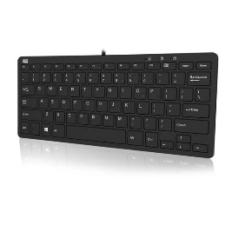 | Adesso Slim Touch Mini Keyboard  Compact keyboard without the number pad to save space. Helps petite individuals or those that have discomfort reaching for the mouse.
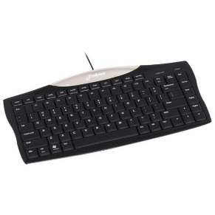 | Evoluent Essentials Compact Keyboard  Compact keyboard without the number pad to save space. Helps petite individuals or those that have discomfort reaching for the mouse.
Mice
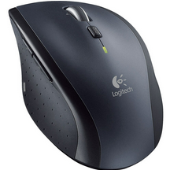 | Logitech Marathon M705 Wireless Mouse - Black  This a large mouse designed to encourage a more natural hand, wrist and forearm posture. Can help alleviate wrist and elbow pain.
Other Accessories
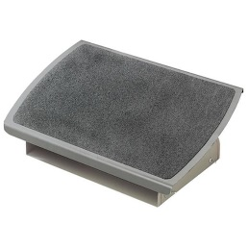 | 3M Adjustable Footrest  This has a sturdy metal base. This is used when using a fixed height workstation to keep your knees at 90 degrees when sitting.
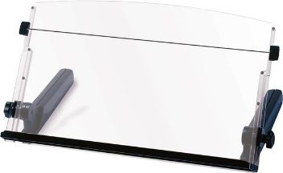 | 3M Adjustable Document Holder  Document holder can reduce neck strain and are useful for individuals who reference documents while using their computer (e.g. data entry, marking, reading etc.)

Furniture

Chairs
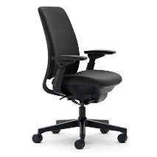 | Steelcase Amia  Height adjustable with numerous adjustments to create a comfortable fit. *Please contact the Procurement Services for pricing options.
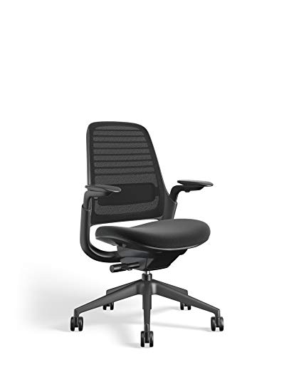 | Steelcase Series 1  CarbonNeutral certified and full adjustability.  *Please contact the Procurement Services for pricing options.
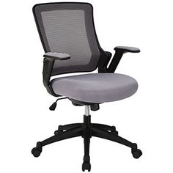 | Teknion Projek  Allows for work at varying heights, has an adjustable footrest.  *Please contact the Procurement Services for pricing options
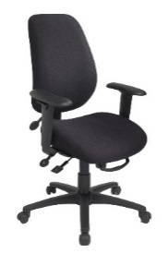 | Ergocentric Saffron (tall back)  Full adjustability, with I higher back for taller individuals.  *Please contact the Procurement Services for pricing options
Height Adjustable Desks
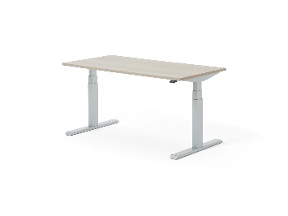 | Steelcase Migration
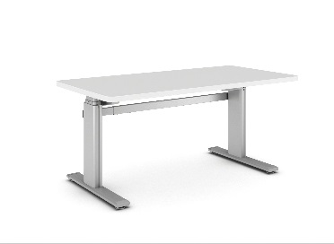 | Solo Sit-to-Stand Desk  This height adjustable desk come in many configurations so can work with existing furniture and office space.
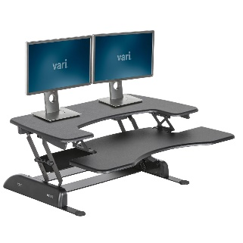 | VariDesk Pro Plus  Turns any standard desk into a standing desk. Offers a tiered design with a lower deck for a keyboard.
*Please contact procurementservices@viu.ca for an up-to-date quote on furniture.

