Building: 310 Interior Date: April 15 & 22, 2025
Names of Inspectors: Kordell Bergen, Kim Sharpe, Robin Boxwood, Dale Baumel

 | Yes | No | N/A
 | Emergency equipment and procedures
A.1 | Fire extinguishers | X
A.2 | Fire detection & suppression systems | X
A.3 | First aid kits | X
A.4 | Eye wash stations | X
A.5 | Emergency lighting | X
A.6 | Accessibility | X
A.7 | Escape routes and muster points signed | X
A.8 | Emergency procedures signed | X
A.9 | Emergency contact information posted | X
A.10 | Emergency drill performed in last 12 months | X
 | Floors, walkways and stairways
B.1 | Well-lit | X
B.2 | No blind corners | X
B.3 | Free of tripping hazards (e.g., clutter, damaged mats, uneven flooring, uncovered cables) | X
B.4 | Dry, clean, and free of slipping hazards | X
B.5 | Railings and guardrails in place and secure | X
 | Entrances and parking lots
C.1 | Well-lit | X
C.2 | Clear of obstructions | X
C.3 | Entrances are secured | X
C.4 | Clear signage in parking lot (no parking, speed limits, direction of traffic, etc.) | X
 | Shop floors and work yards
D.1 | Appropriate lighting for work tasks | X
D.2 | Airflow and ventilation appropriate for work tasks | X
D.3 | Piping for gas, compressed air, etc. clearly labeled | X
D.4 | Electrical control boxes have clear access |  | X
D.5 | Circuit breakers and starter switches clearly marked | X
D.6 | Adequate heating and cooling |  | X
D.7 | Safe noise levels or hearing protection provided as required | X
D.8 | Pedestrian traffic separated from vehicle traffic where practical | X
 | Materials
E.1 | Stacked materials are stable (interlocked, strapped, or other means of restraint) | X
E.2 | Stacked materials are not near ignition sources |  |  | X
E.3 | Stacked materials do not obstruct sprinkler systems | X
E.4 | Containers and storage racks undamaged and appropriate for materials | X
E.5 | Hazardous materials are properly labelled | X
E.6 | Flammable and hazardous materials secured and stored in approved containers | X
E.7 | SDS available and less than three years old | X
 | Tools and Equipment
F.1 | Maintenance log up-to-date | Unknown
F.2 | Inspection log up-to-date | Unknown
F.3 | Defective tools and equipment tagged and removed from service | X
F.4 | PPE is available as required for all workers | X
 | Ladders
G.1 | Ladders are appropriate for the work task | X
G.2 | Ladders are in good condition with no obvious signs of wear and tear | X
 | Work practices – general
I.1 | Workers trained for specific work tasks | X
I.2 | Workers supervised for work tasks | X
I.3 | Tools used for their designed purposes only | X
 | Personal protective equipment (PPE)
J.1 | Workers are trained in correct PPE use | X
J.2 | Used consistently and correctly | X
J.3 | Maintained in good working order | X
J.4 | Inspected and replaced on schedule | X
 | Slipping and tripping avoidance
L.1 | Handrails are used | X
L.2 | Spills cleaned immediately | X
L.3 | Well-fitting, non-slip footwear worn |  |  | X
 | Ergonomics
M.1 | Available assistive equipment and/or mechanical aids used | X
M.2 | Tasks are varied or rotated to minimize repetitive movement | X
M.3 | Loads assessed before lifting or pulling | X
M.4 | Loads maintained close to the body | X
M.5 | Lifting with legs | X
M.6 | Upper body kept erect | X
M.7 | Natural reaching without having to over-extend | X
M.8 | Workstations and seating at proper height | X
 | Safe work practices for high-risk work conform to regulatory requirements and are followed
N.1 | Working at elevation | X
N.2 | Asbestos exposure |  |  | X
N.3 | Exposure to hazardous materials |  |  | X
N.4 | Working in excavations |  |  | X
N.5 | Entry into confined space |  |  | X
N.6 | Working near combustible dust | X
N.7 | Hand falling or bucking |  |  | X
N.8 | Use of explosives, or flammable or combustible materials |  |  | X
N.9 | De-energization, lockout, and safeguarding |  |  | X
N.10 | Exposure to violence | X
 | Washrooms
O.1 | Clean and adequately maintained | X
O.2 | Equipment in good repair |  | X
 | Other areas of focus
P.1 | Digital emergency reader
P.2 | Vines growing into office
P.3 | Paint filter
P.4 | Water leak
P.5 | Shower
Corrective Action | Assigned To
A.3. First aid kits were noted in the stage area of the theatre. Robin confirmed that the Theatre Department was responsible for restocking. | N/A
A.4. No eyewash station in the Theatre Shop. H&S will provide a portable kit. | H&S
A.6. Access to room 109 (CEL) is not accessible, there is no automatic door. I held the door for an individual in a wheelchair during the inspection. | Facility Services / CEL
A.7. The evacuation sign in the External Relations portion of the building is being blocked by a coat rack. This was noted during the 2022 inspection. Relocate the coat rack. | External Relations
B.1. The nosing is the same colour as the carpeting on the stairs leading down to the theatre seating area. Discussed installing lighting on the stairs with Robin. | Theatre
B.3. Tripping hazard on the transition from the stairs to the stage. Can warning tape be added to this transition, or would this impact the visual effect of the page? | Theatre
D.2. Questions around the 3D printers in the Theatre Shop. H&S’s recommendation is to enclose all 3D printers and either filter or vent emissions. H&S will share a Risk Assessment completed for other 3D printers on campus with the Theatre Department. | Theatre / H&S
D.4. Janitor supplies blocking access to the electrical panel in R113. Please move. | Facility Services / External Relations
D.6. Occupants in R140 report inadequate airflow, heating and cooling in their room. | Facility Services / Brand and Marketing
E.5. Chemicals being stored under sink in Theatre box office. Recommend WHMIS2015 training and retraining for workers and work ops. Please review the Chemical Safety pages on the Health and Safety website. Ensure ventilation is installed for safe use of Laser Etching equipment. | Theatre
G.1. Ladder improperly stored. Lay the ladder down or anchor it to the wall. | Theatre
O.2. Multiple stall door locks are missing in theatre washroom (R213). Replace the locks or remove the washroom from service. | Facility Services / Theatre
P.1. Two digital emergency readers were noted in the Theatre near the stage area. H&S will confirm ownership and functionality of these readers. | H&S
P.2. Ivy has grown through the window seal into the interior of office 208. | Facility Services / Theatre
P.3. There is a paint filter on the sink at the back of the stage. Robin reports regularly using this sink to clean paint and in unsure of the last time this filter was checked. | Facility Services / Theatre
P.4. Occupants in R109 (CEL) report a water leak from the ceiling in the back storage room. Occupants report the water leak to be substantial and consistent. | Facility Services / CEL
P.5. There is an old shower in the theatre women’s washroom (R213). The shower head and hose are showing signs of mold. Remediate, remove or take out of service. | Facility Services / Theatre

A.7 B.3 D.4
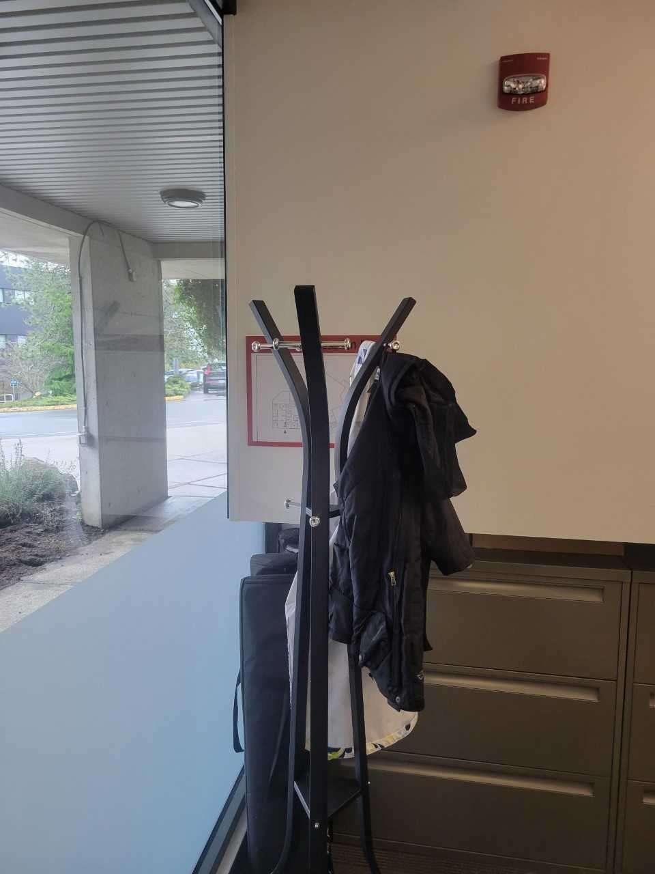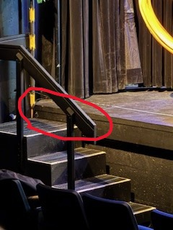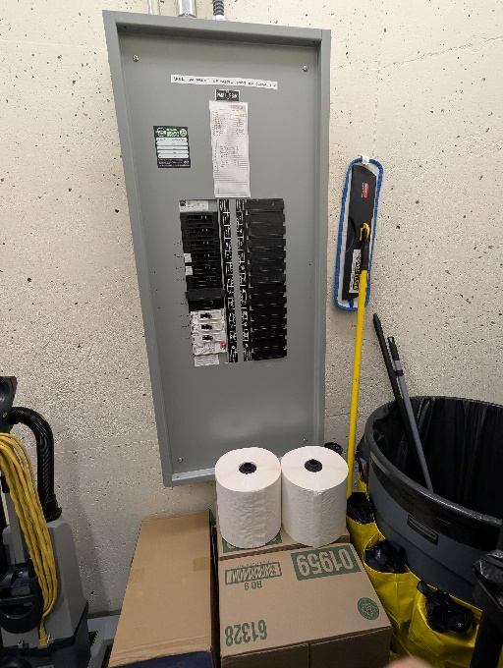

E.5 G.1 O.2
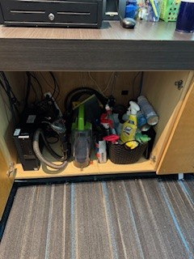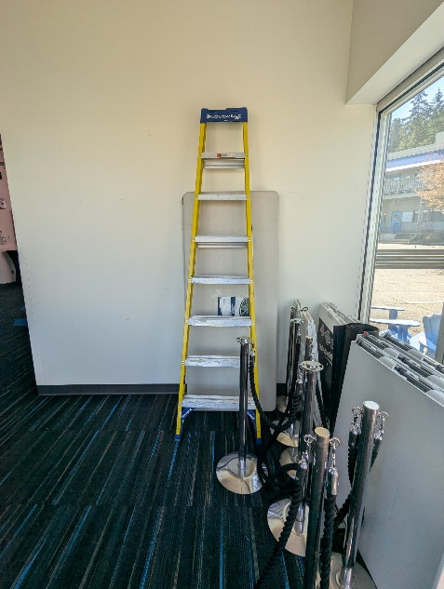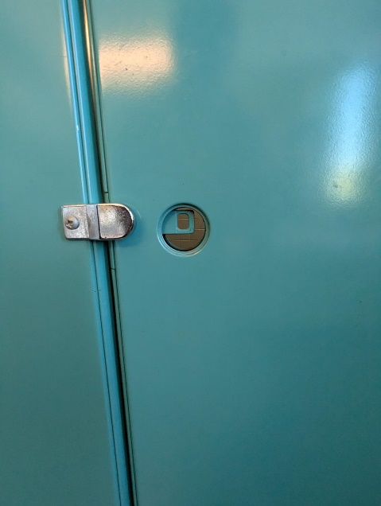

P.2 P.3 P.4
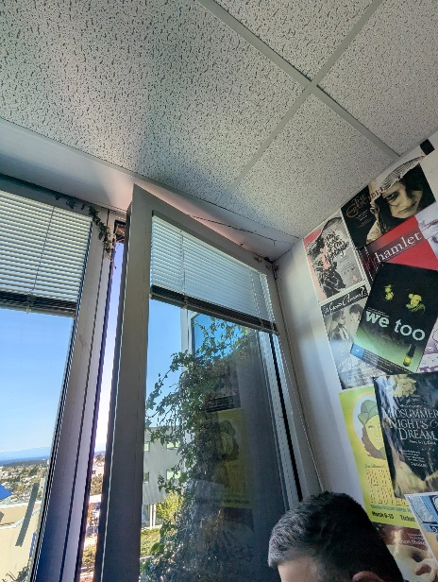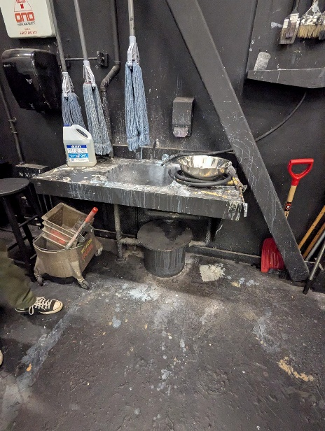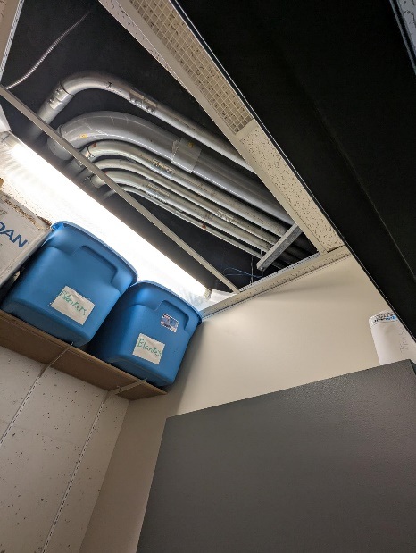

P.5
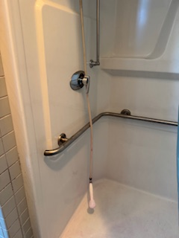

Building: 310 Exterior Date: April 15, 2025
Names of Inspectors: Kordell Bergen, Kim Sharpe, Robin Boxwood

 | Yes | No | N/A
 | Around the Building
A.1 | Is the address sign or number easily visible? | X
A.2 | Is waste stored in appropriate waste or recycling storage areas? | X
A.3 | Is the property kept clear of litter, combustibles, hazardous materials, etc.? |  | X
A.4 | If present, are smoking areas clean? Is an appropriate cigarette butt receptacle available? |  |  | X
 | Parking Lot
B.1 | Are appropriate signs posted (e.g., no parking in fire routes, etc.)? | X
B.2 | Are the parking areas free from trip hazards (e.g., no pot holes, cracks, etc.)? |  |  | X
B.3 | Is the lighting adequate in the area and walkways at night? | X
B.4 | Is the parking lot kept free of debris? | X
B.5 | In winter, is the parking lot free from ice and snow? |  |  | X
 | Stairs
C.1 | Are stairs, stairwells, and landings kept clear and unobstructed? | X
C.2 | In winter, are stairs, stairwells, and landings kept clear from ice and snow? |  |  | X
C.3 | Are stairways adequately lit? | X
C.4 | Are stairs, treads, hand rails, and any guards secure and in good condition? | X
C.5 | Do treads and landings have non-skid surfaces and they are in good condition? | X
 | Exits / Fire Safety
D.1 | Are all emergency exits, exit doors, landings, and steps from the building well marked, unblocked, and kept in good condition? | X
D.2 | In winter, are exits kept free from ice and snow? |  |  | X
D.3 | In winter, is the roof area over the exits free of falling ice and snow hazards? |  |  | X
D.4 | Are exit doors, landings, and steps well lit? Are the lights over the exit doors working and in good repair? | X
D.5 | In winter, is the access ramp clear of ice and snow, and is there good traction? |  |  | X
D.6 | Can the building be easily accessed by the fire department? Are fire lanes accessible and posted? | X
D.7 | Are the fire department hose connections kept clear, accessible and have caps? | X
D.8 | Is the electrical service entrance area clear of trees and branches? | X
D.9 | Are all electrical wires out of reach of the public? | X
D.10 | Are sprinkler heads guarded? Obstructed? | X
 | Grounds
E.1 | Are walkways clear and in good condition? Are there any holes or trip hazards on grounds where workers/public may walk? | X
E.2 | In winter, are ice and snow cleared promptly from walkways? |  |  | X
E.3 | Is security lighting functioning properly? | X
E.4 | Are exit routes (from the grounds) well marked, and kept clear and unobstructed? | X
E.5 | Is fencing in good condition? |  |  | X
E.6 | Is any outdoor machinery in good repair? |  |  | X
 | Loading Areas
G.1 | If required, are pedestrian walkways clearly marked? | X
G.2 | Are vehicles and/or loads secured from accidental movement? | X
G.3 | Is the area kept free of obstructions or debris? | X
G.4 | Are any lifting devices, racking systems, etc. in good condition? |  |  | X
G.5 | If required, are machine guards in place? |  |  | X
Corrective Action | Assigned To
A.3. Excessive vegetation is growing on the second level balconies. One of the offices that we entered had ivy that had grown through the window into the interior office. Is there a long-term plan for these plants? Are they maintained? Should they be removed completely?  Sprinkler lines are hanging from the second level balconies. Should these be removed or reinstalled for the plants? | Facility Services

A.3 A.3 A.3
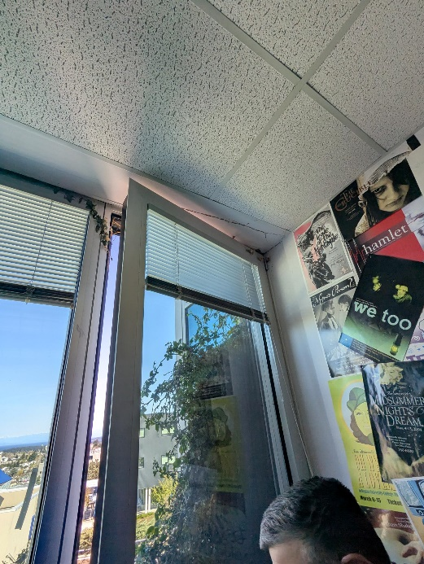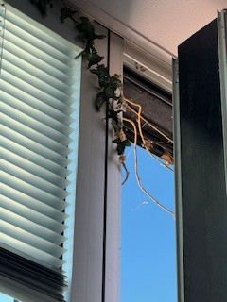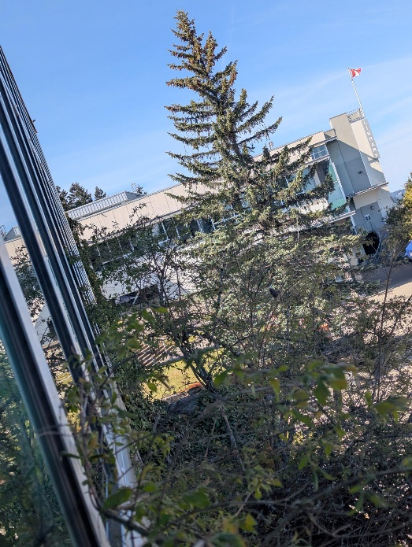

A.3 A.3 A.3
