Building: Student Housing Date: August 8, 2025
Names of Inspectors: Kordell Bergen, Kim Sharpe, Rob Okashimo, Joshua Beaulac

 | Yes | No | N/A
 | Around the Building
A.1 | Is the address sign or number easily visible? | X
A.2 | Is waste stored in appropriate waste or recycling storage areas? | X
A.3 | Is the property kept clear of litter, combustibles, hazardous materials, etc.? |  | X
A.4 | If present, are smoking areas clean? Is an appropriate cigarette butt receptacle available? | X
 | Parking Lot
B.1 | Are appropriate signs posted (e.g., no parking in fire routes, etc.)? | X
B.2 | Are the parking areas free from trip hazards (e.g., no pot holes, cracks, etc.)? | X
B.3 | Is the lighting adequate in the area and walkways at night? |  |  | X
B.4 | Is the parking lot kept free of debris? | X
B.5 | In winter, is the parking lot free from ice and snow? |  |  | X
 | Stairs
C.1 | Are stairs, stairwells, and landings kept clear and unobstructed? |  | X
C.2 | In winter, are stairs, stairwells, and landings kept clear from ice and snow? |  |  | X
C.3 | Are stairways adequately lit? |  |  | X
C.4 | Are stairs, treads, hand rails, and any guards secure and in good condition? | X
C.5 | Do treads and landings have non-skid surfaces and they are in good condition? |  |  | X
 | Exits / Fire Safety
D.1 | Are all emergency exits, exit doors, landings, and steps from the building well marked, unblocked, and kept in good condition? | X
D.2 | In winter, are exits kept free from ice and snow? |  |  | X
D.3 | In winter, is the roof area over the exits free of falling ice and snow hazards? |  |  | X
D.4 | Are exit doors, landings, and steps well lit? Are the lights over the exit doors working and in good repair? | X
D.5 | In winter, is the access ramp clear of ice and snow, and is there good traction? |  |  | X
D.6 | Can the building be easily accessed by the fire department? Are fire lanes accessible and posted? | X
D.7 | Are the fire department hose connections kept clear, accessible and have caps? | X
D.8 | Is the electrical service entrance area clear of trees and branches? | X
D.9 | Are all electrical wires out of reach of the public? | X
D.10 | Are sprinkler heads guarded? Obstructed? | X
 | Grounds
E.1 | Are walkways clear and in good condition? Are there any holes or trip hazards on grounds where workers/public may walk? |  | X
E.2 | In winter, are ice and snow cleared promptly from walkways? |  |  | X
E.3 | Is security lighting functioning properly? | X
E.4 | Are exit routes (from the grounds) well marked, and kept clear and unobstructed? | X
E.5 | Is fencing in good condition? |  | X
E.6 | Is any outdoor machinery in good repair? | X
 | Storage Shed
F.1 | Are hazardous products adequately stored and labelled? | X
F.2 | Are incompatible materials stored separately? |  |  | X
F.3 | Is the shed or area secured and access limited? |  |  | X
F.4 | Is there any sign of leaks or spills? |  | X
F.5 | Are “No Smoking” signs posted when flammable products are stored? |  |  | X
F.6 | Is the storage area protected from exposure to heat, moisture, vibration, flame, etc. as appropriate for the products stored? | X
F.7 | Is equipment and machinery in good condition? | X
 | Miscellaneous
G.1 | BBQ | X
Corrective Action | Assigned To
A.3. Please remove the piles of old vegetation – Fire hazard  Make Wildfire Preparedness Part of Your Summer Plans | FireSmart BC | Facility Services
A.4. Please install signs (and possibly painted markings?) that clearly designate the smoking areas. Smoking should not occur within 6 mteres of any doorways, air intakes or windows that are connected to common areas.  https://www2.gov.bc.ca/gov/content/health/keeping-bc-healthy-safe/tobacco-vapour/requirements-under-tobacco-vapour-product-control-act-regulation/tobacco-vapour-free-places | Facility Services
B.1. Incident Report 10329 sent from Student Housing on July 18, 2025 raised concerns regarding the paint wearing off the speed bumps due to the construction. A solution to bring awareness to the speed bumps was to place cones at all of the speed bumps. The cones that are being used now are very small and unnoticeable. Consider purchasing larger weighted cones until the construction has been completed and the speed bumps can be repainted. | Student Housing Staff
C.1 / E.1. The Housing grounds, stair and landings are overgrown. This is a noticeable change from the last inspection in 2022. | Facility Services
E.5. The fencing to the north of Housing has large holes in it. I’m not sure if this is on VIU property or leads to VIU property. | Student Housing Staff
G.1. Does the gas to the BBQ’s outside B4 need to be locked out? Are these BBQ’s available for students to use 24/7? If not please add a lock to the gas line to prevent unauthorized use or tampering. If these BBQ’s are for student use is a procedure in place to control who has access to them, when and how they are being used? | Student Housing Staff

A.3 A.4 B.1
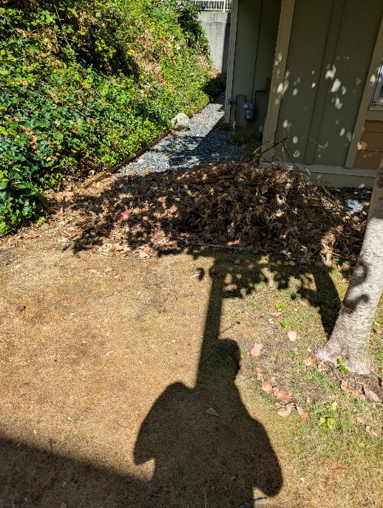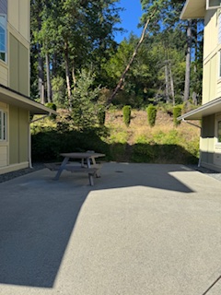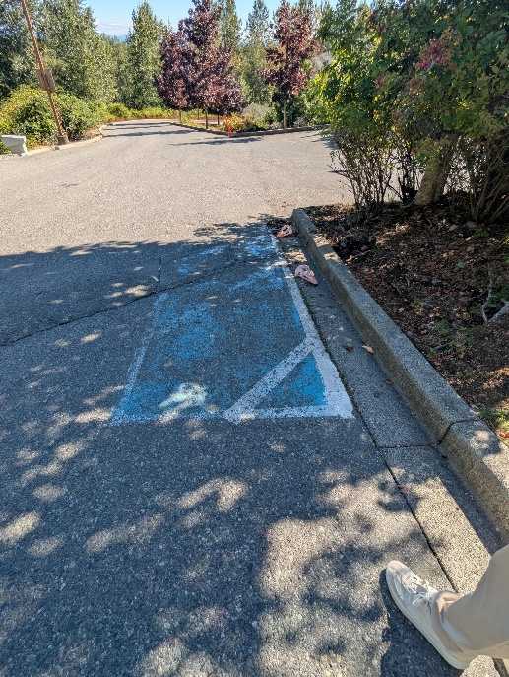

C.1 / E.1 E.5 G.1
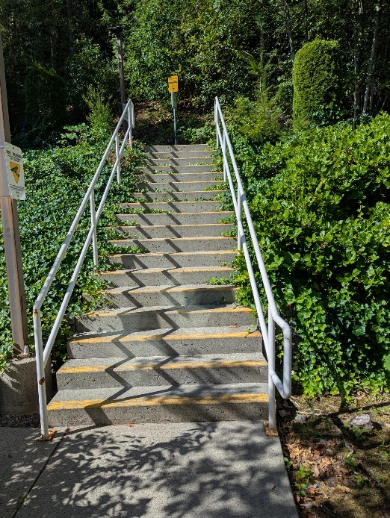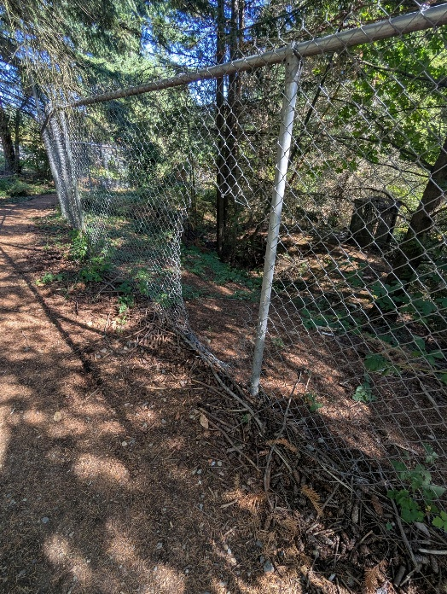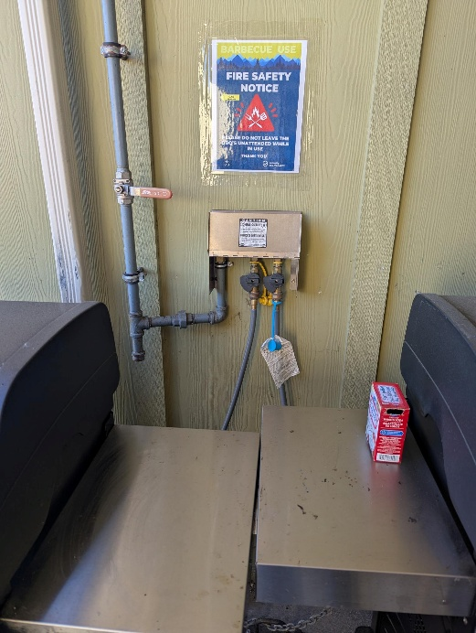

Building: Student Housing – Building 4, 5, 2, 10 Date: August 7, 2025
Names of Inspectors: Kordell Bergen, Rob Okashimo, Kim Sharpe, Joshua Beaulac

 | Yes | No | N/A
 | Emergency equipment and procedures
A.1 | Fire extinguishers | X
A.2 | Fire detection & suppression systems | X
A.3 | First aid kits | X
A.4 | Eye wash stations | X
A.5 | Emergency lighting | X
A.6 | Alarms | X
A.7 | Escape routes and muster points signed | X
A.8 | Emergency procedures signed | X
A.9 | Emergency contact information posted | X
A.10 | Emergency drill performed in last 12 months | X
 | Floors, walkways and stairways
B.1 | Well-lit | X
B.2 | No blind corners | X
B.3 | Free of tripping hazards (e.g., clutter, damaged mats, uneven flooring, uncovered cables) |  | X
B.4 | Dry, clean, and free of slipping hazards | X
B.5 | Railings and guardrails in place and secure | X
 | Entrances and parking lots
C.1 | Well-lit | X
C.2 | Clear of obstructions | X
C.3 | Entrances are secured | X
 | Materials
D.1 | Stacked materials are stable (interlocked, strapped, or other means of restraint) |  | X
D.2 | Stacked materials are not near ignition sources | X
D.3 | Stacked materials do not obstruct sprinkler systems | X
D.4 | Containers and storage racks undamaged and appropriate for materials | X
D.5 | Hazardous materials are properly labelled | X
D.6 | Flammable and hazardous materials secured and stored in approved containers | X
D.7 | SDS available and less than three years old |  |  | X
 | Ladders
E.1 | Ladders are appropriate for the work task | Unknown
E.2 | Ladders are in good condition with no obvious signs of wear and tear |  |  | X
 | Work practices – general
F.1 | Workers trained for specific work tasks | X
F.2 | Workers supervised for work tasks | X
F.3 | Tools used for their designed purposes only | X
 | Personal protective equipment (PPE)
G.1 | Workers are trained in correct PPE use | X
G.2 | Used consistently and correctly |  |  | X
G.3 | Maintained in good working order |  |  | X
G.4 | Inspected and replaced on schedule |  |  | X
 | Slipping and tripping avoidance
H.1 | Handrails are used | X
H.2 | Spills cleaned immediately | X
H.3 | Well-fitting, non-slip footwear worn |  |  | X
 | Emergency Equipment
I.1 | Is all fire control equipment regularly tested and certified? | X
I.2 | Is fire control equipment appropriate for the type of fire it must control? | X
I.3 | Are sprinkler heads guarded? Obstructed? |  | X
I.4 | Is emergency lighting in place and regularly tested? | X
 | Building
J.1 | Do buildings conform to standards with respect to use, occupancy, building services, and plumbing facilities?
J.2 | Check the following structures to ensure safety:
J.3 | - swinging doors | X
J.4 | - floor and wall openings | X
J.5 | - ladders, stairways and ramps | X
J.6 | - guardrails | X
J.7 | Are materials stored safely? |  | X
 | Air Handling System
K.1 | Does air exchange rate meet standard requirements? | X
K.2 | Is the system free of sources of contamination (e.g., asbestos, microorganisms, dust, fumes)? | X
K.3 | Is humidity within recommended range? | X
 | Hazardous Products
L.1 | Are there any hazardous products (e.g., products regulated by WHMIS)? | X
L.2 | - If yes, are the products properly labelled? | X
L.3 | - If yes, is there a corresponding safety data sheet (SDS) for each product? | Unknown
L.4 | - If yes, are workers trained in how to work with or near these products safely? | Unknown
 | Sanitation
M.1 | Are washrooms and food preparation areas clean? | X
M.2 | Are the following provided adequately?
M.3 | - toilets | X
M.4 | - showers | X
M.5 | - potable (drinkable) water | X
M.6 | - clothing storage | X
M.7 | - change rooms | X
M.8 | - field accommodations |  |  | X
M.9 | - lunchrooms | X
M.10 | Are measures in place to prevent the spread of disease? | X
 | General
N.1 | Are extension cords used extensively? (if so, consider installing permanent wiring) |  | X
N.2 | Are electrical or telephone cords exposed in areas where employees may become entangled? |  | X
N.3 | Is electrical wiring properly installed? | X
N.4 | Are machines properly guarded? |  |  | X
N.5 | Does any equipment have sharp metal projections? |  | X
N.6 | Are wall and ceiling fixtures fastened securely? | X
N.7 | Are paper and waste properly disposed of? | X
N.8 | Are desk and file drawers kept closed when not in use? | X
N.9 | Are office accessories stored appropriately? | X
N.10 | Are materials stacked on desks or cabinets? | X
N.11 | Are file cabinet drawers overloaded? |  | X
N.12 | Are file cabinets loaded with the heaviest items in the bottom drawers? | X
N.13 | Are shelves securely fastened to the wall when necessary? | X
N.14 | Are filing stools or wastebaskets placed where they might be tripping hazards? |  | X
 | Miscellaneous
O.1 | Mechanical room access | X
O.2 | Mechanical room storage | X
O.3 | Blocked sign | X
O.4 | Resources poster | X
Corrective Action | Assigned To
A.4. The eye wash in the janitor room on the laundry room of B4 is expired. | Building occupants
A.7. The evacuation signs are not properly installed. Are there evacuation signs in every room? | Building Occupants
B.3. The nosing on the stairs of B5 has detached. Tripping hazard. | Facility Services
D.1. Black bins stacked on storage lockers must be: 4.43 Stacking materials (1) stored in a stable and secure manner. (2) Stacked material or containers must be stabilized as necessary by interlocking, strapping or other effective means of restraint to protect the safety of workers. | Building Occupants
E.1. Is there a ladder or stepping stool available in B4 to access items stored overhead? | Building Occupants
I.3. Some sprinkler heads are guarded, others aren’t, others have stickers. Are there plans to guard all sprinkler heads? | Building Occupants
J.7 / N.9. Chemicals and food being stored together in the CL room and janitor room. Food should not be stored with chemicals. | Building Occupants
K.1. A portable air conditioning unit was noted during the inspection. Are occupants allowed to use personal A/C units in Housing? | Building Occupants
O.1. Access to the mechanical room in the CL room was being blocked with a swiss ball, please keep access clear. | Building Occupants
O.2. Student Housing items being stored in the mechanical room in the CL room. Please remove these items, not a storage room. | Building Occupants
O.3. Suicide sign being blocked by the fridge in B2, please reposition the sign. | Building Occupants
O.3. The stair sign has been taped over in some buildings, please remove. | Building Occupants
O.4. The “Resources” poster does not list Health & Safety (incident reporting) or Campus Security. Should these be listed for occupants? | Building Occupants

A.4 A.7 B.3
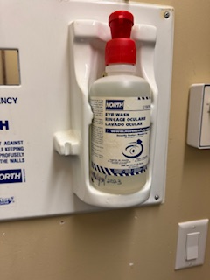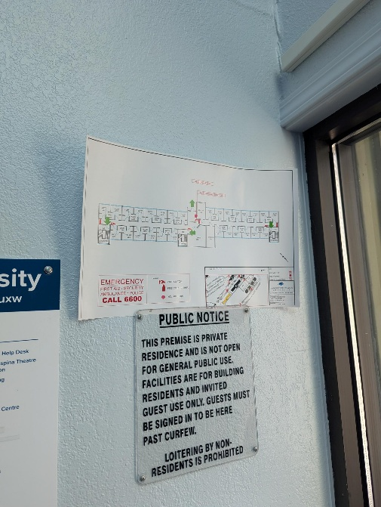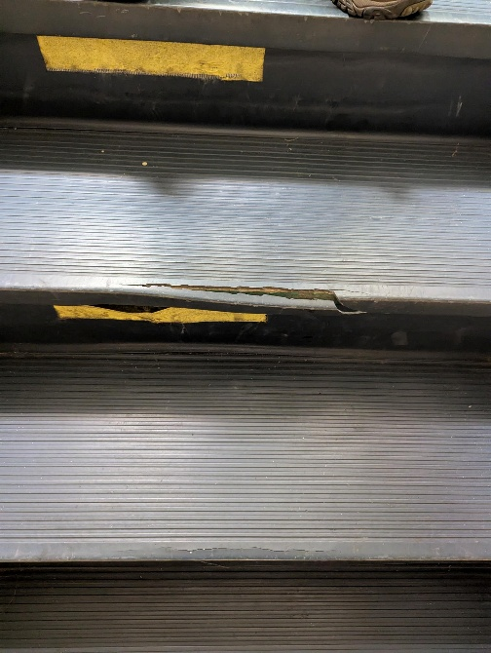

D.1 I.3 I.3
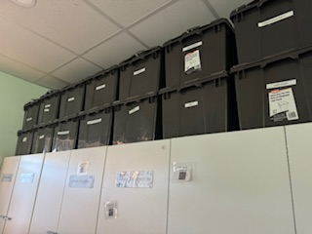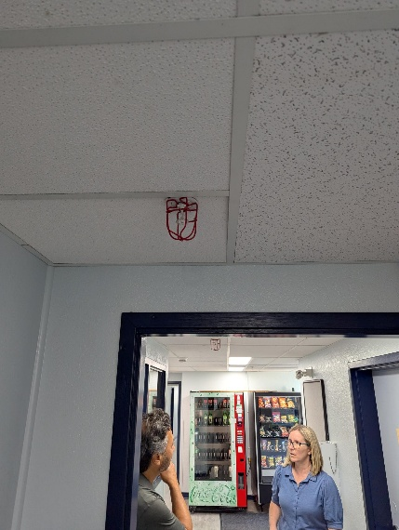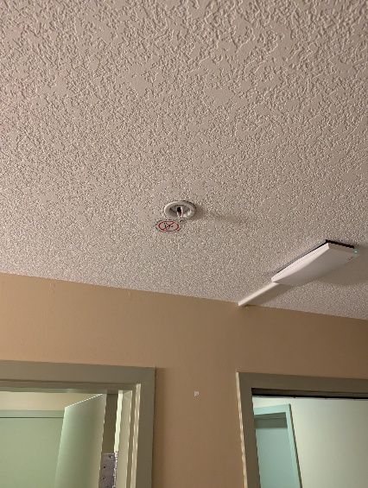

I.3 J.7 / N.9 J.7 / N.9
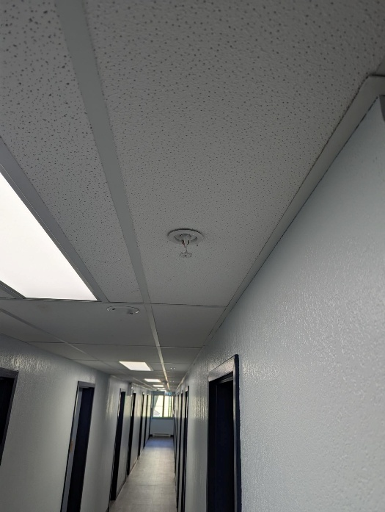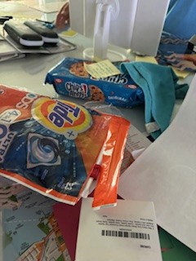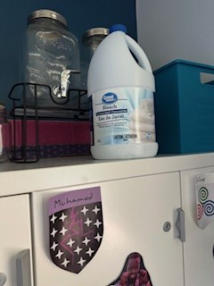

J.7 / N.9 J.7 / N.9 K.1
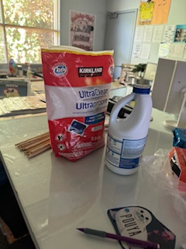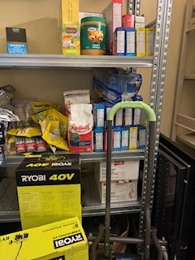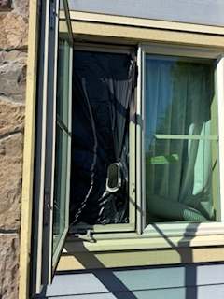

O.1 O.2 O.2
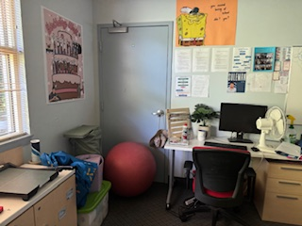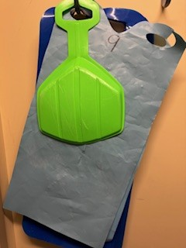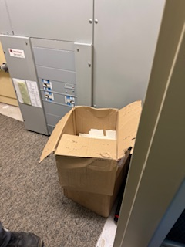

O.3 O.4
