Building: 480 Date: February 11, 2025
Names of Inspectors: Kordell Bergen, Rob Okashimo, Kim Sharpe

 | Yes | No | N/A
 | Bulletin Boards and Signs
A.1 | Are they clean and readable? | X
A.2 | Is the material changed frequently? | X
A.3 | Do items interfere with people walking by? |  | X
 | Floors
B.1 | Is there loose material, debris, worn carpeting? |  | X
B.2 | Are the floors slippery, oily or wet? |  | X
 | Stairways and Aisles
C.1 | Are they clear and unblocked? |  | X
C.2 | Are stairways well lighted? | X
C.3 | Are handrails, handholds in place? | X
C.4 | Are the aisles marked and visible? |  |  | X
 | Equipment
D.1 | Are guards, screens and sound-dampening devices in place and effective? | X
D.2 | Is the furniture in good repair and safe to use? Look for:
D.3 | - chairs that are in poor repair |  | X
D.4 | - sharp edges on desks and cabinets |  | X
D.5 | - poor ergonomics (keyboard elevation, chair adjustment, desk height) |  | X
D.6 | - crowding |  | X
D.7 | Are ladders well maintained and safe to use? | X
 | Emergency Equipment
E.1 | Is all fire control equipment regularly tested and certified? | X
E.2 | Is fire control equipment appropriate for the type of fire it must control? | X
E.3 | Are sprinkler heads guarded? Obstructed? | X
E.4 | Is emergency lighting in place and regularly tested? | X
 | Building
F.1 | Do buildings conform to standards with respect to use, occupancy, building services, and plumbing facilities? | X
F.2 | Check the following structures to ensure safety:
F.3 | - swinging doors | X
F.4 | - floor and wall openings | X
F.5 | - ladders, stairways and ramps | X
F.6 | - guardrails | X
F.7 | Are materials stored safely? | X
 | Air Handling System
G.1 | Does the air exchange rate meet standard requirements? |  | X
G.2 | Is the system free of sources of contamination (e.g., asbestos, microorganisms, dust, fumes)? | X
G.3 | Is humidity within recommended range? | X
 | Hazardous Products
H.1 | Are there any hazardous products (e.g., products regulated by WHMIS)? | X
H.2 | - If yes, are the products properly labelled? | X
H.3 | - If yes, is there a corresponding safety data sheet (SDS) for each product? | X
H.4 | - If yes, are workers trained in how to work with or near these products safely? | Unknown
 | Sanitation
I.1 | Are washrooms and food preparation areas clean? |  | X
I.2 | Are the following provided adequately?
I.3 | - toilets | X
I.4 | - showers |  |  | X
I.5 | - potable (drinkable) water | X
I.6 | - clothing storage |  |  | X
I.7 | - change rooms |  |  | X
I.8 | - field accommodations |  |  | X
I.9 | - lunchrooms | X
I.10 | Are measures in place to prevent the spread of disease? | X
 | Security
J.1 | Do entry and exit procedures provide workers personal security at night? | X
J.2 | Are emergency (evacuation, fire, bomb threat, hostile person) procedures in place? | X
 | Lighting
K.1 | Are lamp reflectors clean? | X
K.2 | Are bulbs missing? | X
K.3 | Are any areas dark? | X
 | Material Storage
L.1 | Are materials neatly and safely piled? | X
L.2 | Are there stepladders or stools to get to materials on higher shelves? | X
L.3 | Are storage shelves overloaded or beyond their rated capacity? |  | X
L.4 | Are large and heavy objects stored on lower shelves? | X
L.5 | Are passageways and work areas clear of obstructions? |  | X
 | General
M.1 | Are extension cords used extensively? (if so, consider installing permanent wiring) |  | X
M.2 | Are electrical or telephone cords exposed in areas where employees may become entangled? |  | X
M.3 | Is electrical wiring properly installed? | X
M.4 | Are machines properly guarded? |  |  | X
M.5 | Does any equipment have sharp metal projections? |  | X
M.6 | Are wall and ceiling fixtures fastened securely? |  | X
M.7 | Are paper and waste properly disposed of? | X
M.8 | Are desk and file drawers kept closed when not in use? | X
M.9 | Are office accessories stored appropriately? | X
M.10 | Are materials stacked on desks or cabinets? |  | X
M.11 | Are file cabinet drawers overloaded? |  | X
M.12 | Are file cabinets loaded with the heaviest items in the bottom drawers? |  |  | X
M.13 | Are shelves securely fastened to the wall when necessary? | X
M.14 | Are filing stools or wastebaskets placed where they might be tripping hazards? | X
 | Miscellaneous
N.1 | Bunsen burner in fume hood | X
N.2 | Overhead hazard | X
N.3 | Ventilation | X
N.4 | Corrosion | X
N.5 | Filter cover | X
N.6 | Fish Fins | X
N.7 | Food in lab fridge | X
N.8 | Loose step | X
N.9 | Broken thermometer | X
Corrective Action | Assigned To
C.1. / L.5. Multiple exits are being blocked.  Janitorial supplies are blocking an emergency exit on the East side of the building.  A mop and chair are blocking the emergency exit on the North end of the building.  A fire cabinet is blocking an exit on the South end of the building.  These exits must be cleared. | Todd Barsby  Derek Mann (janitorial)
E.1. A fire extinguisher is being blocked in Room103, please remove the items in front of the fire extinguisher and keep the fire extinguisher accessible. | Todd Barsby
G.1. Ventilation in Room 101 is passive/not constantly running. Flammable liquids are being stored in large quantity in this room. This room was previously investigated by WorkSafeBC with the recommendation to reduce the quantity of flammable liquids stored (complete), and upgrade the ventilation to ensure sparking doesn’t happen when the system switch is turned on passively (incomplete). The WorkSafeBC inspection report is attached to this email. | Todd Barsby
I.1. There is a drawer of rotting apples in the fridge. | Todd Barsby
M.6. Ceiling panels are falling in Room 100B and the hallway outside Room 109 & 110. | Facility Services / IT Services
N.1. A Bunsen burner is being used in a laminar flow hood. Using a Bunsen burner (the heat) disrupts the laminar airflow, compromising the sterility of the work area and samples; use a micro-burner, an electric incinerator, or disposable loops instead. Use can also potentially damage the HEPA filter within the cabinet. | Todd Barsby
N.2. Add caution tape and an overhead hazard sign. | Facility Services
N.3. Is the ventilation appropriate for the chemicals being stored in Rooms 100B & 100A? | Todd Barsby/Facility Services
N.4. Corrosives are being stored in the metal flammable cabinet in Room 100A, these chemicals should be stored in corrosive-resistant containers. | Todd Barsby
N.5. The filter cover on the base of the laminar flow hood in Room 100 is falling off. The filter integrity may be impacted. | Todd Barsby
N.6. Numerous boxes of fish fins in the ground floor storage room. Biohazard? Animal Care? | Jennifer Kebe
N.7. Garlic is being stored in the lab fridge in Room 100. If the food is for consumption, it should be removed, if it is for an experiment, it should be labelled ‘not for human consumption.’ | Todd Barsby
N.8. The step leading into the freezer building is loose. Can this be bolted to the building or concrete? | Facility Servcies
N.9. The thermometer for the fridge in Room 100 appears broken. | Todd Barsby

C.1/L.5 C.1/L.5 C.1/L.5
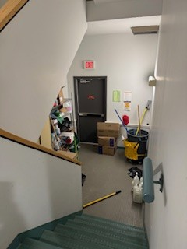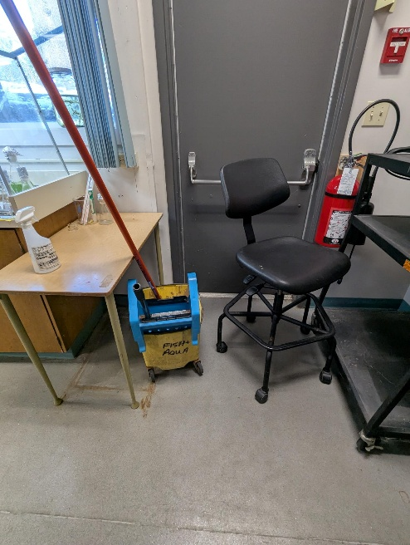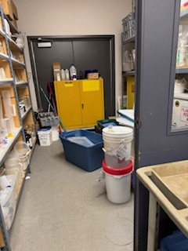

E.1 I.1 M.6
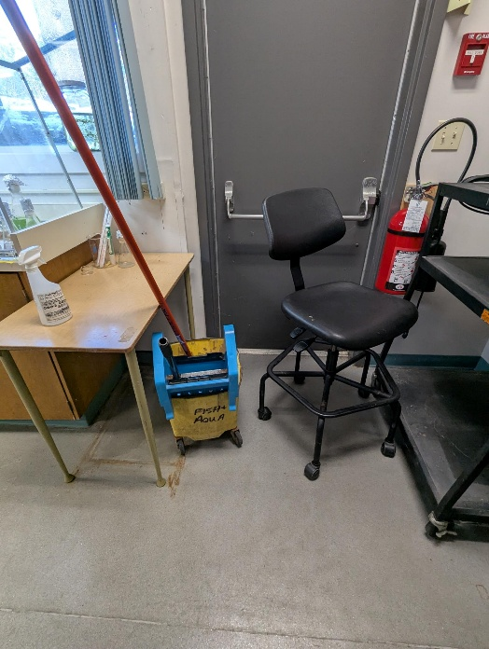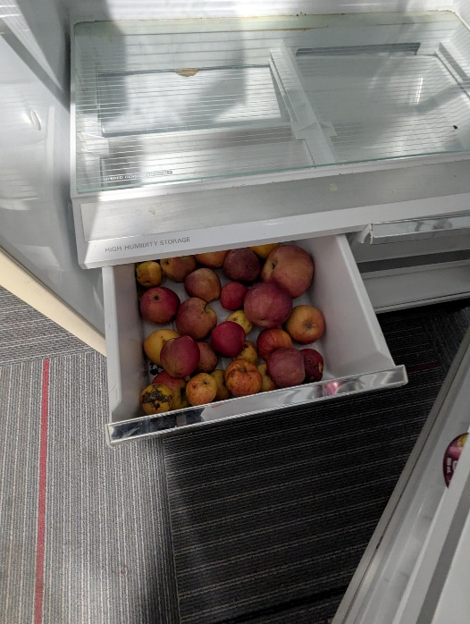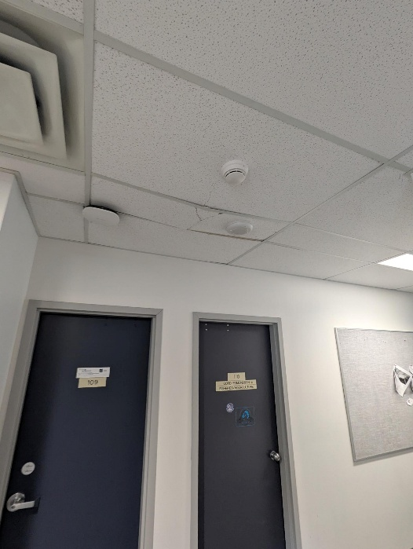

M.6 N.1 N.2
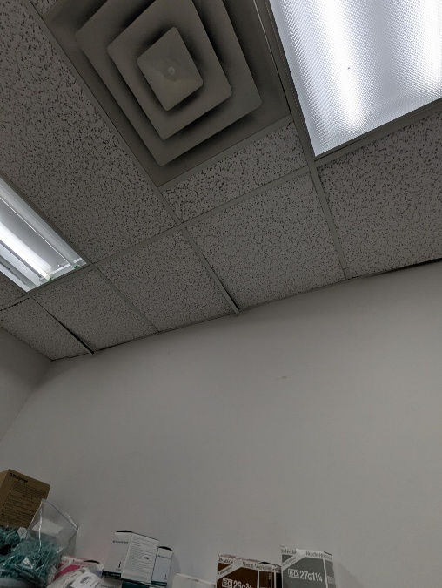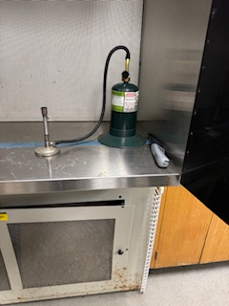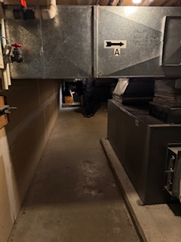

N.3 N.4
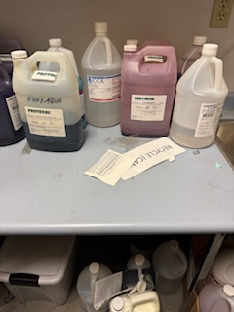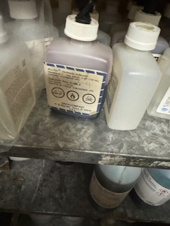

N.5 N.6
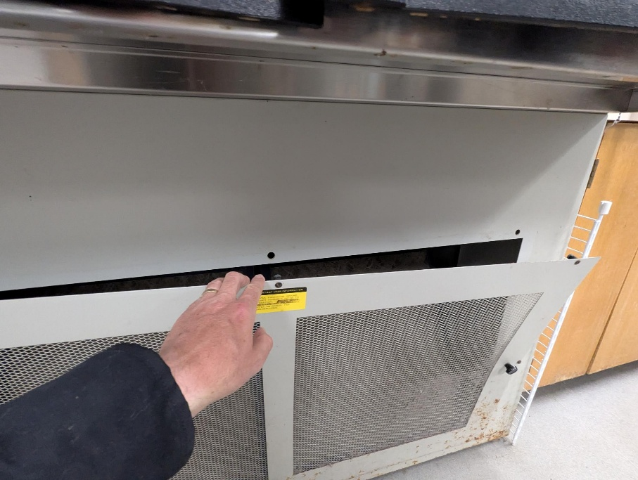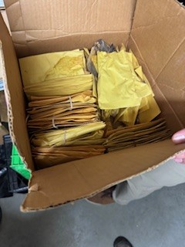

N.7 N.8 N.9
