Building: 700 – Cowichan Campus Date: January 26, 2023
Names of Inspectors: Kim Sharpe, Robin Boxwood, Margot Croft, Dale Baumel, Kim Lesiuk, Tracy Giles

 | Yes | No | N/A
 | Bulletin Boards and Signs
A.1 | Are they clean and readable? | X
A.2 | Is the material changed frequently? | X
A.3 | Do items interfere with people walking by? |  | X
 | Floors
B.1 | Is there loose material, debris, worn carpeting? |  | X
B.2 | Are the floors slippery, oily or wet? |  | X
 | Stairways and Aisles
C.1 | Are they clear and unblocked? | X
C.2 | Are stairways well lighted? | X
C.3 | Are handrails, handholds in place? | X
C.4 | Are the aisles marked and visible? | X
 | Equipment
D.1 | Are guards, screens and sound-dampening devices in place and effective? |  |  | X
D.2 | Is the furniture in good repair and safe to use? Look for:
D.3 | - chairs that are in poor repair |  | X
D.4 | - sharp edges on desks and cabinets |  | X
D.5 | - poor ergonomics (keyboard elevation, chair adjustment, desk height) |  | X
D.6 | - crowding | X
D.7 | Are ladders well maintained and safe to use? | X
 | Emergency Equipment
E.1 | Is all fire control equipment regularly tested and certified? | X
E.2 | Is fire control equipment appropriate for the type of fire it must control? | X
E.3 | Is emergency lighting in place and regularly tested? | X
 | Building
F.1 | Do buildings conform to standards with respect to use, occupancy, building services, and plumbing facilities? | X
F.2 | Check the following structures to ensure safety:
F.3 | - swinging doors | X
F.4 | - floor and wall openings | X
F.5 | - ladders, stairways and ramps |  | X
F.6 | - guardrails | X
F.7 | Are materials stored safely? | X
 | Air Handling System
G.1 | Does air exchange rate meet standard requirements? | X
G.2 | Is the system free of sources of contamination (e.g., asbestos, microorganisms, dust, fumes)? | X
G.3 | Is humidity within recommended range? | X
 | Hazardous Products
H.1 | Are there any hazardous products (e.g., products regulated by WHMIS)? | X
H.2 | - If yes, are the products properly labelled? |  | X
H.3 | - If yes, is there a corresponding safety data sheet (SDS) for each product? |  |  | Unknown
H.4 | - If yes, are workers trained in how to work with or near these products safely? |  |  | X
 | Sanitation
I.1 | Are washrooms and food preparation areas clean? | X
I.2 | Are the following provided adequately?
I.3 | - toilets | X
I.4 | - showers | X
I.5 | - potable (drinkable) water | X
I.6 | - clothing storage | X
I.7 | - change rooms | X
I.8 | - field accommodations | X
I.9 | - lunchrooms | X
I.10 | Are measures in place to prevent the spread of disease? | X
 | Security
J.1 | Do entry and exit procedures provide workers personal security at night? | X
J.2 | Are emergency (evacuation, fire, bomb threat, hostile person) procedures in place? | X
 | Lighting
K.1 | Are lamp reflectors clean? | X
K.2 | Are bulbs missing? |  | X
K.3 | Are any areas dark? |  | X
 | Material Storage
L.1 | Are materials neatly and safely piled? |  | X
L.2 | Are there stepladders or stools to get to materials on higher shelves? |  |  | X
L.3 | Are storage shelves overloaded or beyond their rated capacity? |  | X
L.4 | Are large and heavy objects stored on lower shelves? |  | X
L.5 | Are passageways and work areas clear of obstructions? |  | X
 | General
M.1 | Are extension cords used extensively? (if so, consider installing permanent wiring) |  | X
M.2 | Are electrical or telephone cords exposed in areas where employees may become entangled? | X
M.3 | Is electrical wiring properly installed? | X
M.4 | Are machines properly guarded? | X
M.5 | Does any equipment have sharp metal projections? | X
M.6 | Are wall and ceiling fixtures fastened securely? |  | X
M.7 | Are paper and waste properly disposed of? | X
M.8 | Are desk and file drawers kept closed when not in use? | X
M.9 | Are office accessories stored appropriately? | X
M.10 | Are materials stacked on desks or cabinets? | X
M.11 | Are file cabinet drawers overloaded? | X
M.12 | Are file cabinets loaded with the heaviest items in the bottom drawers? | X
M.13 | Are shelves securely fastened to the wall when necessary? |  | X
M.14 | Are filing stools or wastebaskets placed where they might be tripping hazards? |  | X
 | Chemical Safety
N.1 | Is there less than 25 L of flammables in the open lab and containers are no larger than 5 L? | X
N.2 | Are Fume Hoods kept tidy, functional, & annually certified? Fume hood sashes are at/below arrow indicated? |  | X
N.3 | Are emergency eyewash and showers accessible, labelled and tested regularly? |  | X
N.4 | Are gas cylinders properly segregated (e.g. hydrogen and oxygen tanks are segregated), labeled and secured? Located away from exits and sources of heat and moisture? | X
N.5 | Are there proper supplier/workplace labels on all containers, are MSDS readily available, incompatibles separated, and properly stored? |  | X
N.6 | Is an up-to-date chemical inventory available? |  |  | X
N.7 | Shelves and chemical containers in good condition (no leaks, rust) |  | X
N.8 | Spill control equipment (neutralizers, absorbent pads) are present |  |  | X
 | Miscellaneous
O.1 | Room 260 door | X
O.2 | Items stored behind door | X
O.3 | Emergency egress concerns | X
Corrective Action | Assigned To | Date to be completed by
F.5. The wheelchair ramp on the rooftop is very slippery, we recommend installing anti-slip material to the ramp. | Facility Services | 1 month
L.1. Concerns were raised over the amount of clutter in the IT storage room. This presents a fire hazard. | Building occupants | 1 week
L.4. Large boxes are being stored on top shelves, please move items to open lower shelves. | Building occupants | 1 week
L.5. A whiteboard was blocking an emergency exit, it was moved by the inspection team. Please keep exits clear and visible. | Building occupants | N/A
M.2. Network cords are running along the wall in the bookstore. These cords should be covered and secured to the wall or floor. | Facility Services/IT | 1 month
M.6. Employees report loose and falling ceiling tiles throughout the building. Ceiling tiles should be checked for safety. | Facility Services | 1 month
M.10. A new sit-stand desk is being used for storage outside of R115. These desks are in very high demand, please contact Facility Services through the Material Handling Request to have this desk picked up for redistribution. | Building occupants/Cowichan IT | 1 week
M.13. Storage racks not secured in teaching kitchen, nursing lab. The recommendation is for these racks to be anchored to the floor or wall. | Facility Services | 1 month
N.2. Annual inspections of Laminar flow hoods (LFH) are recommended. Health and Safety will add these to the annual list of LFHs to be tested by HEPA Filter Services in July 2024. Cost for services will be added to the invoice to Cowichan Campus. | Health and Safety | 6 months
N.3. Monthly eye wash inspections are a WorkSafeBC requirement. Please keep a record of your inspections. https://www.worksafebc.com/en/law-policy/occupational-health-safety/searchable-ohs-regulation/ohs-regulation/part-05-chemical-and-biological-substances#SectionNumber:5.93 | Building occupants | asap
N.5. Unclear labels, possible containment issues with chemical storage in prep lab. Conduct chemical review. Annual Chemical Inventory required https://www.worksafebc.com/en/law-policy/occupational-health-safety/searchable-ohs-regulation/ohs-regulation/part-05-chemical-and-biological-substances#SectionNumber:5.98 | Building occupants/Laboratory personnel | 1 month
N.7. Corrosive chemicals are being stored on metal shelves in teaching kitchen. A corrosive storage cabinet should be added to this area. https://www.worksafebc.com/en/law-policy/occupational-health-safety/searchable-ohs-regulation/ohs-regulation/part-05-chemical-and-biological-substances#SectionNumber:5.21 | Building occupants/Culinary Arts | 3 months
O.1. The door to R260 does not appear to be working properly, please have Facility Services fix this door. | Facility Services | 1 week
O.2. Items are being stored behind the door to shipping/receiving limiting the door swing. Please remove these items. | Building occupants | 1 week
O.3. Concerns were raised by employees of the Registration Office over the lack of a 2nd exit for evacuation purposes. Shelter-in-place training is recommended for this employee group. | Campus Administrator/Health and Safety (Emergency) | 1 month
Notes on deficiencies / other comments
Pictures attached below.

F.5 L.1 L.1
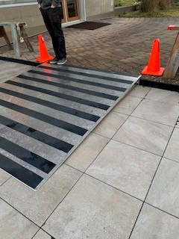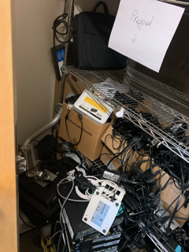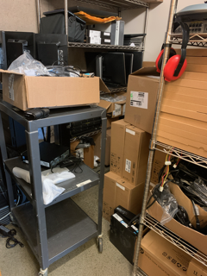

L.4 L.5 M.6
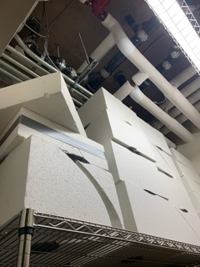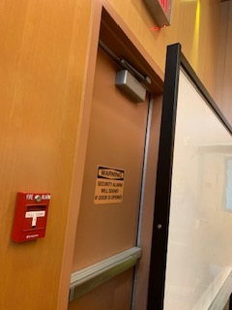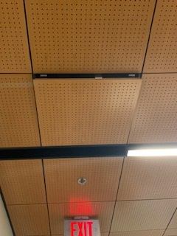

M.13 M.13 N.2
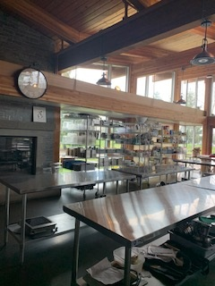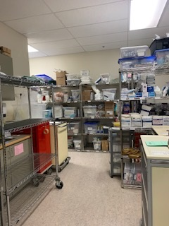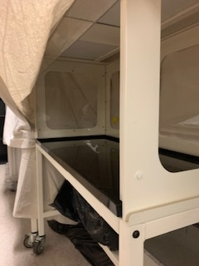

N.5 N.7 N.7
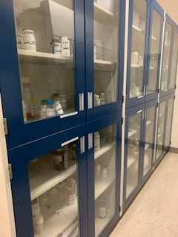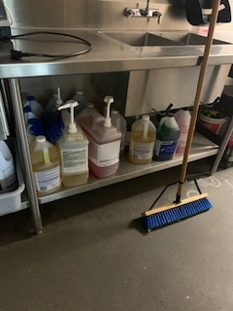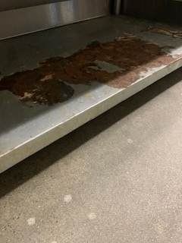

O.1 O.2
