Building: 315 Date: February 20, 2024
Names of Inspectors: Kordell Bergen, Kim Sharpe, Rob Okashimo, Jannine Grant

 | Yes | No | N/A
 | Around the Building
A.1 | Is the address sign or number easily visible? | X
A.2 | Is waste stored in appropriate waste or recycling storage areas? | X
A.3 | Is the property kept clear of litter, combustibles, hazardous materials, etc.? | X
A.4 | If present, are smoking areas clean? Is an appropriate cigarette butt receptacle available? |  |  | X
 | Parking Lot
B.1 | Are appropriate signs posted (e.g., no parking in fire routes, etc.)? | X
B.2 | Are the parking areas free from trip hazards (e.g., no pot holes, cracks, etc.)? | X
B.3 | Is the lighting adequate in the area and walkways at night? | X
B.4 | Is the parking lot kept free of debris? | X
B.5 | In winter, is the parking lot free from ice and snow? |  |  | X
 | Stairs
C.1 | Are stairs, stairwells, and landings kept clear and unobstructed? | X
C.2 | In winter, are stairs, stairwells, and landings kept clear from ice and snow? |  |  | X
C.3 | Are stairways adequately lit? | X
C.4 | Are stairs, treads, hand rails, and any guards secure and in good condition? | X
C.5 | Do treads and landings have non-skid surfaces and they are in good condition? |  | X
 | Exits / Fire Safety
D.1 | Are all emergency exits, exit doors, landings, and steps from the building well marked, unblocked, and kept in good condition? | X
D.2 | In winter, are exits kept free from ice and snow? |  |  | X
D.3 | In winter, is the roof area over the exits free of falling ice and snow hazards? |  |  | X
D.4 | Are exit doors, landings, and steps well lit? Are the lights over the exit doors working and in good repair? | X
D.5 | In winter, is the access ramp clear of ice and snow, and is there good traction? |  |  | X
D.6 | Can the building be easily accessed by the fire department? Are fire lanes accessible and posted? | X
D.7 | Are the fire department hose connections kept clear, accessible and have caps? | X
D.8 | Is the electrical service entrance area clear of trees and branches? | X
D.9 | Are all electrical wires out of reach of the public? | X
 | Grounds
E.1 | Are walkways clear and in good condition? Are there any holes or trip hazards on grounds where workers/public may walk? | X
E.2 | In winter, are ice and snow cleared promptly from walkways? |  |  | X
E.3 | Is security lighting functioning properly? | X
E.4 | Are exit routes (from the grounds) well marked, and kept clear and unobstructed? | X
E.5 | Is fencing in good condition? |  |  | X
E.6 | Is any outdoor machinery in good repair? |  |  | X
 | Miscellaneous
F.1 | Dead trees noted – fire hazards | X
Corrective Action | Assigned To
C.5. Building occupants report that the wooden deck becomes extremely slippery when wet, this was verified during the inspection. The metal grating that was installed needs to be turned 90 degrees, in its current orientation it is just as slippery as the bare deck. Are there plans to add additional grip to the rest of the deck? | Facility Services

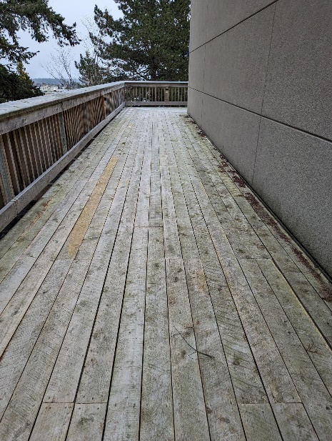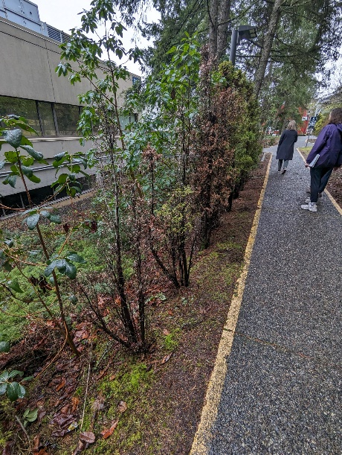

Building: 315 - Interior Date: February 20, 2024
Names of Inspectors: Kordell Bergen, Kim Sharpe, Rob Okashimo, Jannine Grant

 | Yes | No | N/A
 | Bulletin Boards and Signs
A.1 | Are they clean and readable? |  |  | X
A.2 | Is the material changed frequently? |  |  | X
A.3 | Do items interfere with people walking by? |  |  | X
 | Floors
B.1 | Is there loose material, debris, worn carpeting? | X
B.2 | Are the floors slippery, oily or wet? |  | X
 | Stairways and Aisles
C.1 | Are they clear and unblocked? | X
C.2 | Are stairways well lighted? | X
C.3 | Are handrails, handholds in place? | X
C.4 | Are the aisles marked and visible? | X
 | Equipment
D.1 | Are guards, screens and sound-dampening devices in place and effective? |  |  | X
D.2 | Is the furniture in good repair and safe to use? Look for:
D.3 | - chairs that are in poor repair |  | X
D.4 | - sharp edges on desks and cabinets |  | X
D.5 | - poor ergonomics (keyboard elevation, chair adjustment, desk height) |  | X
D.6 | - crowding |  | X
D.7 | Are ladders well maintained and safe to use? |  |  | X
 | Emergency Equipment
E.1 | Is all fire control equipment regularly tested and certified? | X
E.2 | Is fire control equipment appropriate for the type of fire it must control? | X
E.3 | Is emergency lighting in place and regularly tested? | X
 | Building
F.1 | Do buildings conform to standards with respect to use, occupancy, building services, and plumbing facilities? | X
F.2 | Check the following structures to ensure safety:
F.3 | - swinging doors | X
F.4 | - floor and wall openings | X
F.5 | - ladders, stairways and ramps | X
F.6 | - guardrails | X
F.7 | Are materials stored safely? | X
 | Air Handling System
G.1 | Does air exchange rate meet standard requirements? | X
G.2 | Is the system free of sources of contamination (e.g., asbestos, microorganisms, dust, fumes)? | X
G.3 | Is humidity within recommended range? | X
 | Hazardous Products
H.1 | Are there any hazardous products (e.g., products regulated by WHMIS)? |  |  | X
H.2 | - If yes, are the products properly labelled? |  |  | X
H.3 | - If yes, is there a corresponding safety data sheet (SDS) for each product? |  |  | X
H.4 | - If yes, are workers trained in how to work with or near these products safely? |  |  | X
 | Sanitation
I.1 | Are washrooms and food preparation areas clean? | X
I.2 | Are the following provided adequately?
I.3 | - toilets | X
I.4 | - showers | X
I.5 | - potable (drinkable) water | X
I.6 | - clothing storage |  |  | X
I.7 | - change rooms |  |  | X
I.8 | - field accommodations |  |  | X
I.9 | - lunchrooms |  |  | X
I.10 | Are measures in place to prevent the spread of disease? | X
 | Security
J.1 | Do entry and exit procedures provide workers personal security at night? | X
J.2 | Are emergency (evacuation, fire, bomb threat, hostile person) procedures in place? | X
 | Lighting
K.1 | Are lamp reflectors clean? | X
K.2 | Are bulbs missing? |  | X
K.3 | Are any areas dark? |  | X
 | Material Storage
L.1 | Are materials neatly and safely piled? |  | X
L.2 | Are there stepladders or stools to get to materials on higher shelves? |  |  | X
L.3 | Are storage shelves overloaded or beyond their rated capacity? |  | X
L.4 | Are large and heavy objects stored on lower shelves? | X
L.5 | Are passageways and work areas clear of obstructions? | X
 | General
M.1 | Are extension cords used extensively? (if so, consider installing permanent wiring) |  | X
M.2 | Are electrical or telephone cords exposed in areas where employees may become entangled? |  | X
M.3 | Is electrical wiring properly installed? | X
M.4 | Are machines properly guarded? |  |  | X
M.5 | Does any equipment have sharp metal projections? |  |  | X
M.6 | Are wall and ceiling fixtures fastened securely? | X
M.7 | Are paper and waste properly disposed of? | X
M.8 | Are desk and file drawers kept closed when not in use? | X
M.9 | Are office accessories stored appropriately? | X
M.10 | Are materials stacked on desks or cabinets? | X
M.11 | Are file cabinet drawers overloaded? |  | X
M.12 | Are file cabinets loaded with the heaviest items in the bottom drawers? | X
M.13 | Are shelves securely fastened to the wall when necessary? | X
M.14 | Are filing stools or wastebaskets placed where they might be tripping hazards? |  | X
Miscellaneous
N.1 | “Fire Hazard” heater in R23455 | X
N.2 | Hole in the wall in R32453 | X
N.3 | Ceiling tiles missing R102 | X
N.4 | Dead phone R108 | X
N.5 | Light cover R113 | X
N.6 | Air conditioner R113 | X
N.7 | Box of chemicals R202 | X
N.8 | Room 215A | X
Corrective Action | Assigned To
B.1. Torn carpeting in R113. Submit a work order to have fixed. | Todd Barsby/Eve Stringham
L.1. There is a door being stored in the 1st floor hallway. Submit a work order to have it removed or have the building occupants move it. | Todd Barsby/Eve Stringham
M.10. There appears to be old office equipment stacked near the 2nd floor exit. Submit a Material Handling request to dispose of these items – Fire hazard. | Todd Barsby/Eve Stringham
N.1. There is a portable heater in R108 that is marked as a “Fire Hazard.” This item should be removed from service, | Elizabeth Brimacombe
N.2. There is a hole in R104. HSS will submit a work order to Facilities Services to have this fixed. | HSS
N.3. There is a ceiling tile missing in R102. HSS will submit a work order to Facilities Services to have this replaced. | HSS
N.4. There is a phone in R108 that does not work HSS will submit a work order to IT to have this removed. | HSS
N.5. The light cover in R113 needs to be replaced. Submit a work order to Facility Services to have this fixed. | Todd Barsby/Eve Stringham
N.6. The air conditioner in R113 is missing its cover. Does this unit still work? Does it need to be serviced? | Todd Barsby/Eve Stringham
N.7. A box of chemicals was found in R202. These need to be sorted and properly stored or disposed of. | Todd Barsby/Eve Stringham
N.8. A room inventory needs to be conducted in this room. Unused/broken/obsolete items should be disposed of – hoarding issue/fire hazards. | Todd Barsby/Eve Stringham

B.1 L.1 M.10
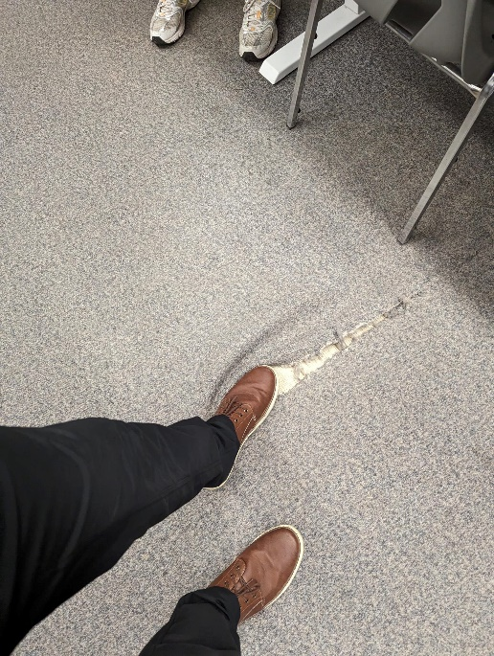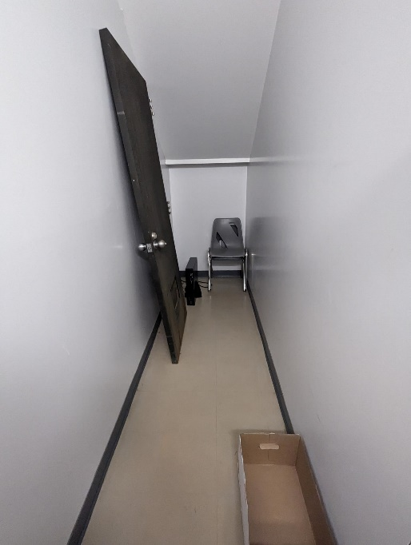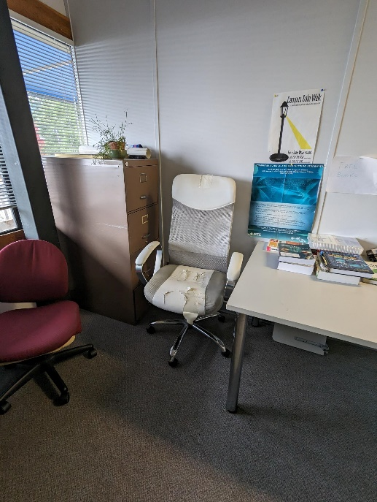

N.1. N.2 N.3
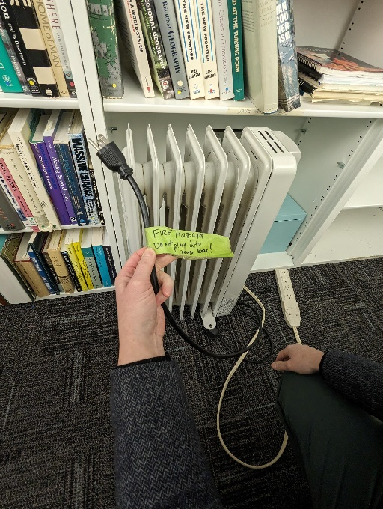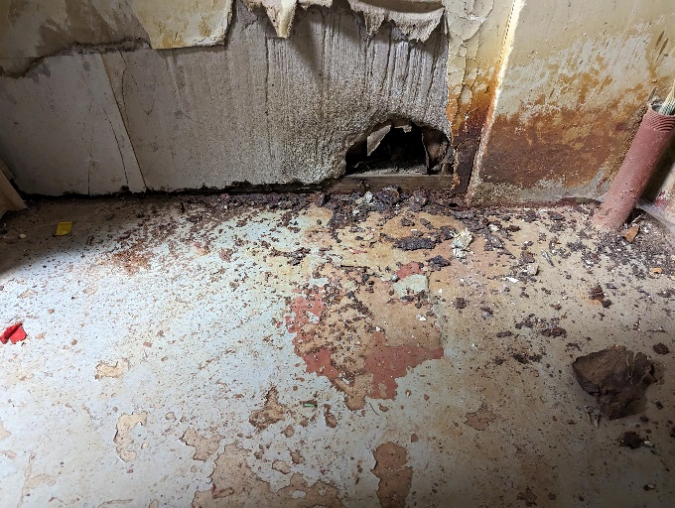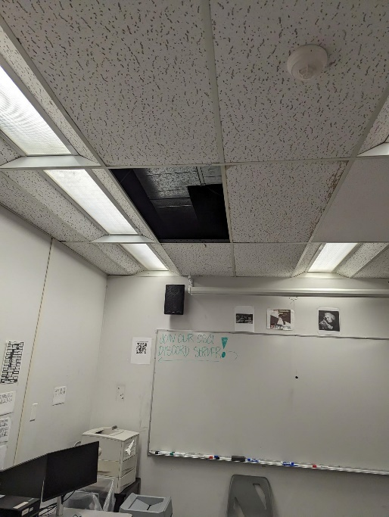

N.4 N.5 N.6
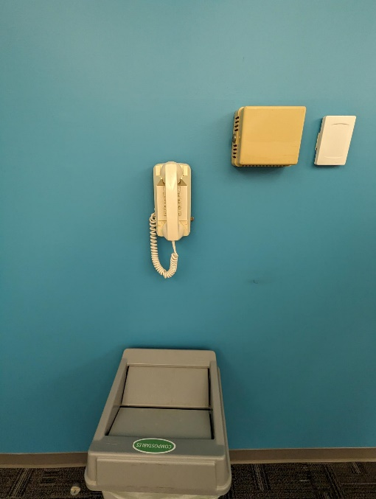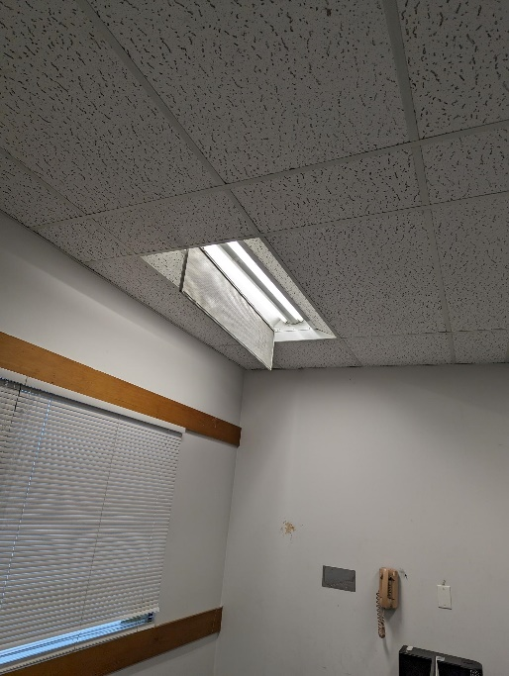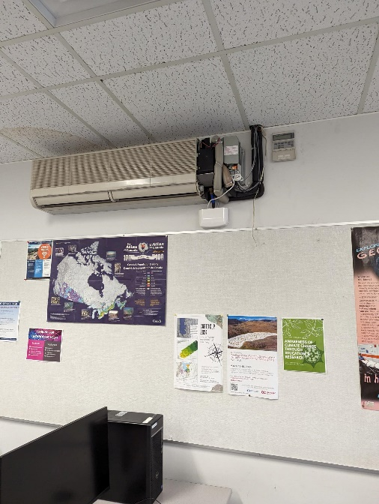

N.7 N.8 N.8
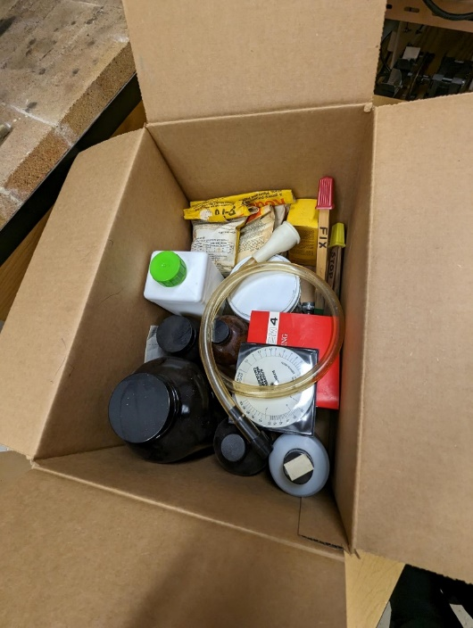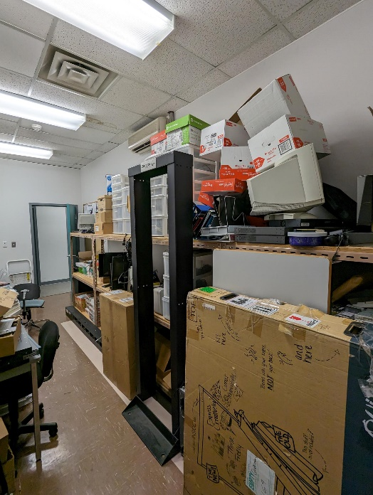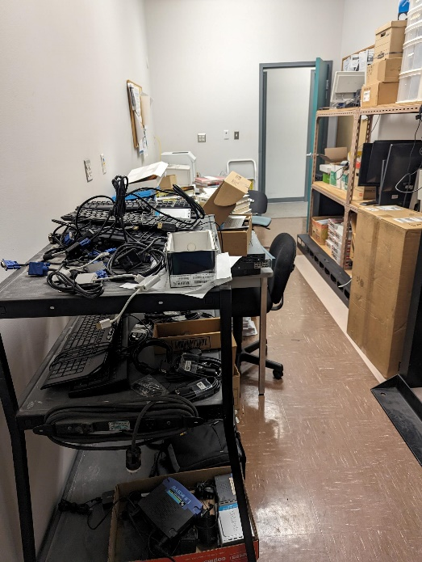

Building: 315 - Lab Date: February 20, 2024
Names of Inspectors: Kordell Bergen, Kim Sharpe, Rob Okashimo, Jannine Grant

 | Yes | No | N/A
A.1 | General Safety
A.2 | Are fire extinguishers, fire exits, emergency showers, stairwells, electrical panels kept clear of materials, equipment and spills? |  | X
A.3 | Are Fire Extinguishers adequate for the chemicals used, accessible, signage visible, charged and inspected within last year? | X
A.4 | Are Emergency EXIT signs illuminated? |  | X
A.5 | Is appropriate PPE is being used? (lab coats, safety eyewear, etc.). No shorts or sandals are worn. | Unknown
A.6 | Is there evidence of food, drink or chewing gum? | X
 | Doors / Floors / Aisles
B.1 | Aisles are unobstructed and allow visibility and movement | X
B.2 | Doorways are unobstructed and allow visibility and movement | X
B.3 | Doors opening into pedestrian traffic are posted with prominent caution signs |  |  | X
B.4 | Floors / carpets are free from holes, loose edges, worn areas or depressions | X
B.5 | Materials stored on the floor are away from doors / aisles and are < 3ft. high | X
B.6 | Lighting is adequate in aisles and walkways | X
 | Physical Hazards
C.1 | Is heating and ventilation adequate? (Consider too hot, too cold?) | X
C.2 | Is air quality adequate? (Consider: unfamiliar smells, odours) | X
C.3 | Are lighting levels in the work area adequate? (Consider: Too bright/dim, lights not working?) | X
 | Cabinets / Shelving Units
D.1 | Cabinets are closed when not in use | X
D.2 | Cabinets / shelving are bolted together, to the floor, or to the wall | X
D.3 | Heavy objects are not stored on top of tall cabinets / shelves |  | X
D.4 | Lips/heavy gauge wire is in place to prevent chemicals, containers and other materials from falling off of shelves |  | X
 | Equipment / Electrical
E.1 | Metal equipment are free of burrs or sharp edges | X
E.2 | Electrical cords are not run over heat sources, through doorways, or across aisles | X
E.3 | Frayed or damaged electrical cords/outlets/connections are removed from service and/or replaced | X
E.4 | Electrical cords are secured/bundled to prevent tripping hazard | X
E.5 | Lighting is adequate in work areas | X
E.6 | Equipment that is ‘customized’ by the lab has received engineering certification prior to being put into service |  |  | X
 | Fire Safety / Emergency Evacuations
F.1 | Access to fire extinguishers and pull stations is clear | X
F.2 | Locations of fire extinguishers /pull stations are clearly identified | X
F.3 | Fire extinguishers have been inspected within the last year and pins are secure | X
F.4 | Emergency procedures and evacuation plans are current and posted | X
F.5 | Emergency telephones numbers are close to phones | Out of date
F.6 | Smoke and fire alarms are in place and operational | X
F.7 | Emergency exits are not blocked with materials, equipment or shrubbery |  | X
F.8 | Emergency exits open easily |  | X
F.9 | Emergency lighting units are provided for the workplace and exit paths |  | X
F.10 | Emergency lighting is operational |  | X
 | Ergonomic Hazards
G.1 | Are materials stored to prevent overreaching? | X
G.2 | If materials are on the floor, are they stacked no more than 3 boxes high? |  | X
 | Chemical Safety
H.1 | Is there less than 25 L of flammables in the open lab and containers are no larger than 5 L? | X
H.2 | Are Fume Hoods kept tidy, functional, & annually certified? Fume hood sashes are at/below arrow indicated? |  |  | X
H.3 | Are emergency eyewash and showers accessible, labelled and tested regularly? |  | X
H.4 | Are gas cylinders properly segregated (e.g. hydrogen and oxygen tanks are segregated), labeled and secured? Located away from exits and sources of heat and moisture? |  | X
H.5 | Are there proper supplier/workplace labels on all containers, are MSDS readily available, incompatibles separated, and properly stored? | Unknown
H.6 | Is an up-to-date chemical inventory available? | Unknown
H.7 | Shelves and chemical containers in good condition (no leaks, rust) | X
H.8 | Spill control equipment (neutralizers, absorbent pads) are present | Unknown
 | Biological Safety
J.1 | Biological materials are not stored in hallways or chaseways in unlocked freezers or refrigerators |  |  | X
J.2 | Do the biohazardous waste containers have lids and are they labelled? |  |  | X
J.3 | Biohazard signs are posted in all labs handling infectious materials |  |  | X
J.4 | Lab coats, gowns or scrubs are in use in labs handling infectious materials |  |  | X
J.5 | Disinfectants are on hand for sanitizing bench tops and treating spills |  |  | X
J.6 | Biological safety cabinet(s) were certified within the last 12 months |  |  | X
 | Personal Security
L.1 | Emergency call buttons are in place and operational (if applicable) |  |  | X
L.2 | Access to main office areas is controlled |  |  | X
L.3 | There is signage that states all visitors must check in with Reception (or alternate) |  |  | X
L.4 | Workers that work alone (after hours or in areas of isolation) are familiar with VIU’s Working Alone procedure |  |  | X
L.5 | Workers are aware of SafeWalk |  |  | X
 | Safety Information
M.1 | Safety Committee minutes are posted in visible area accessible by all staff | X
M.2 | Safety manuals, work procedures, MSDS relevant to the work area are easily accessible by all employees | X
 | Worker Awareness (Questions you can ask)
N.1 | Workers know where to go and who to call for first-aid assistance | Unknown
N.2 | Do workers know about the VIU Online MSDS system for chemicals | Unknown
N.3 | Workers can identify their safety representative on the on the Safety Committee | Unknown
N.4 | Workers know the location of and how to use fire extinguishers / pull stations | Unknown
N.5 | Workers know the evacuation procedures and where to gather outside | Unknown
N.6 | Workers know the evacuation procedures and where to gather outside | Unknown
N.7 | Workers know who the emergency warden is for their area | Unknown
 | Miscellaneous
O.1 | Old Chemicals on shelf | X
O.2 | Radiation | X
O.3 | Unknown substance in drawer, identify and remove | X
O.4 | Nitrogen tank | X
O.5 | Room 202 chemicals | X
O.6 | Room 202 clutter | X
O.7 | Room 202 fume hood | X
O.8 | Room 202 storage | X
Corrective Action | Assigned To
A.2. Both emergency exits in R219 are blocked, these doors need to be accessible.  https://www.worksafebc.com/en/law-policy/occupational-health-safety/searchable-ohs-regulation/ohs-regulation/part-04-general-conditions#SectionNumber:4.43 | Todd Barsby/Eve Stringham
A.3. An expired fire extinguisher was noted in R219. This should be removed or labelled as out of service. | Todd Barsby/Eve Stringham
A.4. Exit signs were not noted during the inspection. Illuminated signs should be present.  https://www.worksafebc.com/en/law-policy/occupational-health-safety/searchable-ohs-regulation/ohs-regulation/part-04-general-conditions#SectionNumber:4.43 | Todd Barsby/Eve Stringham
A.6. Room 219 is being used as a lab and a kitchen. This needs to be either a lab or a kitchen, not both.  https://www.worksafebc.com/en/law-policy/occupational-health-safety/searchable-ohs-regulation/ohs-regulation/part-30-laboratories | Todd Barsby/Eve Stringham
D.3. Heavy items are being stored on the top shelf along the middle of the room. These items should be removed from the top shelf. | Todd Barsby/Eve Stringham
D.4. Consider installing railings/cables on shelves. | Todd Barsby/Eve Stringham
F.5. Emergency information is out of date. Please replace with current information | Todd Barsby/Eve Stringham
F.9. Emergency lighting was not noted during the inspection. | Todd Barsby/Eve Stringham
H.3. An eyewash station was not noted during the inspection, based on the items noted in the inspection, this is a requirement of the space. Please install an eyewash station or remove all chemicals.  https://www.worksafebc.com/en/law-policy/occupational-health-safety/searchable-ohs-regulation/ohs-regulation/part-05-chemical-and-biological-substances#SectionNumber:5.86 | Todd Barsby/Eve Stringham
H.4. 7 lecture bottles are being stored in a drawer. These need to be stored properly or removed.  https://www.worksafebc.com/en/law-policy/occupational-health-safety/searchable-ohs-regulation/ohs-regulation/part-05-chemical-and-biological-substances#SectionNumber:5.43 | Todd Barsby/Eve Stringham
H.6. Is a chemical inventory available for this room? Is it current? | Todd Barsby/Eve Stringham
H.8. Is a spill kit available? | Todd Barsby/Eve Stringham
O.1. Chemicals are being improperly stored. | Todd Barsby/Eve Stringham
O.2. Radioactive material is being stored in the cupboard, the contact information is no longer correct. Does the department still need this clock? Can it be disposed of? | Todd Barsby/Eve Stringham
O.3. Housekeeping is needed in this room. There are unknown substances in drawers. Staff should review the space and dispose of any unused items and clean the room. | Todd Barsby/Eve Stringham
O.4. A nitrogen tank was noted during the inspection. This should be labelled as empty. | Todd Barsby/Eve Stringham
O.5. Chemicals found in drawer of R202. This speaks to the general level of clutter and hoarding in this room. Is there a chemical inventory available for R202? SDS? | Todd Barsby/Eve Stringham
O.6. A room inventory needs to be conducted in this room. Unused/broken/obsolete items should be disposed of – this is a hoarding issue/fire hazard. | Todd Barsby/Eve Stringham
O.7. The fume hood is being used as storage. | Todd Barsby/Eve Stringham
O.8. Boxes in R202 are being stored for Chemistry. They should be delivered to B210 – this is a hoarding issue/fire hazard. | Todd Barsby/Eve Stringham

A.2 A.2 A.3
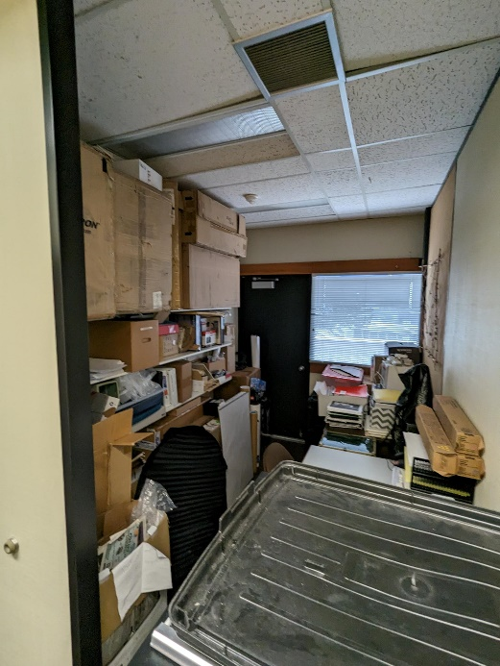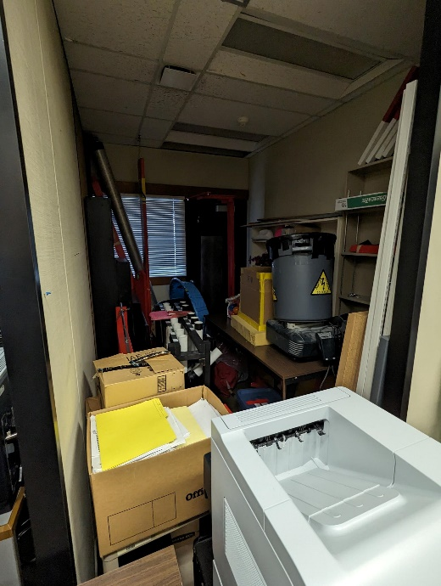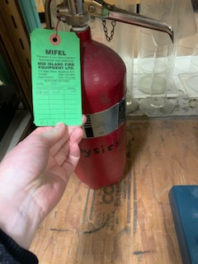

A.6 A.6 D.3
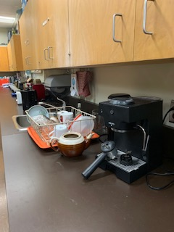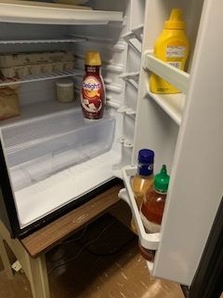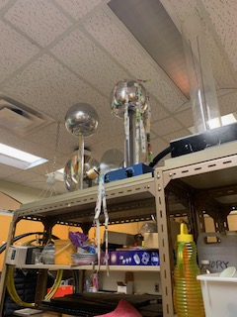

H.4 O.1 O.2
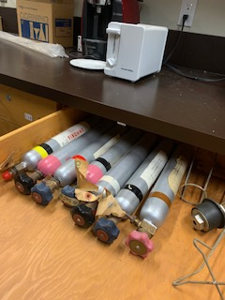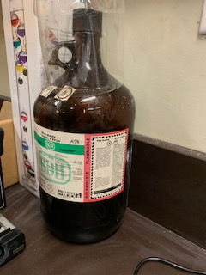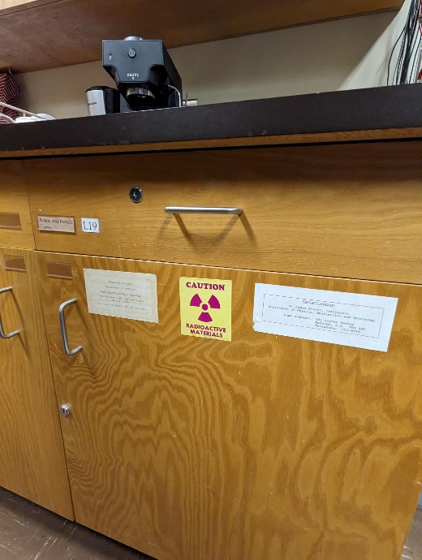

O.3 O.4 O.5
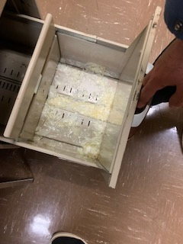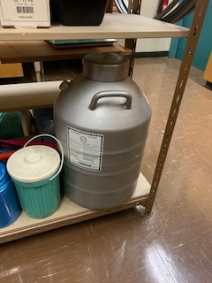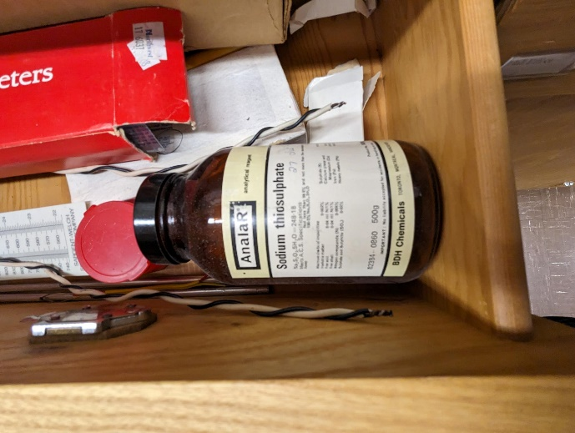

O.6 O.7 O.8
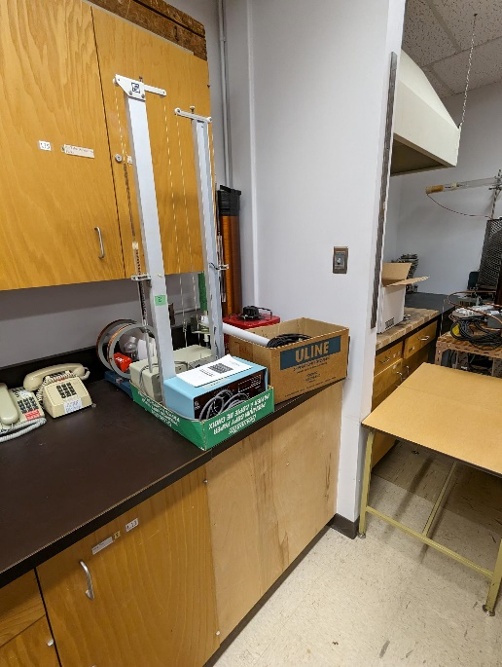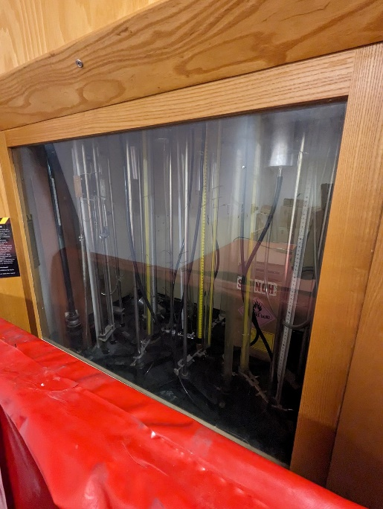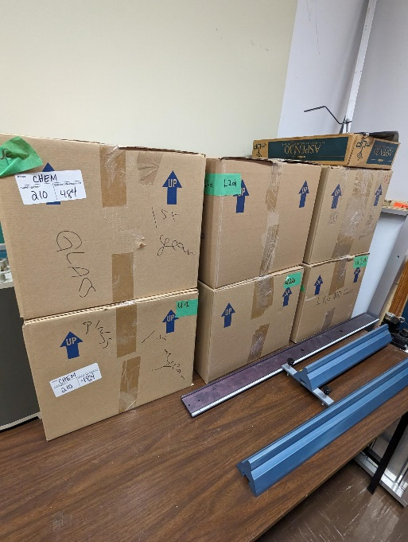

Building: 315 - Shop Date: February 20, 2024
Names of Inspectors: Kordell Bergen, Kim Sharpe, Rob Okashimo, Jannine Grant

 | Yes | No | N/A
 | Emergency and Hazard Information
A.1 | Emergency phone numbers posted? Are phones available? | X
A.2 | Are exits clearly marked and accessible? | X
A.3 | Are evacuation maps posted? | X
A.4 | Are emergency evacuation drills conducted at least annually? | X
A.5 | Are first aid attendants available with kits fully stocked and inspected? |  |  | X
A.6 | Are Level 1 Attendant’s qualifications current? |  |  | X
A.7 | Do students know where and how to receive care for an injury | Unknown
A.8 | Are signs present for emergency safety equipment (eyewash, exits etc.)? |  | X
A.9 | Are appropriate fire extinguishers available and inspected regularly? |  | X
A.10 | Are flammable materials stored in a flammable storage cabinet? |  | X
A.11 | Chemical inventories up to date |  | X
A.12 | SDS sheets available and current |  | X
 | Floors
B.1 | Is there loose material, debris, worn carpeting? |  | X
B.2 | Are the floors slippery, oily or wet? |  | X
 | Stairways and Aisles
C.1 | Are they clear and unblocked? |  | X
C.2 | Are stairways well lighted? |  |  | X
C.3 | Are handrails, handholds in place? |  |  | X
C.4 | Are the aisles marked and visible? |  |  | X
 | Safety Administration
D.1 | Have all students received general orientation and safety training e.g. MSDS, PPE, evacuations, etc.? | Unknown
D.2 | Have all students been trained on the equipment that they operate? | Unknown
D.3 | Have students received other specialized training: Lockout/Tagout, Respirators, Tools (hand/power), PPE, ect | Unknown
D.4 | Is orientation/safety training documented? | Unknown
D.5 | Do students have access to the orientation information? | Unknown
D.6 | Are regularly scheduled safety meetings conducted in the shop? | Unknown
D.7 | Has a hazard assessment been done in order to select appropriate PPE? | Unknown
D.8 | Is PPE provided and used whenever necessary? | Unknown
D.9 | Are there chemicals or controlled substances in the shop? Is WHMIS training provided? Are SDS’s available? | Unknown
 | Housekeeping, Ventilation, Illumination
E.1 | Are all work areas clean and orderly? |  | X
E.2 | Are waste containers kept clean and emptied daily? | X
E.3 | Is food kept in the designated area at all times? | X
E.4 | Are all cabinets and shelves secured or anchored? | X
E.5 | Are all machines/equipment secured or anchored? | X
E.6 | Are floors in good condition and kept dry? | X
E.7 | Are all light fixtures adequate and functioning properly? | X
E.8 | Dust extractors in good working order |  | X
E.9 | Exhaust fans functioning |  |  | X
E.10 | “No Eating/Drinking/Smoking” signs posted |  | X
 | Electrical Safety/Portable Tools
F.1 | Are all plugs, cords, and panels enclosed, and in good condition? | X
F.2 | Do all extension cords have grounding? |  |  | X
F.3 | Are extension cords used only temporarily? |  |  | X
F.4 | Are cords secured so they do not run across pathways, under doors or the walls? | X
F.5 | Is the breaker panel locked? |  |  | X
F.6 | Are ground fault circuit interrupters available for use in wet areas? |  |  | X
F.7 | Are hand-tools effectively grounded or Double insulated? | Unknown
F.8 | Are hand/power tools inspected regularly? | Unknown
 | Mechanical Safety
G.1 | Is defective equipment promptly reported, labeled, and replaced? | Unknown
G.2 | Can equipment be locked out? |  | X
G.3 | Safeguards prevent workers’ hands, arms and other body parts from making contact with dangerous moving parts |  | X
G.4 | Safeguards have not been tampered with, altered or removed |  |  | X
G.5 | Powered machinery/equipment has start and stop controls located within easy reach of the operator has controls and switches whose functions are clearly identified |  | X
G.6 | Are machines regularly cleaned and maintained? | Unknown
G.7 | Are maintenance records, calibrations, certifications of each machine kept on file? | Unknown
G.8 | Do authorized people perform the repairs? | Unknown
G.9 | Physical hazards are marked in a manner that clearly identifies the hazard |  |  | X
 | Spill Response
H.1 | Do personnel know the location of the closest First Aid Kit? | Unknown
H.2 | Do personnel know the location of the closet Spill Kit? | Unknown
H.3 | Are personnel familiar with Vancouver Island Universities Spill Procedures? | Unknown
 | WHMIS
I.1 | Have all personnel received WHMIS training? | Unknown
I.2 | Are all hazardous materials labeled according to the WHMIS Regulations? | Unknown
I.3 | Is there a current inventory of all hazardous substances in the area? | Unknown
I.4 | Do personnel know where to find current (<3 years) SDS for the materials being used? | Unknown
 | Emergency Eyewash/Showers
J.1 | Are personnel familiar with the location of the nearest eyewash / shower? |  | X
J.2 | Is the eyewash station / shower clean and clear of debris? |  |  | X
J.3 | Have emergency shower(s) been tested in the last 12 months and have a tag indicating testing date? |  |  | X
 | Lighting
K.1 | Are lamp reflectors clean? | X
K.2 | Are bulbs missing? |  | X
K.3 | Are any areas dark? |  | X
 | Material Storage
L.1 | Are materials neatly and safely piled? | X
L.2 | Are there stepladders or stools to get to materials on higher shelves? |  |  | X
L.3 | Are storage shelves overloaded or beyond their rated capacity? |  | X
L.4 | Are large and heavy objects stored on lower shelves? | X
L.5 | Are passageways and work areas clear of obstructions? | X
 | Miscellaneous
M.1 | Spot welder | X
M.2 | Soldering equipment | X
M.3 | 3D printer | X
Corrective Action | Assigned To
A.8. An eyewash station was not seen during the inspection. If this area remains a shop an eyewash is required. | Eve Stringham/Todd Barsby
A.9. A fire extinguisher was not seen during the inspection. If this area remains a shop a fire extinguisher is required. | Eve Stringham/Todd Barsby
A.10. Flammable chemicals are being stored on the counter. These need to be removed or properly stored. | Eve Stringham/Todd Barsby
A.11/12. Is a chemical inventory available for this room? Previous inspections show chemicals being stored in the cupboard. Chemicals were on the counter during this inspection. No SDS sheets noted. | Eve Stringham/Todd Barsby
C.1. Empty boxes are being stacked in the hallway. These need to be removed. | Eve Stringham/Todd Barsby
E.1. Boxes are stacked on the counter. This room is being used as a storage room. It can not be used as a storage room and shop. Remove the boxes or remove the tools. | Eve Stringham/Todd Barsby
E.8. No dust extractors are installed in the room. HVAC Ventilation is not designed to handle combustible dust. Room and HVAC assessment and cleaning (arranged by department/faculty) to remove fire hazard immediately. This was also noted in 2015 inspection. | Eve Stringham/Todd Barsby
E.10. Eating and drinking is not allowed in shops. Sign needed. | Eve Stringham/Todd Barsby
G.2. Is lock out equipment available for maintenance? | Eve Stringham/Todd Barsby
G.3. No guards noted on the power tools. JOHSC recommends installing guards on all power tools. | Eve Stringham/Todd Barsby
G.5. There is only 1 emergency stop in the room, it is located near the door. This is too far away for many of the power tools. Emergency stops must be within arm’s reach of the tool. | Eve Stringham/Todd Barsby
M.1. There is a spot welder in the shop with no ventilation. This welder can not be used until local exhaust ventilation is installed. The JOHSC recommends connecting with the Welding Department for a full assessment of this space if the plan is to use the spot welder. | Eve Stringham/Todd Barsby
M.2. Soldering equipment is being stored beside combustible materials, remove the boxes. There is no ventilation in this room. Local exhaust ventilation is required to solder indoors. | Eve Stringham/Todd Barsby
M.3. The JOHSC recommends enclosing the 3D printer and installing ventilation to remove exposure to nano particles. | Eve Stringham/Todd Barsby

A.10/11/12 C.1 E.1
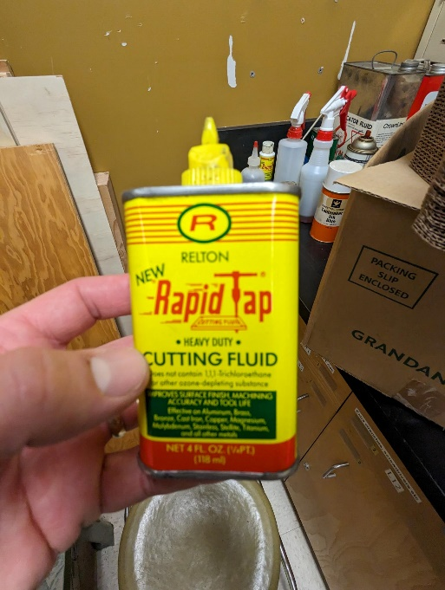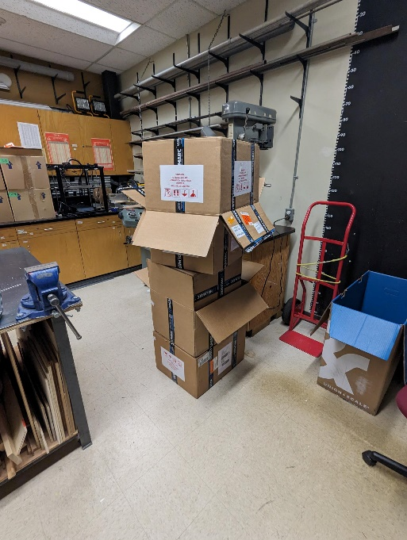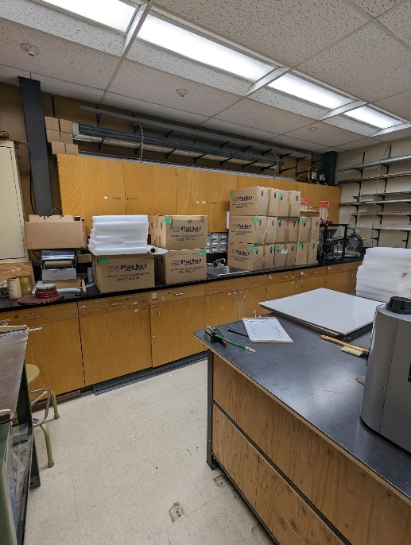

E.8 G.3 M.1
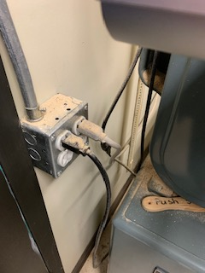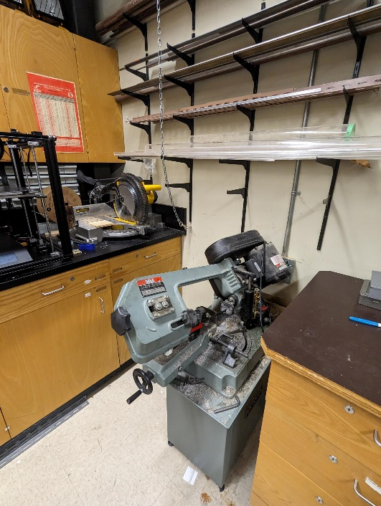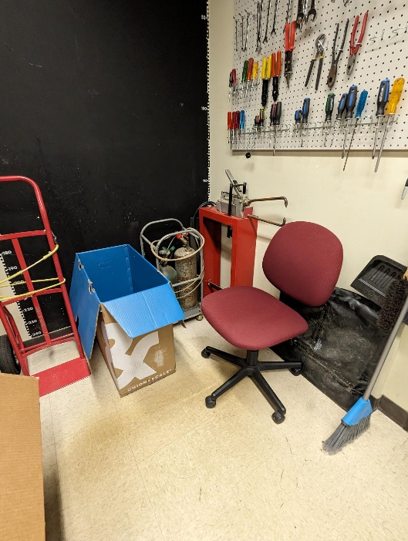

M.2 M.3
