Instructions for accessing your COVID-19 Exposure Control Plan course certificate in VIU Learn
- Complete the course quiz, once you are done you will see this screen. NOTE: you must get 100% to access a certificate.
  - Click “Done”
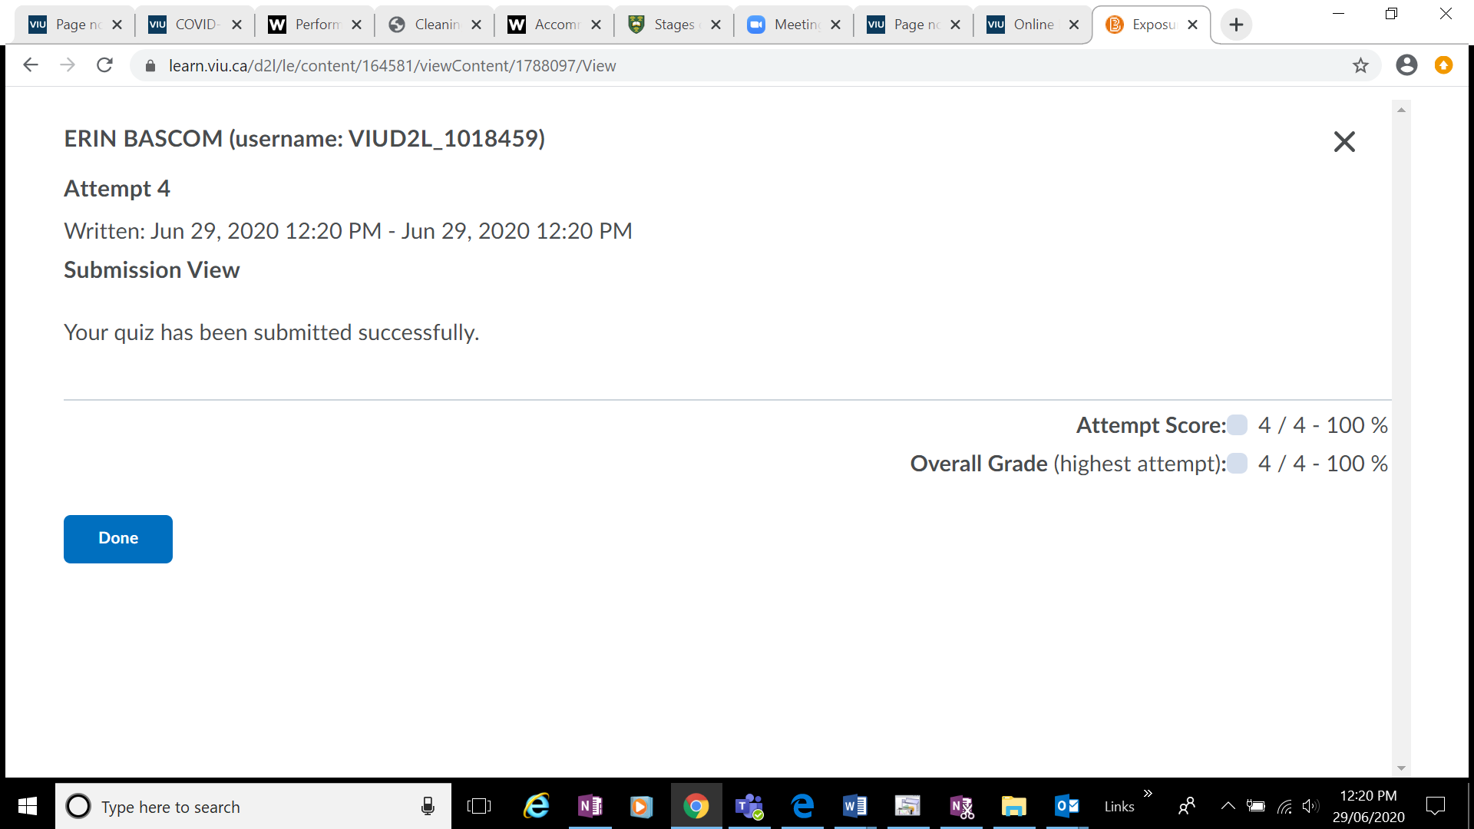
- Click the advance arrow
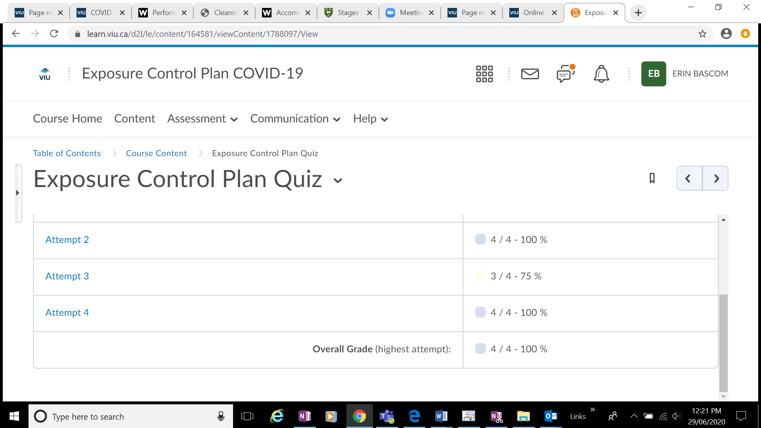
- Click on the link provided
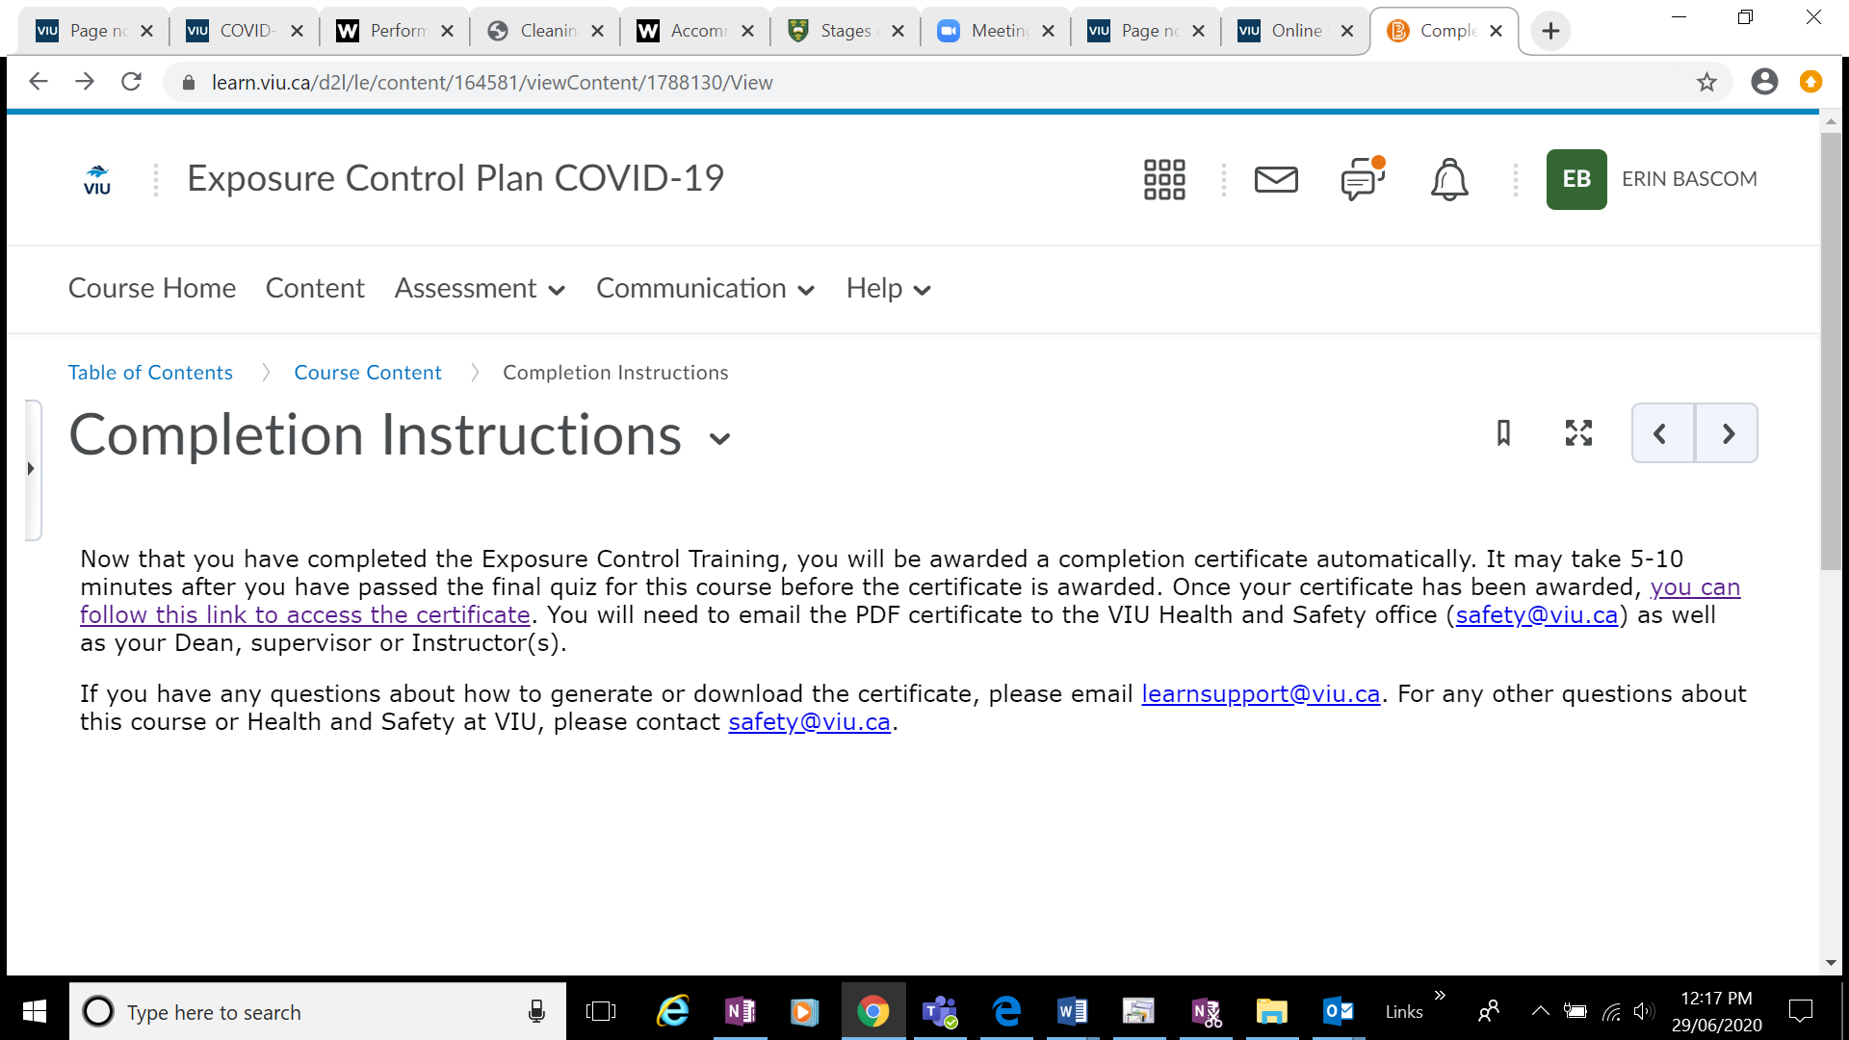
- Click on the Certificate
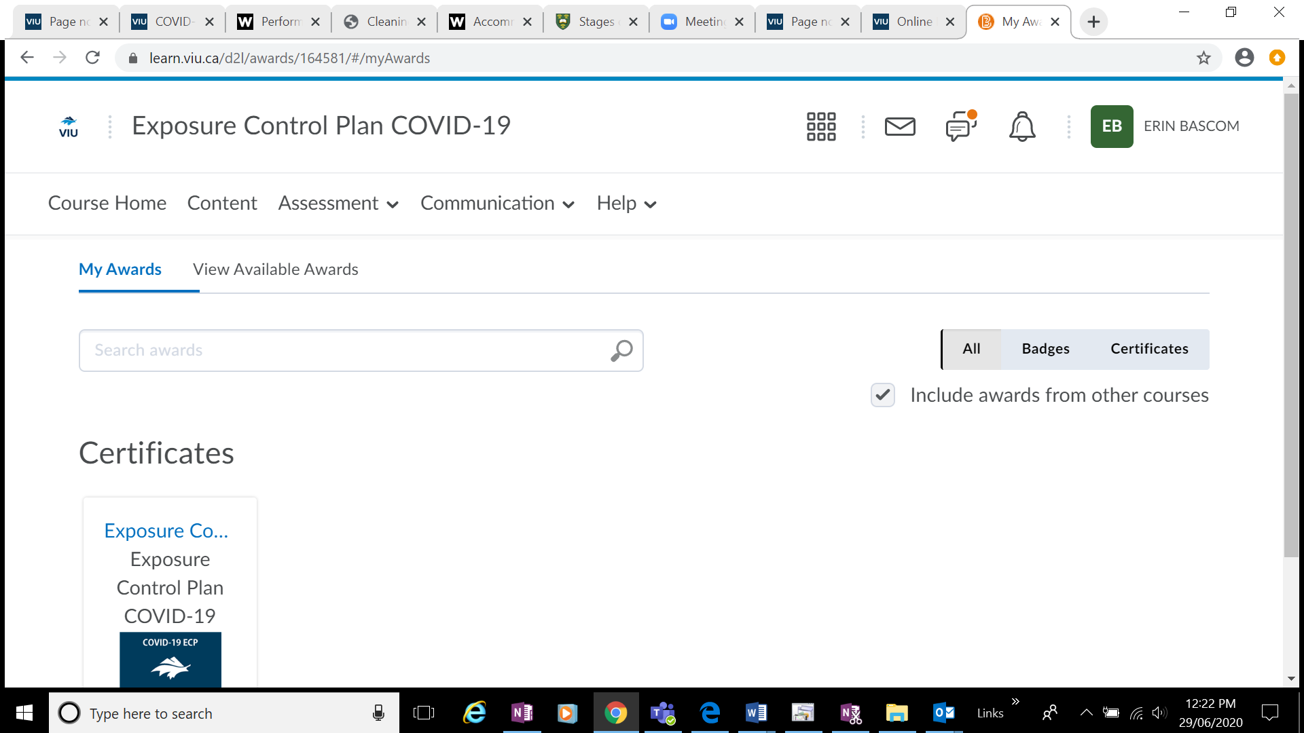

- Scroll down. Then Click on “Generate Certificate”. Download the pdf that opens and email to safety@viu.ca and your Manager.
