Invoice Number | purchase date | Equipment Name | Model Number | Serial Number | Quantity | Value at time of Purchase | Image of Equipment or Tool  (actual or from manufacturer) | Invoice Total
EXAMPLE  86832 | 6/8/2021 | 91R Stihl |  | 527340199 | 1 | 459.95 | 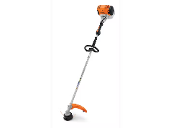 | 459.95
 | Click or tap to enter a date.
 | Click or tap to enter a date.
 | Click or tap to enter a date.
 | Click or tap to enter a date.
 | Click or tap to enter a date.
 | Click or tap to enter a date.
 | Click or tap to enter a date.
 | Click or tap to enter a date.
 | Click or tap to enter a date.
 | Click or tap to enter a date.
 | Click or tap to enter a date.
 | Click or tap to enter a date.
 | Click or tap to enter a date.
 | Click or tap to enter a date.
 | Click or tap to enter a date.
 | Click or tap to enter a date.
 | Click or tap to enter a date.
 | Click or tap to enter a date.
 | Click or tap to enter a date.
 | Click or tap to enter a date.
 | Click or tap to enter a date.
 | Click or tap to enter a date.
Subtotal

