Building: 460 Date: July 17, 2025
Names of Inspectors: Kordell Bergen, Kim Sharpe, Mathews Tharakan, Joshua Beaulac

 | Yes | No | N/A
 | Around the Building
A.1 | Is the address sign or number easily visible? | X
A.2 | Is waste stored in appropriate waste or recycling storage areas? | X
A.3 | Is the property kept clear of litter, combustibles, hazardous materials, etc.? | X
A.4 | If present, are smoking areas clean? Is an appropriate cigarette butt receptacle available? | X
 | Parking Lot
B.1 | Are appropriate signs posted (e.g., no parking in fire routes, etc.)? | X
B.2 | Are the parking areas free from trip hazards (e.g., no pot holes, cracks, etc.)? | X
B.3 | Is the lighting adequate in the area and walkways at night? |  |  | X
B.4 | Is the parking lot kept free of debris? | X
B.5 | In winter, is the parking lot free from ice and snow? | X
 | Stairs
C.1 | Are stairs, stairwells, and landings kept clear and unobstructed? | X
C.2 | In winter, are stairs, stairwells, and landings kept clear from ice and snow? |  |  | X
C.3 | Are stairways adequately lit? |  |  | X
C.4 | Are stairs, treads, hand rails, and any guards secure and in good condition? | X
C.5 | Do treads and landings have non-skid surfaces and they are in good condition? | X
 | Exits / Fire Safety
D.1 | Are all emergency exits, exit doors, landings, and steps from the building well marked, unblocked, and kept in good condition? | X
D.2 | In winter, are exits kept free from ice and snow? |  |  | X
D.3 | In winter, is the roof area over the exits free of falling ice and snow hazards? |  |  | X
D.4 | Are exit doors, landings, and steps well lit? Are the lights over the exit doors working and in good repair? |  |  | X
D.5 | In winter, is the access ramp clear of ice and snow, and is there good traction? |  |  | X
D.6 | Can the building be easily accessed by the fire department? Are fire lanes accessible and posted? | X
D.7 | Are the fire department hose connections kept clear, accessible and have caps? | X
D.8 | Is the electrical service entrance area clear of trees and branches? | X
D.9 | Are all electrical wires out of reach of the public? | X
D.10 | Are sprinkler heads guarded? Obstructed? |  |  | X
 | Grounds
E.1 | Are walkways clear and in good condition? Are there any holes or trip hazards on grounds where workers/public may walk? | X
E.2 | In winter, are ice and snow cleared promptly from walkways? |  |  | X
E.3 | Is security lighting functioning properly? |  |  | X
E.4 | Are exit routes (from the grounds) well marked, and kept clear and unobstructed? | X
E.5 | Is fencing in good condition? |  |  | X
E.6 | Is any outdoor machinery in good repair? |  |  | X
 | Storage Shed
F.1 | Are hazardous products adequately stored and labelled? |  |  | X
F.2 | Are incompatible materials stored separately? |  |  | X
F.3 | Is the shed or area secured and access limited? |  |  | X
F.4 | Is there any sign of leaks or spills? |  |  | X
F.5 | Are “No Smoking” signs posted when flammable products are stored? |  |  | X
F.6 | Is the storage area protected from exposure to heat, moisture, vibration, flame, etc. as appropriate for the products stored? |  |  | X
F.7 | Is equipment and machinery in good condition? |  |  | X
 | Loading Areas
G.1 | If required, are pedestrian walkways clearly marked? |  |  | X
G.2 | Are vehicles and/or loads secured from accidental movement? | X
G.3 | Is the area kept free of obstructions or debris? | X
G.4 | Are any lifting devices, racking systems, etc. in good condition? |  |  | X
G.5 | If required, are machine guards in place? |  |  | X
Corrective Action | Assigned To | Date to be completed by
Notes on deficiencies / other comments

Excellent job on the repairs and upkeep of the exterior of B460. The inspection in 2022 noted 14 hazards associated with the exterior of B460. All hazards have been rectified and no new hazards identified. Great work.

Building: 460 Date: July 17, 2025
Names of Inspectors: Kordell Bergen, Kim Sharpe, Mathews Tharakan, Joshua Beaulac

 | Yes | No | N/A
 | Bulletin Boards and Signs
A.1 | Are they clean and readable? | X
A.2 | Is the material changed frequently? | X
A.3 | Do items interfere with people walking by? |  | X
 | Floors
B.1 | Is there loose material, debris, worn carpeting? |  | X
B.2 | Are the floors slippery, oily or wet? |  | X
 | Stairways and Aisles
C.1 | Are they clear and unblocked? |  | X
C.2 | Are stairways well lighted? | X
C.3 | Are handrails, handholds in place? | X
C.4 | Are the aisles marked and visible? | X
 | Equipment
D.1 | Are guards, screens and sound-dampening devices in place and effective? | X
D.2 | Is the furniture in good repair and safe to use? Look for:
D.3 | - chairs that are in poor repair |  | X
D.4 | - sharp edges on desks and cabinets |  | X
D.5 | - poor ergonomics (keyboard elevation, chair adjustment, desk height) |  | X
D.6 | - crowding |  | X
D.7 | Are ladders well maintained and safe to use? | X
 | Emergency Equipment
E.1 | Is all fire control equipment regularly tested and certified? | X
E.2 | Is fire control equipment appropriate for the type of fire it must control? | X
E.3 | Are sprinkler heads guarded? Obstructed? | X
E.4 | Is emergency lighting in place and regularly tested? | X
 | Building
F.1 | Do buildings conform to standards with respect to use, occupancy, building services, and plumbing facilities? | X
F.2 | Check the following structures to ensure safety:
F.3 | - swinging doors | X
F.4 | - floor and wall openings | X
F.5 | - ladders, stairways and ramps | X
F.6 | - guardrails | X
F.7 | Are materials stored safely? | X
 | Air Handling System
G.1 | Does air exchange rate meet standard requirements? | X
G.2 | Is the system free of sources of contamination (e.g., asbestos, microorganisms, dust, fumes)? | X
G.3 | Is humidity within recommended range? | X
 | Hazardous Products
H.1 | Are there any hazardous products (e.g., products regulated by WHMIS)? | Unknown
H.2 | - If yes, are the products properly labelled? |  | X
H.3 | - If yes, is there a corresponding safety data sheet (SDS) for each product? | Unknown
H.4 | - If yes, are workers trained in how to work with or near these products safely? | Unknown
 | Sanitation
I.1 | Are washrooms and food preparation areas clean? | X
I.2 | Are the following provided adequately?
I.3 | - toilets | X
I.4 | - showers | X
I.5 | - potable (drinkable) water | X
I.6 | - clothing storage |  |  | X
I.7 | - change rooms | X
I.8 | - field accommodations | X
I.9 | - lunchrooms |  | X
I.10 | Are measures in place to prevent the spread of disease? | X
 | Security
J.1 | Do entry and exit procedures provide workers personal security at night? | X
J.2 | Are emergency (evacuation, fire, bomb threat, hostile person) procedures in place? | X
 | Lighting
K.1 | Are lamp reflectors clean? | X
K.2 | Are bulbs missing? |  | X
K.3 | Are any areas dark? |  | X
 | Material Storage
L.1 | Are materials neatly and safely piled? | X
L.2 | Are there stepladders or stools to get to materials on higher shelves? | X
L.3 | Are storage shelves overloaded or beyond their rated capacity? |  | X
L.4 | Are large and heavy objects stored on lower shelves? | X
L.5 | Are passageways and work areas clear of obstructions? |  | X
 | General
M.1 | Are extension cords used extensively? (if so, consider installing permanent wiring) |  | X
M.2 | Are electrical or telephone cords exposed in areas where employees may become entangled? |  | X
M.3 | Is electrical wiring properly installed? | X
M.4 | Are machines properly guarded? | X
M.5 | Does any equipment have sharp metal projections? |  | X
M.6 | Are wall and ceiling fixtures fastened securely? | X
M.7 | Are paper and waste properly disposed of? | X
M.8 | Are desk and file drawers kept closed when not in use? | X
M.9 | Are office accessories stored appropriately? | X
M.10 | Are materials stacked on desks or cabinets? | X
M.11 | Are file cabinet drawers overloaded? |  | X
M.12 | Are file cabinets loaded with the heaviest items in the bottom drawers? | X
M.13 | Are shelves securely fastened to the wall when necessary? |  | X
M.14 | Are filing stools or wastebaskets placed where they might be tripping hazards? | X
 | Miscellaneous
N.1 | Eye wash | X
N.2 | 3D Printer | X
N.3 | Vacuum | X
N.4 | Gun Safe | X
Corrective Action | Assigned To
C.1 / L.5. The aisles in R210 do not meet BC Fire Code 2.7.1. Means of Egress requirements.  M.13. The same shelves are stacked with equipment < 6 feet high in front of windows, the shelves are not anchored.  These shelves need to be relocated to meet the egress requirements for the room and properly anchored when moved to their new location. | Bill Floyd
D.7. Two ladders are being stored in R102. Please lay the ladders down or strap them to the wall. | Facility Services
H.1 – 4. Unlabeled substance in R208 (lab). WHMIS requires a workplace label be affixed to identify contents when they are transferred from the original container into workplace containers. https://www.worksafebc.com/en/law-policy/occupational-health-safety/searchable-ohs-regulation/ohs-regulation/part-05-chemical-and-biological-substances#SectionNumber:5.10  Please label the contents, ensure correct storage and review VIU’s WHMIS training available on VIU Learn: https://learn.viu.ca/d2l/loginh/ | Bill Floyd
I.9. Food and personal dishes used to consume food are being stored in cabinets and the fridge in R208.  Food stored in laboratory (cabinet and fridge) - BCOHS regulation Parts4.84(2) and 30.17(2)(3)  (2) Smoking, eating or drinking is not permitted in any laboratory area.  (3) Food for consumption must not be kept in the laboratory, and laboratory glassware, vessels and containers must not be used to prepare or store food or beverages for consumption.”  Please move all food and food preparation / consumption tools and equipment out of the laboratory into the storage / office / kitchen space on upper floor of B460 or other non-laboratory space.  **4.84(2): An area suitable for food storage means a place where stored food is protected from workplace contaminants.** | Bill Floyd
L.1. R208 (lab) is quite messy and could use a clean-up. Aisles are blocked, counters are full. | Bill Floyd
N.1. The eye wash in R208 (lab) had not been flushed in a long time and is not fit for use until properly flushed. SectionE 5.93(2) of the OHS Regulation ("Regulation") states:  (2) The employer must ensure that a plumbed emergency eyewash or shower facility is full flow tested at least once per month, for a sufficient length of time to completely flush the branch of the water line supplying the eyewash.  https://www.ccohs.ca/oshanswers/safety_haz/emer_showers.html | Bill Floyd
N.2. Until more research can be completed it is strongly recommended that occupants only use 3D printers with integrated filters or printers that are contained with the ability to vent to the exterior when in use. | Building Occupants
N.3. A vacuum is being stored in Mechanical room 333. Please remove. I’m not sure if this belongs to the building occupants or janitorial | Building Occupants / Facility Services
N.4. A gun safe was noted in R210. Please confirm if firearms are stored in this location. | Bill Floyd

C.1, L.5, M.13 D.7 H.1
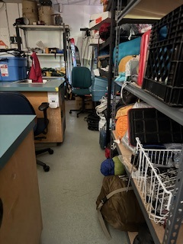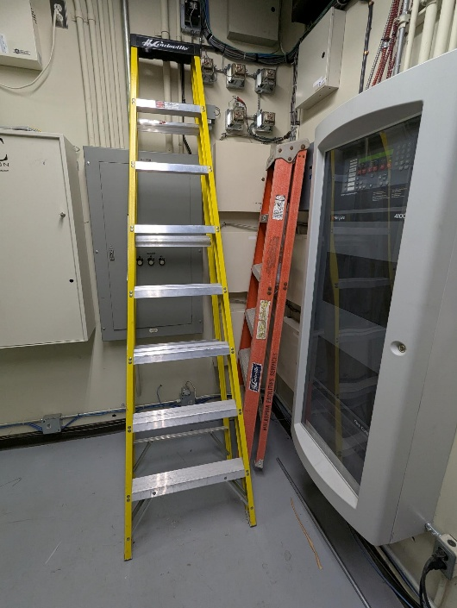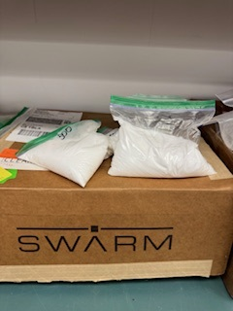

I.9 I.9 N.3
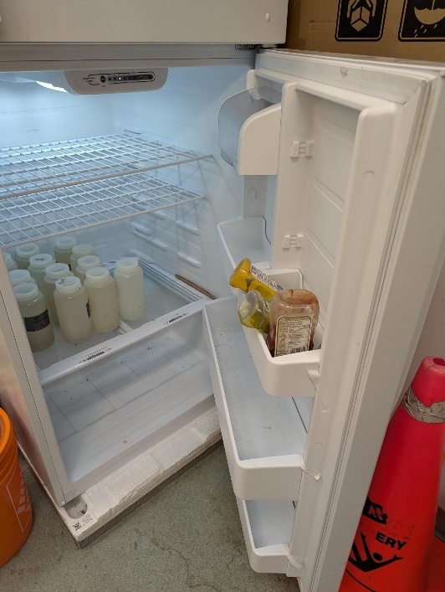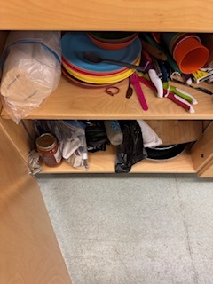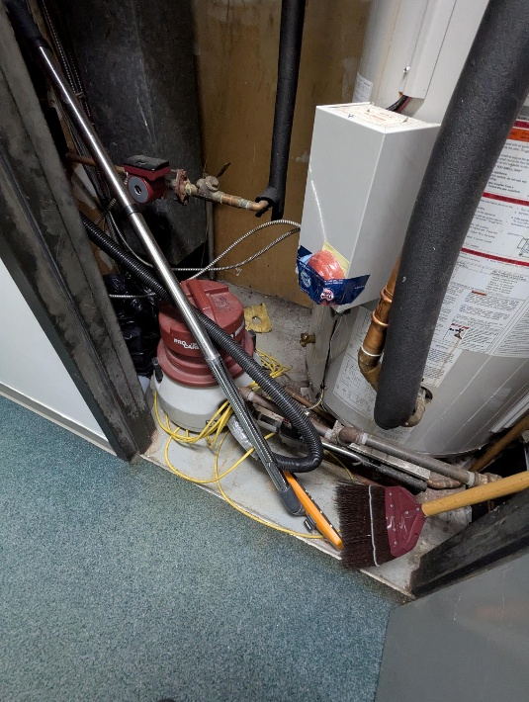

N.4
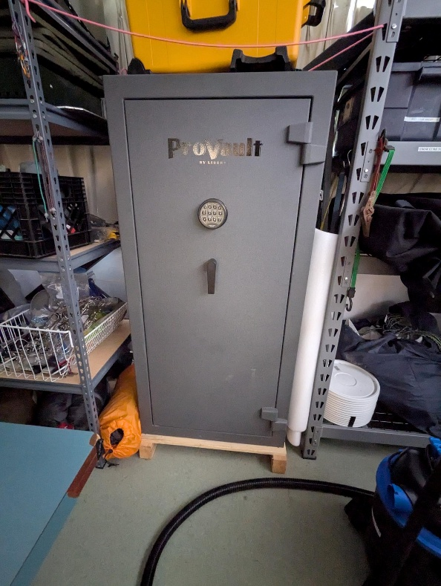

Building: 460 Date: July 17, 2025
Names of Inspectors: Kordell Bergen, Kim Sharpe, Mathews Tharakan, Joshua Beaulac

 | Yes | No | N/A
 | Emergency and Hazard Information
A.1 | Emergency phone numbers posted? Are phones available? | X
A.2 | Are exits clearly marked and accessible? | X
A.3 | Are evacuation maps posted? | X
A.4 | Are emergency evacuation drills conducted at least annually? | X
A.5 | Are first aid attendants available with kits fully stocked and inspected? | X
A.6 | Do students know where and how to receive care for an injury | X
A.7 | Are signs present for emergency safety equipment (eyewash, exits etc.)? | X
A.8 | Are appropriate fire extinguishers available and inspected regularly? | X
A.9 | Are flammable materials stored in a flammable storage cabinet? | X
A.10 | Chemical inventories up to date | X
A.11 | MSDS sheets available and current | X
 | Floors
B.1 | Is there loose material, debris, worn carpeting? |  | X
B.2 | Are the floors slippery, oily or wet? |  | X
 | Stairways and Aisles
C.1 | Are they clear and unblocked? | X
C.2 | Are stairways well lighted? |  |  | X
C.3 | Are handrails, handholds in place? |  |  | X
C.4 | Are the aisles marked and visible? | X
 | Safety Administration
D.1 | Have all students received general orientation and safety training e.g. MSDS, PPE, evacuations, etc.? | X
D.2 | Have all students been trained on the equipment that they operate? | X
D.3 | Have students received other specialized training: Lockout/Tagout, Respirators, Tools (hand/power), PPE, ect | X
D.4 | Is orientation/safety training documented? | Unknown
D.5 | Do students have access to the orientation information? | Unknown
D.6 | Are regularly scheduled safety meetings conducted in the shop? | Unknown
D.7 | Has a hazard assessment been done in order to select appropriate PPE? | X
D.8 | Is PPE provided and used whenever necessary? | X
D.9 | Are there chemicals or controlled substances in the shop? Is WHMIS training provided? Are SDS’s available? | X
 | Housekeeping, Ventilation, Illumination
E.1 | Are all work areas clean and orderly? | X
E.2 | Are waste containers kept clean and emptied? | X
E.3 | Is food kept in the designated area at all times? | X
E.4 | Are all cabinets and shelves secured or anchored? | X
E.5 | Are all machines/equipment secured or anchored? | X
E.6 | Are floors in good condition and kept dry? | X
E.7 | Are all light fixtures adequate and functioning properly? | X
E.8 | Dust extractors in good working order | X
E.9 | Exhaust fans functioning | X
E.10 | “No Eating/Drinking/Smoking” signs posted | X
 | Electrical Safety/Portable Tools
F.1 | Are all plugs, cords, and panels enclosed, and in good condition? | X
F.2 | Do all extension cords have grounding? |  |  | X
F.3 | Are extension cords used only temporarily? | X
F.4 | Are cords secured so they do not run across pathways, under doors or the walls? | X
F.5 | Is the breaker panel locked? |  |  | X
F.6 | Are ground fault circuit interrupters available for use in wet areas? |  |  | X
F.7 | Are hand-tools effectively grounded or Double insulated? | X
F.8 | Are hand/power tools inspected regularly? | X
 | Mechanical Safety
G.1 | Is defective equipment promptly reported, labeled, and replaced? | X
G.2 | Can equipment be locked out? | X
G.3 | Safeguards prevent workers’ hands, arms and other body parts from making contact with dangerous moving parts | X
G.4 | Safeguards have not been tampered with, altered or removed | X
G.5 | Powered machinery/equipment has start and stop controls located within easy reach of the operator has controls and switches whose functions are clearly identified | X
G.6 | Are machines regularly cleaned and maintained? | X
G.7 | Are maintenance records, calibrations, certifications of each machine kept on file? | Unknown
G.8 | Do authorized people perform the repairs? | Unknown
G.9 | Physical hazards are marked in a manner that clearly identifies the hazard | X
 | Spill Response
H.1 | Do personnel know the location of the closest First Aid Kit? | X
H.2 | Do personnel know the location of the closet Spill Kit? | Unknown
H.3 | Are personnel familiar with Vancouver Island Universities Spill Procedures? | Unknown
 | WHMIS
I.1 | Have all personnel received WHMIS training? | X
I.2 | Are all hazardous materials labeled according to the WHMIS Regulations? | X
I.3 | Is there a current inventory of all hazardous substances in the area? | X
I.4 | Do personnel know where to find current (<3 years) SDS for the materials being used? | X
 | Emergency Eyewash/Showers
J.1 | Are personnel familiar with the location of the nearest eyewash / shower? | X
J.2 | Is the eyewash station / shower clean and clear of debris? | X
J.3 | Have emergency shower(s) been tested in the last 12 months and have a tag indicating testing date? | X
 | Lighting
K.1 | Are lamp reflectors clean? | X
K.2 | Are bulbs missing? |  | X
K.3 | Are any areas dark? |  | X
 | Material Storage
L.1 | Are materials neatly and safely piled? | X
L.2 | Are there stepladders or stools to get to materials on higher shelves? | X
L.3 | Are storage shelves overloaded or beyond their rated capacity? |  | X
L.4 | Are large and heavy objects stored on lower shelves? | X
L.5 | Are passageways and work areas clear of obstructions? | X
 | General
M.1 | Is electrical wiring properly installed? | X
M.2 | Does any equipment have sharp metal projections? |  | X
M.3 | Are wall and ceiling fixtures fastened securely? | X
M.4 | Are paper and waste properly disposed of? | X
M.5 | Are desk and file drawers kept closed when not in use? | X
M.6 | Are office accessories stored appropriately? | X
M.7 | Are materials stacked on desks or cabinets? |  | X
M.8 | Are file cabinet drawers overloaded? |  | X
M.9 | Are file cabinets loaded with the heaviest items in the bottom drawers? | X
M.10 | Are shelves securely fastened to the wall when necessary? | X
Corrective Action | Assigned To
J.1. The closest eyewash station is in the hallway adjacent to the shop. As chemicals are present in the shop, please have a portable eyewash on hand in the shop. https://www.onoworkandsafety.com/products/dynamic-complete-eye-wash-station-32oz | Devon Ayotte
Fume hood #FH9: Fume hood has not been tested/certified. Create Work Order to add a lock and locking mechanism to the fume hood sash and body of fume hood to attach/secure the lock. Should be a Facilities Lockout Lock that is used. This will take the fume hood out of service entirely as it is not required in the facility/by the building occupants at this time.  Once Locked out, Facilities can turn the fume hood off. Re-balancing may be required. | Building Occupants  Facility Services

I would like to recognize the work and effort that Devon has put into cleaning up the shop space in B460. 22 hazards were identified in the shop three years ago, there were none identified during our inspection this year with one recommended improvement. Great work Devon.

