Building: 325 Perimeter Date: June 18, 2025
Names of Inspectors: Kordell Bergen, Kim Sharpe, Jason Sutton, Robin Boxwood, Jannine Grant

 | Yes | No | N/A
 | Around the Building
A.1 | Is the address sign or number easily visible? | X
A.2 | Is waste stored in appropriate waste or recycling storage areas? | X
A.3 | Is the property kept clear of litter, combustibles, hazardous materials, etc.? |  | X
A.4 | If present, are smoking areas clean? Is an appropriate cigarette butt receptacle available? |  |  | X
 | Parking Lot
B.1 | Are appropriate signs posted (e.g., no parking in fire routes, etc.)? | X
B.2 | Are the parking areas free from trip hazards (e.g., no pot holes, cracks, etc.)? | X
B.3 | Is the lighting adequate in the area and walkways at night? | X
B.4 | Is the parking lot kept free of debris? |  | X
B.5 | In winter, is the parking lot free from ice and snow? |  |  | X
 | Stairs
C.1 | Are stairs, stairwells, and landings kept clear and unobstructed? | X
C.2 | In winter, are stairs, stairwells, and landings kept clear from ice and snow? |  |  | X
C.3 | Are stairways adequately lit? | X
C.4 | Are stairs, treads, hand rails, and any guards secure and in good condition? | X
C.5 | Do treads and landings have non-skid surfaces and they are in good condition? | X
 | Exits / Fire Safety
D.1 | Are all emergency exits, exit doors, landings, and steps from the building well marked, unblocked, and kept in good condition? |  | X
D.2 | In winter, are exits kept free from ice and snow? |  |  | X
D.3 | In winter, is the roof area over the exits free of falling ice and snow hazards? |  |  | X
D.4 | Are exit doors, landings, and steps well lit? Are the lights over the exit doors working and in good repair? | X
D.5 | In winter, is the access ramp clear of ice and snow, and is there good traction? |  |  | X
D.6 | Can the building be easily accessed by the fire department? Are fire lanes accessible and posted? | X
D.7 | Are the fire department hose connections kept clear, accessible and have caps? | X
D.8 | Is the electrical service entrance area clear of trees and branches? |  |  | X
D.9 | Are all electrical wires out of reach of the public? | X
D.10 | Are sprinkler heads guarded? Obstructed? |  |  | X
 | Grounds
E.1 | Are walkways clear and in good condition? Are there any holes or trip hazards on grounds where workers/public may walk? | X
E.2 | In winter, are ice and snow cleared promptly from walkways? |  |  | X
E.3 | Is security lighting functioning properly? | X
E.4 | Are exit routes (from the grounds) well marked, and kept clear and unobstructed? | X
E.5 | Is fencing in good condition? |  |  | X
E.6 | Is any outdoor machinery in good repair? |  |  | X
 | Outdoor Kiln Area
F.1 | Are hazardous products adequately stored and labelled? |  | X
F.2 | Are incompatible materials stored separately? | X
F.3 | Is the shed or area secured and access limited? | X
F.4 | Is there any sign of leaks or spills? |  | X
F.5 | Is the storage area protected from exposure to heat, moisture, vibration, flame, etc. as appropriate for the products stored? | X
F.6 | Is equipment and machinery in good condition? | X
 | Miscellaneous
G.1 | Roof Access | X
Corrective Action | Assigned To
A.3. Dead vegetation around the building. This presents a fire hazard. Please remove. | Facility Services
A.3.1 Pile of wood and debris, this creates an area for rodents to live. Please remove. | Building Occupants
A.3.2 The wooden benches at the south end of the building are deteriorating. Fix or remove please. | Facility Services
A.3.4 A Large rock is being used as a door stop at the main entrance. Remove the rock and install a door stop. | Facility Services
B.4. Large metal object located beside the dumpsters. Committee member reports this item being here for years. Heavy Duty Mechanics can remove and dispose of this item. | Building Occupants
D.1. The egress route for the emergency exit on the West side of the building is blocked by blackberry bushes / vegetation. | Facility Services
F.1. Unsecured gas cylinders in the Kiln Area. The cylinders in their current location are exposed to heat (kiln) and require a method to secure them from falling (strap, chain, etc). | Building Occupants
G.1. What fall protection is in place for roof access? Consider installing “control Zones” (markings 2 metres from the edge of the roof). | Facility Services

A.3 A.3.1 A.3.2
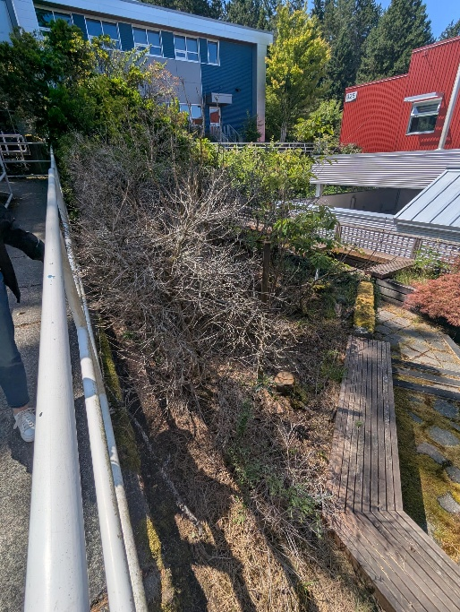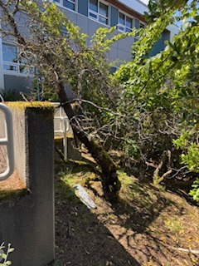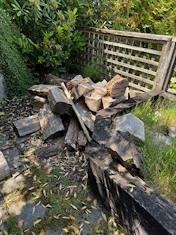

A.3.3 A.3.4 B.4
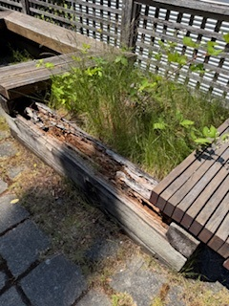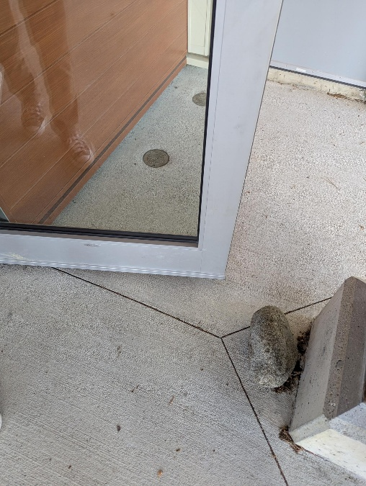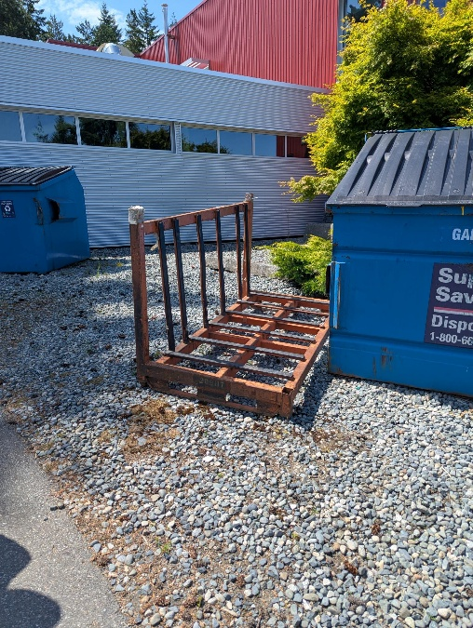

D.1 D.1 F.1
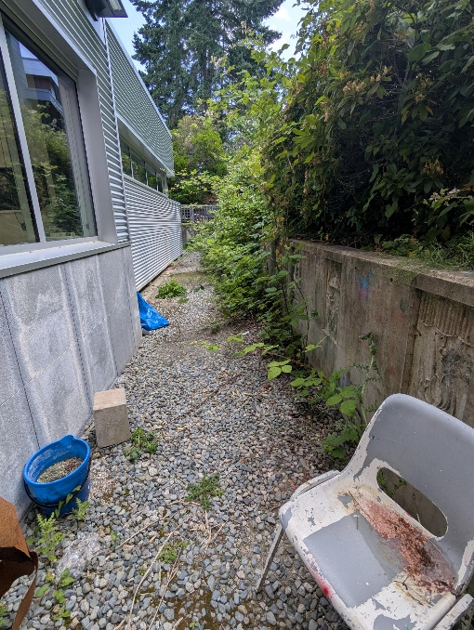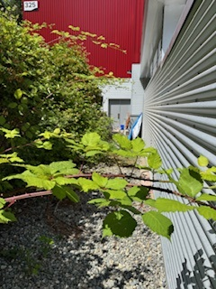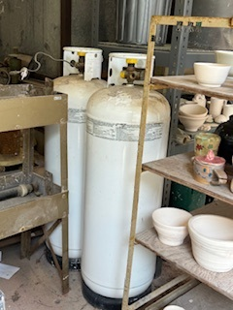

G.1
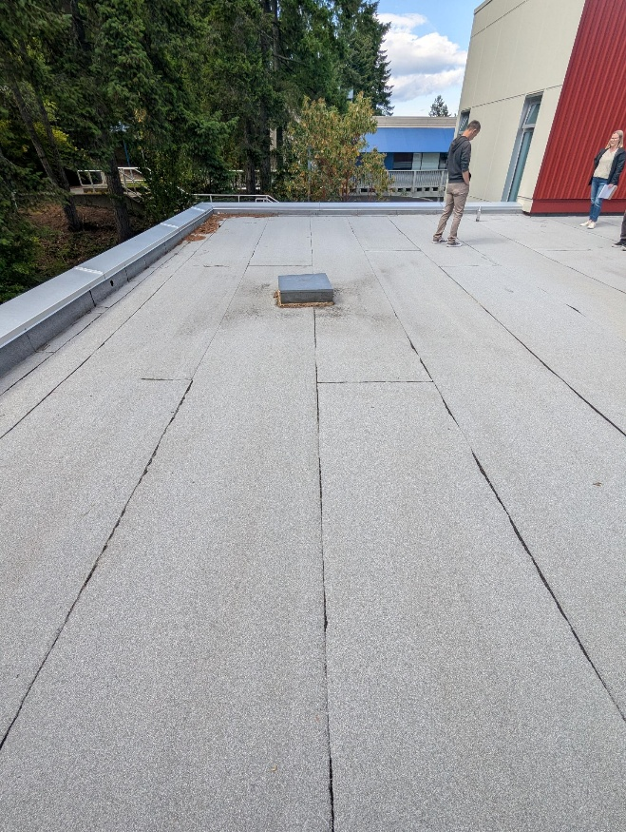

Building: 325 Interior - Offices Date: June 18, 2025
Names of Inspectors: Kordell Bergen, Kim Sharpe, Robin Boxwood, Jason Sutton, Jannine Grant

 | Yes | No | N/A
 | Bulletin Boards and Signs
A.1 | Are they clean and readable? | X
A.2 | Is the material changed frequently? | X
A.3 | Do items interfere with people walking by? |  | X
 | Floors
B.1 | Is there loose material, debris, worn carpeting? |  | X
B.2 | Are the floors slippery, oily or wet? |  | X
 | Stairways and Aisles
C.1 | Are they clear and unblocked? | X
C.2 | Are stairways well lighted? | X
C.3 | Are handrails, handholds in place? | X
C.4 | Are the aisles marked and visible? | X
 | Equipment
D.1 | Are guards, screens and sound-dampening devices in place and effective? | X
D.2 | Is the furniture in good repair and safe to use? Look for:
D.3 | - chairs that are in poor repair |  | X
D.4 | - sharp edges on desks and cabinets |  | X
D.5 | - poor ergonomics (keyboard elevation, chair adjustment, desk height) |  | X
D.6 | - crowding |  | X
D.7 | Are ladders well maintained and safe to use? |  |  | X
 | Emergency Equipment
E.1 | Is all fire control equipment regularly tested and certified? | X
E.2 | Is fire control equipment appropriate for the type of fire it must control? | X
E.3 | Are sprinkler heads guarded? Obstructed? | X
E.4 | Is emergency lighting in place and regularly tested? | X
 | Building
F.1 | Do buildings conform to standards with respect to use, occupancy, building services, and plumbing facilities? | X
F.2 | Check the following structures to ensure safety:
F.3 | - swinging doors | X
F.4 | - floor and wall openings | X
F.5 | - ladders, stairways and ramps | X
F.6 | - guardrails | X
F.7 | Are materials stored safely? | X
 | Air Handling System
G.1 | Does air exchange rate meet standard requirements? | Unknown
G.2 | Is the system free of sources of contamination (e.g., asbestos, microorganisms, dust, fumes)? | X
G.3 | Is humidity within recommended range? | X
 | Hazardous Products
H.1 | Are there any hazardous products (e.g., products regulated by WHMIS)? | X
H.2 | - If yes, are the products properly labelled? | X
H.3 | - If yes, is there a corresponding safety data sheet (SDS) for each product? | X
H.4 | - If yes, are workers trained in how to work with or near these products safely? | X
 | Sanitation
I.1 | Are washrooms and food preparation areas clean? | X
I.2 | Are the following provided adequately?
I.3 | - toilets | X
I.4 | - showers | X
I.5 | - potable (drinkable) water | X
I.6 | - clothing storage |  |  | X
I.7 | - change rooms |  |  | X
I.8 | - field accommodations |  |  | X
I.9 | - lunchrooms |  |  | X
I.10 | Are measures in place to prevent the spread of disease? | X
 | Security
J.1 | Do entry and exit procedures provide workers personal security at night? | X
J.2 | Are emergency (evacuation, fire, bomb threat, hostile person) procedures in place? | X
 | Lighting
K.1 | Are lamp reflectors clean? | X
K.2 | Are bulbs missing? |  | X
K.3 | Are any areas dark? |  | X
 | Material Storage
L.1 | Are materials neatly and safely piled? | X
L.2 | Are there stepladders or stools to get to materials on higher shelves? | X
L.3 | Are storage shelves overloaded or beyond their rated capacity? |  | X
L.4 | Are large and heavy objects stored on lower shelves? |  | X
L.5 | Are passageways and work areas clear of obstructions? | X
 | General
M.1 | Are extension cords used extensively? (if so, consider installing permanent wiring) | X
M.2 | Are electrical or telephone cords exposed in areas where employees may become entangled? |  | X
M.3 | Is electrical wiring properly installed? | X
M.4 | Are machines properly guarded? |  | X
M.5 | Does any equipment have sharp metal projections? | X
M.6 | Are wall and ceiling fixtures fastened securely? | X
M.7 | Are paper and waste properly disposed of? | X
M.8 | Are desk and file drawers kept closed when not in use? | X
M.9 | Are office accessories stored appropriately? | X
M.10 | Are materials stacked on desks or cabinets? |  | X
M.11 | Are file cabinet drawers overloaded? |  | X
M.12 | Are file cabinets loaded with the heaviest items in the bottom drawers? | X
M.13 | Are shelves securely fastened to the wall when necessary? | X
M.14 | Are filing stools or wastebaskets placed where they might be tripping hazards? |  | X
 | Miscellaneous
N.1 | Eye wash | X
N.2 | Emergency Manual | X
N.3 | Plotter Printer | X
N.4 | Second floor kiln | X
N.5 | Label Switches | X
N.6 | Spray Room Fan | X
N.7 | Parts Washer | X
N.8 | Acid Etching | X
Corrective Action | Assigned To
C.1. Numerous doors on the second floor have items stacked in front of them, or covering them preventing use. Occupant access to the doors is not required under the building code, but it can create confusion in an emergency. Post signs notifying occupants that the doors are no longer functional. Consider removing the door handle and installing a plate. | Building Occupants / Facility Services
E.1. The fire extinguisher on the second floor hallway needs a new bracket, the current one is too small. | Facility Services
F.3. The accessible door for R110 did not work. | Facility Services
G.1. Is the ventilation in R123 adequate for the working being performed? H&S will arrange an air quality assessment during the school year. | Health and Safety Services
H.1. Best practice is to store flammable liquids (paint thinner) in a locked, flammable storage cabinet. It is currently being stored on open, wooden shelves. Is there a SWP for working with this product?  Recochem Inc. Paint Thinner SDS | Building Occupants
I.1. There is a very old fridge on the lower-level hallway and all the items inside have frozen solid. If this fridge is no longer used, please dispose of it. | Building Occupants
L.4. Large vases being stored on the top shelf in the ceramic room, please relocate to a lower shelf. | Building Occupants
M.1. Extensive power bars being used in R110. Please have an electrician review this for safety. | Building Occupants / Facility Services
M.4. Please lock out the cutting press and paper cutters when not in use or remove from public access (hallways). | Building Occupants
N.1. The eye wash should have dust covers on the nozzles and run weekly. The weekly inspection and operation should be recorded and posted. CCOHS | Building Occupants
N.2. There is an emergency manual beside the door to the shop dated 2002. Please remove. | Building Occupants
N.3. None of the committee members were familiar with the plotter printer. Is there a SWP for its use? Does it require lock out during maintenance? | Building Occupants
N.4. The kiln on the second floor does not meet manufacturer requirements for use. This was noted during the 2022 inspection and not rectified. Building 325 is wood framed.  “Set the kiln on a level and stable surface; if the floor is not concrete, it is essential that the kiln be placed on a non-flammable surface such as fire brick or cement block.”  https://coneartkilns.com/skin/frontend/default/blank/downloadable/Instruction%20manual-Pottery%20Kiln.pdf | Building Occupants
N.5. Some rooms (121) have switches all over the walls with no description of what they do or operate. Please labels the switches in the R123, 121, 119 to identify their purpose. | Building Occupants
N.6. Verify that the fans in the Spray Room (104) work. | Facility Services
N.7. Concerns about the parts washer in R121. HHS will address these concerns in a separate email. | Health & Safety Services
N8. N.7. Concerns about the acid etching in R121. HHS will address these concerns in a separate email. | Health & Safety Services

C.1 C.1 E.1
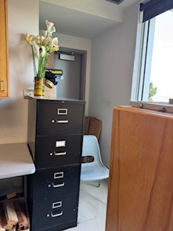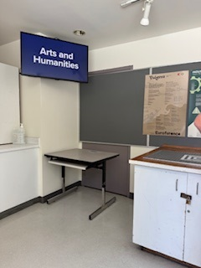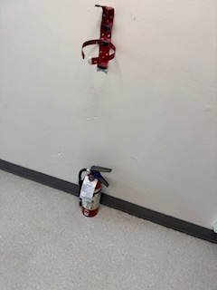

H.1 H.1 I.1
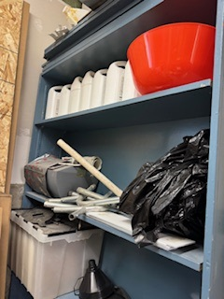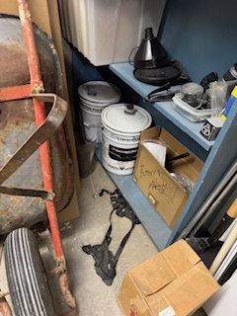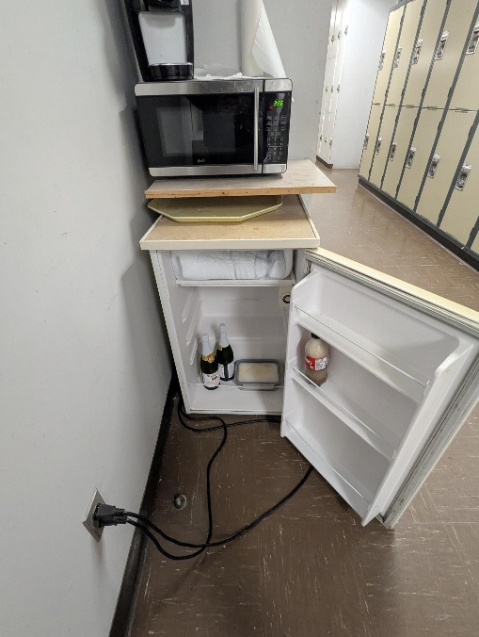

L.4 M.1 M.4
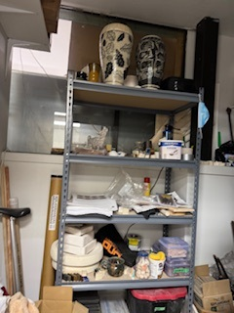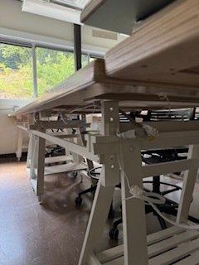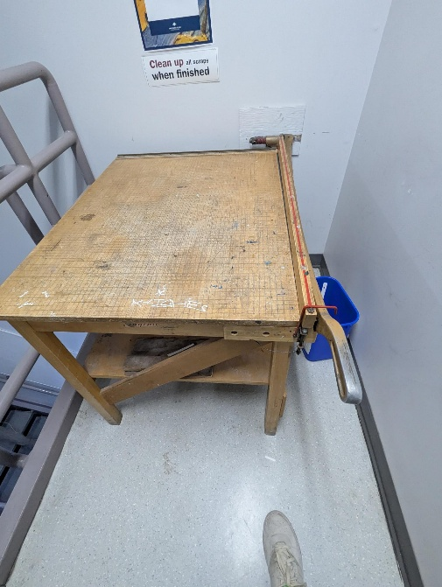

M.4 N.1 N.1
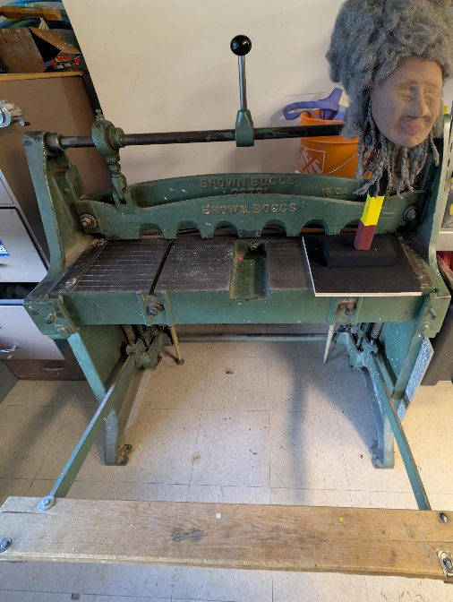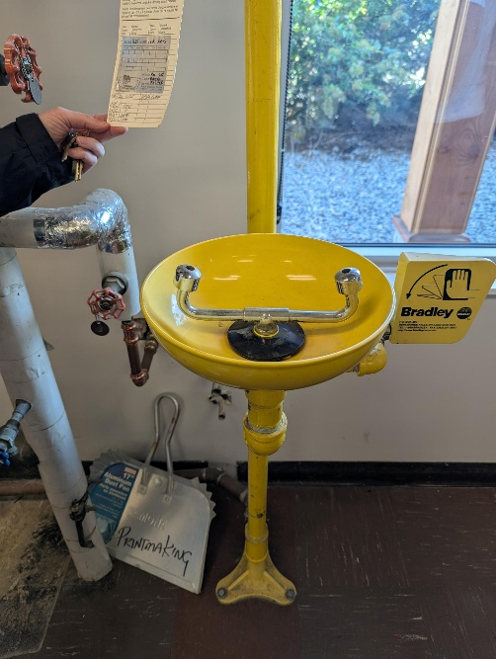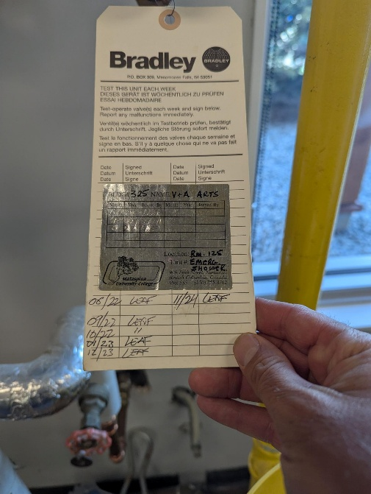

N.2 N.3 N.7
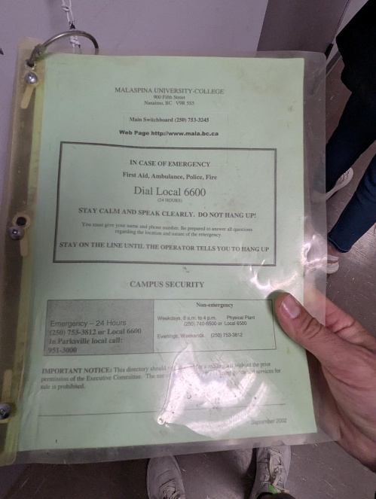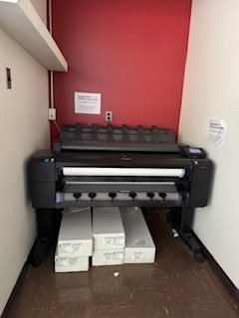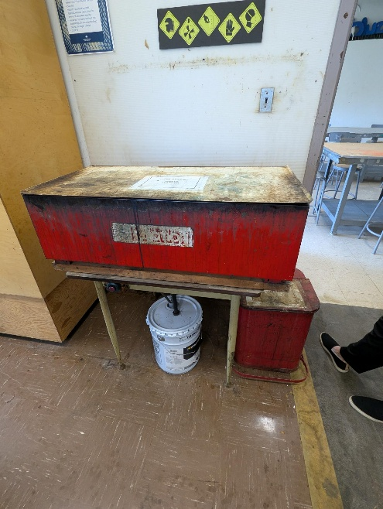

N.8
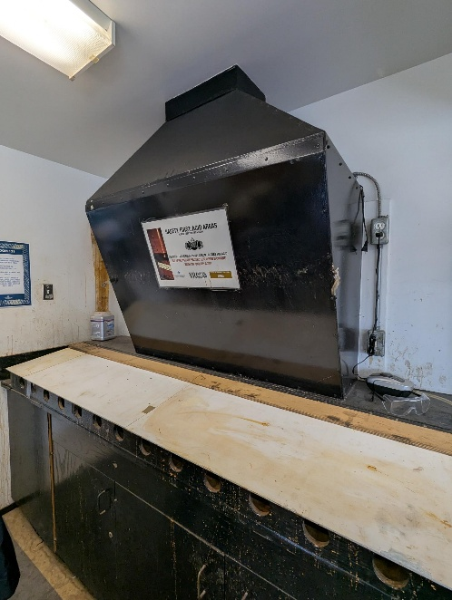

Building: 325 Interior - Shop Date: June 18, 2025
Names of Inspectors: Kordell Bergen, Kim Sharpe, Robin Boxwood, Jason Sutton, Jannine Grant

 | Yes | No | N/A
 | Emergency and Hazard Information
A.1 | Emergency phone numbers posted? Are phones available? | X
A.2 | Are exits clearly marked and accessible? | X
A.3 | Are evacuation maps posted? | X
A.4 | Are emergency evacuation drills conducted at least annually? | X
A.5 | Are first aid attendants available with kits fully stocked and inspected? | X
A.6 | Are Level 1 Attendant’s qualifications current? |  |  | X
A.7 | Do students know where and how to receive care for an injury | X
A.8 | Are signs present for emergency safety equipment (eyewash, exits etc.)? | X
A.9 | Are appropriate fire extinguishers available and inspected regularly? | X
A.10 | Are flammable materials stored in a flammable storage cabinet? | X
A.11 | Chemical inventories up to date | X
A.12 | MSDS sheets available and current | X
 | Floors
B.1 | Is there loose material, debris, worn carpeting? |  | X
B.2 | Are the floors slippery, oily or wet? |  | X
 | Stairways and Aisles
C.1 | Are they clear and unblocked? | X
C.2 | Are stairways well lighted? |  |  | X
C.3 | Are handrails, handholds in place? |  |  | X
C.4 | Are the aisles marked and visible? | X
 | Safety Administration
D.1 | Have all students received general orientation and safety training e.g. MSDS, PPE, evacuations, etc.? | X
D.2 | Have all students been trained on the equipment that they operate? | X
D.3 | Have students received other specialized training: Lockout/Tagout, Respirators, Tools (hand/power), PPE, ect | X
D.4 | Is orientation/safety training documented? | X
D.5 | Do students have access to the orientation information? | X
D.6 | Are regularly scheduled safety meetings conducted in the shop? | X
D.7 | Has a hazard assessment been done in order to select appropriate PPE? | X
D.8 | Is PPE provided and used whenever necessary? | X
D.9 | Are there chemicals or controlled substances in the shop? Is WHMIS training provided? Are SDS’s available? |  |  | X
 | Housekeeping, Ventilation, Illumination
E.1 | Are all work areas clean and orderly? | X
E.2 | Are waste containers kept clean? | X
E.3 | Is food kept in the designated area at all times? | X
E.4 | Are all cabinets and shelves secured or anchored? | X
E.5 | Are all machines/equipment secured or anchored? | X
E.6 | Are floors in good condition and kept dry? | X
E.7 | Are all light fixtures adequate and functioning properly? | X
E.8 | Dust extractors in good working order | X
E.9 | Exhaust fans functioning | X
E.10 | “No Eating/Drinking/Smoking” signs posted | X
 | Electrical Safety/Portable Tools
F.1 | Are all plugs, cords, and panels enclosed, and in good condition? | X
F.2 | Do all extension cords have grounding? | X
F.3 | Are extension cords used only temporarily? | X
F.4 | Are cords secured so they do not run across pathways, under doors or the walls? | X
F.5 | Is the breaker panel locked? | X
F.6 | Are ground fault circuit interrupters available for use in wet areas? |  |  | X
F.7 | Are hand-tools effectively grounded or Double insulated? | X
F.8 | Are hand/power tools inspected regularly? | X
 | Mechanical Safety
G.1 | Is defective equipment promptly reported, labeled, and replaced? | X
G.2 | Can equipment be locked out? | X
G.3 | Safeguards prevent workers’ hands, arms and other body parts from making contact with dangerous moving parts | X
G.4 | Safeguards have not been tampered with, altered or removed | X
G.5 | Powered machinery/equipment has start and stop controls located within easy reach of the operator has controls and switches whose functions are clearly identified | X
G.6 | Are machines regularly cleaned and maintained? | X
G.7 | Are maintenance records, calibrations, certifications of each machine kept on file? |  | X
G.8 | Do authorized people perform the repairs? |  | X
G.9 | Physical hazards are marked in a manner that clearly identifies the hazard | X
 | Spill Response
H.1 | Do personnel know the location of the closest First Aid Kit? | X
H.2 | Do personnel know the location of the closet Spill Kit? |  |  | X
H.3 | Are personnel familiar with Vancouver Island Universities Spill Procedures? |  |  | X
 | WHMIS
I.1 | Have all personnel received WHMIS training? | X
I.2 | Are all hazardous materials labeled according to the WHMIS Regulations? |  |  | X
I.3 | Is there a current inventory of all hazardous substances in the area? |  |  | X
I.4 | Do personnel know where to find current (<3 years) SDS for the materials being used? | X
 | Emergency Eyewash/Showers
J.1 | Are personnel familiar with the location of the nearest eyewash / shower? | X
J.2 | Is the eyewash station / shower clean and clear of debris? | X
J.3 | Have emergency shower(s) been tested in the last 12 months and have a tag indicating testing date? |  |  | X
 | Lighting
K.1 | Are lamp reflectors clean? | X
K.2 | Are bulbs missing? | X
K.3 | Are any areas dark? | X
 | Material Storage
L.1 | Are materials neatly and safely piled? | X
L.2 | Are there stepladders or stools to get to materials on higher shelves? | X
L.3 | Are storage shelves overloaded or beyond their rated capacity? |  | X
L.4 | Are large and heavy objects stored on lower shelves? | X
L.5 | Are passageways and work areas clear of obstructions? | X
 | General
M.1 | Is electrical wiring properly installed? | X
M.2 | Does any equipment have sharp metal projections? | X
M.3 | Are wall and ceiling fixtures fastened securely? | X
M.4 | Are paper and waste properly disposed of? | X
M.5 | Are desk and file drawers kept closed when not in use? | X
M.6 | Are office accessories stored appropriately? | X
M.7 | Are materials stacked on desks or cabinets? |  | X
M.8 | Are file cabinet drawers overloaded? |  | X
M.9 | Are file cabinets loaded with the heaviest items in the bottom drawers? |  |  | X
M.10 | Are shelves securely fastened to the wall when necessary? | X
 | Miscellaneous
N.1 | Lock out Tag out | X
Corrective Action | Assigned To
M.2. Consider switching to self-retracting utility knives as a best practice. | Building Occupants
N.1. Please review the De-energization & Lockout program on the Health and Safety Website.  - Consider painting common locks (locks put on equipment to prevent unauthorized  use) yellow to match other departments.  - Purchase Lock out Locks and equipment for the Technicians to use.  - Create SWP’s for locking out. | Building Occupants / Health and Safety

M.2 N.1 N.1
