Building: 356 Date: March 19, 2024
Names of Inspectors: Kordell Bergen, Rob Okashimo, Jannine Grant

 | Yes | No | N/A
 | Bulletin Boards and Signs
A.1 | Are they clean and readable? | X
A.2 | Is the material changed frequently? | X
A.3 | Do items interfere with people walking by? |  | X
 | Floors
B.1 | Is there loose material, debris, worn carpeting? | X
B.2 | Are the floors slippery, oily or wet? |  | X
 | Stairways and Aisles
C.1 | Are they clear and unblocked? |  | X
C.2 | Are stairways well lighted? | X
C.3 | Are handrails, handholds in place? | X
C.4 | Are the aisles marked and visible? | X
 | Equipment
D.1 | Are guards, screens and sound-dampening devices in place and effective? | X
D.2 | Is the furniture in good repair and safe to use? Look for:
D.3 | - chairs that are in poor repair |  | X
D.4 | - sharp edges on desks and cabinets |  | X
D.5 | - poor ergonomics (keyboard elevation, chair adjustment, desk height) |  | X
D.6 | - crowding |  | X
D.7 | Are ladders well maintained and safe to use? |  |  | X
 | Emergency Equipment
E.1 | Is all fire control equipment regularly tested and certified? | X
E.2 | Is fire control equipment appropriate for the type of fire it must control? | X
E.3 | Is emergency lighting in place and regularly tested? | X
E.4 | Is there adequate fire suppression in the building? |  | X
 | Building
F.1 | Do buildings conform to standards with respect to use, occupancy, building services, and plumbing facilities? | X
F.2 | Check the following structures to ensure safety:
F.3 | - swinging doors | X
F.4 | - floor and wall openings | X
F.5 | - ladders, stairways and ramps | X
F.6 | - guardrails | X
F.7 | Are materials stored safely? | X
 | Air Handling System
G.1 | Does air exchange rate meet standard requirements? | X
G.2 | Is the system free of sources of contamination (e.g., asbestos, microorganisms, dust, fumes)? | X
G.3 | Is humidity within recommended range? | X
 | Hazardous Products
H.1 | Are there any hazardous products (e.g., products regulated by WHMIS)? |  | X
H.2 | - If yes, are the products properly labelled? |  |  | X
H.3 | - If yes, is there a corresponding safety data sheet (SDS) for each product? |  |  | X
H.4 | - If yes, are workers trained in how to work with or near these products safely? |  |  | X
 | Sanitation
I.1 | Are washrooms and food preparation areas clean? | X
I.2 | Are the following provided adequately?
I.3 | - toilets | X
I.4 | - showers | X
I.5 | - potable (drinkable) water | X
I.6 | - clothing storage |  |  | X
I.7 | - change rooms | X
I.8 | - field accommodations |  |  | X
I.9 | - lunchrooms | X
I.10 | Are measures in place to prevent the spread of disease? | X
 | Security
J.1 | Do entry and exit procedures provide workers personal security at night? | X
J.2 | Are emergency (evacuation, fire, bomb threat, hostile person) procedures in place? | X
 | Lighting
K.1 | Are lamp reflectors clean? | X
K.2 | Are bulbs missing? |  | X
K.3 | Are any areas dark? |  | X
 | Material Storage
L.1 | Are materials neatly and safely piled? | X
L.2 | Are there stepladders or stools to get to materials on higher shelves? |  |  | X
L.3 | Are storage shelves overloaded or beyond their rated capacity? |  | X
L.4 | Are large and heavy objects stored on lower shelves? | X
L.5 | Are passageways and work areas clear of obstructions? | X
 | General
M.1 | Are extension cords used extensively? (if so, consider installing permanent wiring) |  | X
M.2 | Are electrical or telephone cords exposed in areas where employees may become entangled? |  | X
M.3 | Is electrical wiring properly installed? | X
M.4 | Are machines properly guarded? |  |  | X
M.5 | Does any equipment have sharp metal projections? |  | X
M.6 | Are wall and ceiling fixtures fastened securely? | X
M.7 | Are paper and waste properly disposed of? | X
M.8 | Are desk and file drawers kept closed when not in use? | X
M.9 | Are office accessories stored appropriately? | X
M.10 | Are materials stacked on desks or cabinets? |  | X
M.11 | Are file cabinet drawers overloaded? |  | X
M.12 | Are file cabinets loaded with the heaviest items in the bottom drawers? | X
M.13 | Are shelves securely fastened to the wall when necessary? | X
M.14 | Are filing stools or wastebaskets placed where they might be tripping hazards? |  | X
 | Miscellaneous | X
O.1 | Stairwell trim | X
O.2 | Room 101C first aid kit | X
O.3 | 2nd floor electrical room | X
O.4 | Ceiling panel | X
O.5 | 3rd floor landing | X
Corrective Action | Assigned To
B.1. The wheelchair route stickers are starting to peel, this has created a tripping hazard. | Universal Access
C.1. Roller carts being stored on 1st floor, North hallway. Is there a better place to store these? | Building Occupants
E.4. A fire extinguisher is recommended in the Coffee Room/Student Area 231. Toaster oven, toaster microwave, and kettle all noted and in use. | Building Occupants
O.1. Wall trim on the 1st floor, South stairwell needs to be reattached. | Facility Services
O.2. Room 101C has what looks to be a level 2 first aid kit. Does this belong to security? Building occupants? | Security Services/Building Occupants
O.3. Items being stored in 2nd floor electrical room. Please remove, this area is not a storage area. | Building Occupants
O.4. The fire sprinkler on the 3rd floor appears to have leaked. | Facility Services

B.1 C.1 O.1
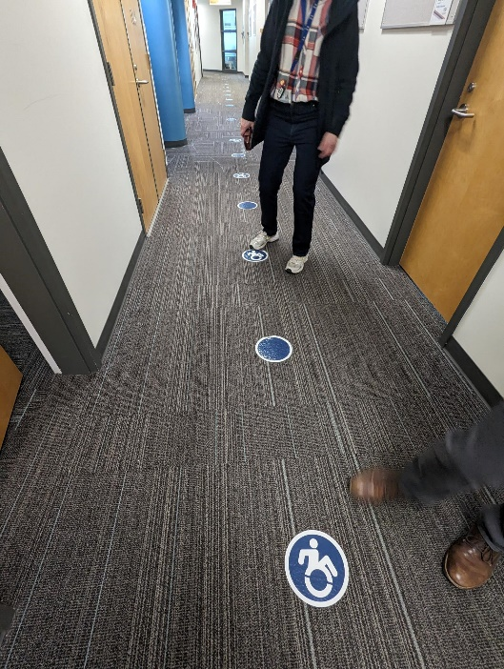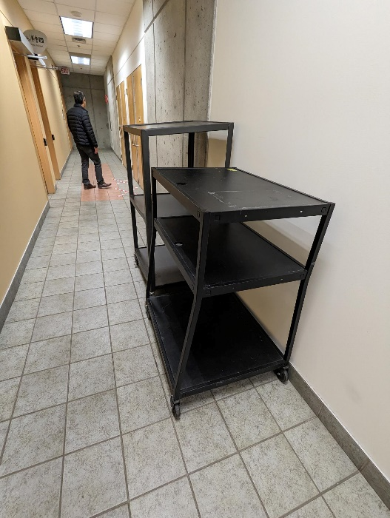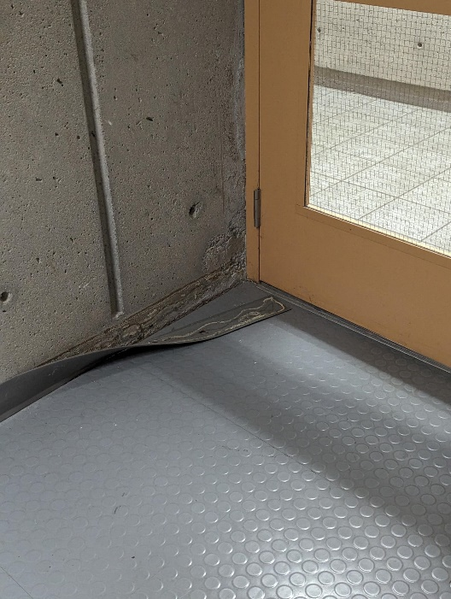

O.3 O.4
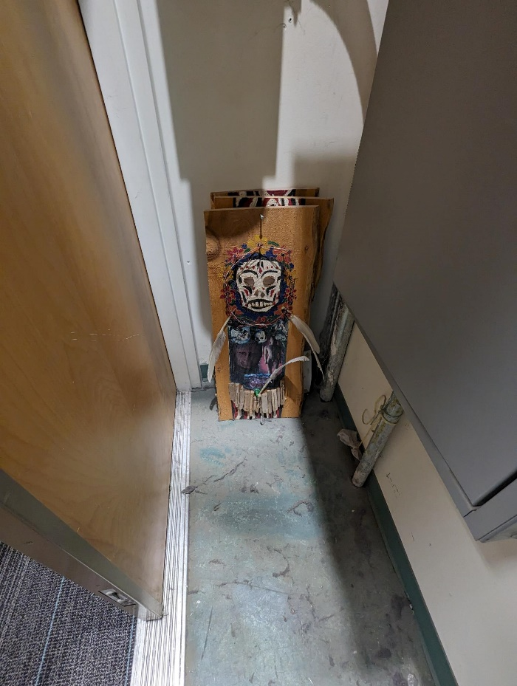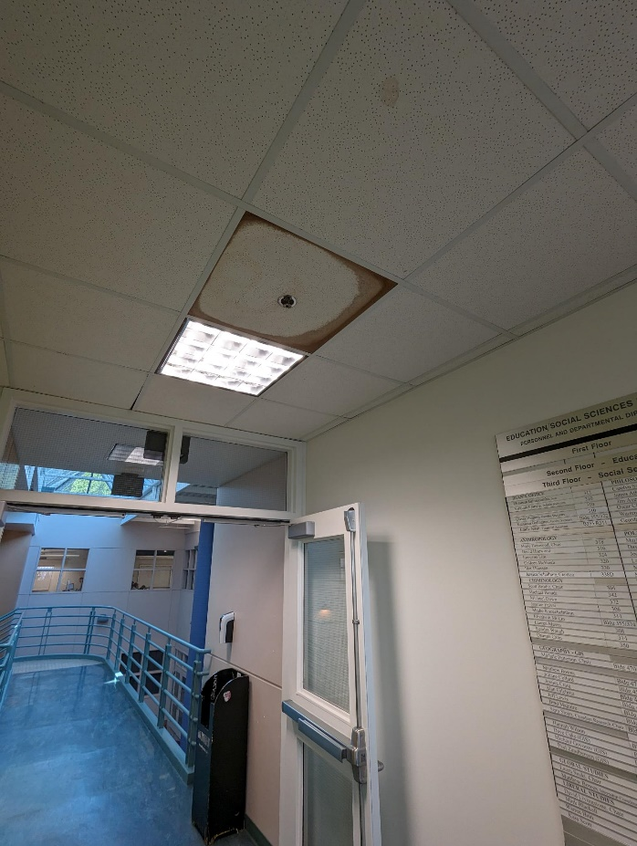

Building: 356 Date: March 19, 2024
Names of Inspectors: Kordell Bergen, Rob Okashimo, Jannine Grant

 | Yes | No | N/A
 | Around the Building
A.1 | Is the address sign or number easily visible? | X
A.2 | Is waste stored in appropriate waste or recycling storage areas? | X
A.3 | Is the property kept clear of litter, combustibles, hazardous materials, etc.? |  | X
A.4 | If present, are smoking areas clean? Is an appropriate cigarette butt receptacle available? |  | X
 | Parking Lot
B.1 | Are appropriate signs posted (e.g., no parking in fire routes, etc.)? | X
B.2 | Are the parking areas free from trip hazards (e.g., no pot holes, cracks, etc.)? | X
B.3 | Is the lighting adequate in the area and walkways at night? | X
B.4 | Is the parking lot kept free of debris? | X
B.5 | In winter, is the parking lot free from ice and snow? |  |  | X
 | Stairs
C.1 | Are stairs, stairwells, and landings kept clear and unobstructed? | X
C.2 | In winter, are stairs, stairwells, and landings kept clear from ice and snow? |  |  | X
C.3 | Are stairways adequately lit? | X
C.4 | Are stairs, treads, hand rails, and any guards secure and in good condition? | X
C.5 | Do treads and landings have non-skid surfaces and they are in good condition? | X
 | Exits / Fire Safety
D.1 | Are all emergency exits, exit doors, landings, and steps from the building well marked, unblocked, and kept in good condition? | X
D.2 | In winter, are exits kept free from ice and snow? |  |  | X
D.3 | In winter, is the roof area over the exits free of falling ice and snow hazards? |  |  | X
D.4 | Are exit doors, landings, and steps well lit? Are the lights over the exit doors working and in good repair? | X
D.5 | In winter, is the access ramp clear of ice and snow, and is there good traction? |  |  | X
D.6 | Can the building be easily accessed by the fire department? Are fire lanes accessible and posted? | X
D.7 | Are the fire department hose connections kept clear, accessible and have caps? | X
D.8 | Is the electrical service entrance area clear of trees and branches? | X
D.9 | Are all electrical wires out of reach of the public? | X
 | Grounds
E.1 | Are walkways clear and in good condition? Are there any holes or trip hazards on grounds where workers/public may walk? |  | X
E.2 | In winter, are ice and snow cleared promptly from walkways? |  |  | X
E.3 | Is security lighting functioning properly? | X
E.4 | Are exit routes (from the grounds) well marked, and kept clear and unobstructed? | X
E.5 | Is fencing in good condition? | X
E.6 | Is any outdoor machinery in good repair? | X
 | Storage Shed
F.1 | Are hazardous products adequately stored and labelled? |  |  | X
F.2 | Are incompatible materials stored separately? |  |  | X
F.3 | Is the shed or area secured and access limited? | X
F.4 | Is there any sign of leaks or spills? |  | X
F.5 | Are “No Smoking” signs posted when flammable products are stored? |  |  | X
F.6 | Is the storage area protected from exposure to heat, moisture, vibration, flame, etc. as appropriate for the products stored? | X
F.7 | Is equipment and machinery in good condition? | X
 | Miscellaneous
G.1 | Bike Racks | X
Corrective Action | Assigned To
A.3. Exterior garbages are overflowing. | Facility Services
A.4. Smoking area is overflowing with cigarette butts. | Facility Services
E.1. Dirt and rocks in front of 2nd floor entrance/exit. Tripping hazard. | Facility Services
G.1. The bike rack in the picture is broken at the base and no longer secured to the concrete. The second bike rack is not broken, but the anchors in the concrete have failed and the bike rack can be moved. | Facility Services

A.3 A.4 E.1
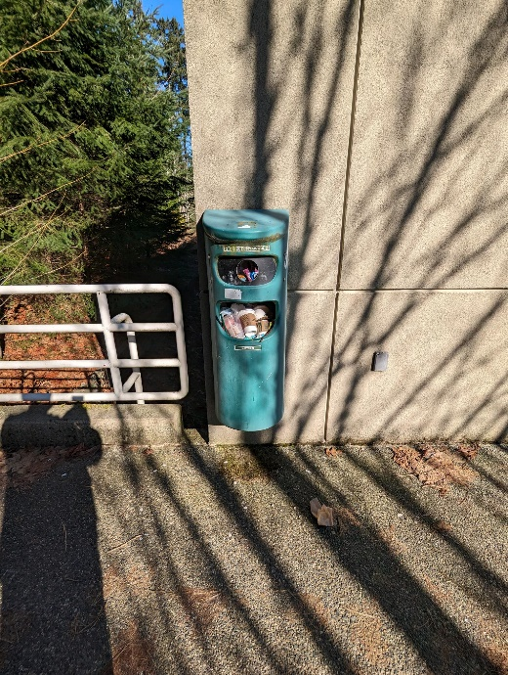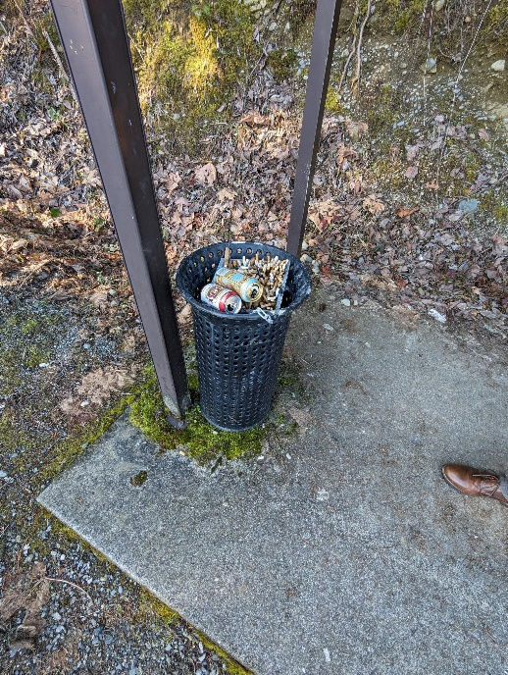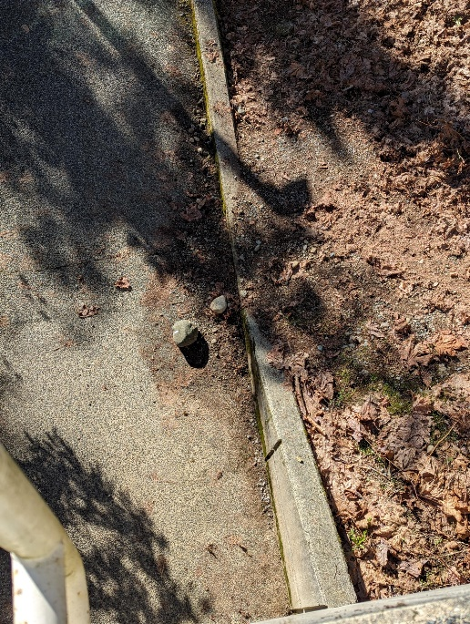

G.1
