Building: 190 Interior Date: March 4, 2025
Names of Inspectors: Kordell Bergen, Jannine Grant

 | Yes | No | N/A
Bulletin Boards and Signs

A.1 | Are they clean and readable? | X
A.2 | Is the material changed frequently? |  | X
A.3 | Do items interfere with people walking by? |  | X
Floors

B.1 | Is there loose material, debris, worn carpeting? |  | X
B.2 | Are the floors slippery, oily or wet? |  | X
B.3 | Tripping hazards on floor? | X
Stairways and Aisles

C.1 | Are they clear and unblocked? | X
C.2 | Are stairways well lighted? | X
C.3 | Are handrails, handholds in place? | X
C.4 | Are the aisles marked and visible? | X
Equipment

D.1 | Are guards, screens and sound-dampening devices in place and effective? |  |  | X
D.2 | Is the furniture in good repair and safe to use? Look for: | X
D.3 | - chairs that are in poor repair | X
D.4 | - sharp edges on desks and cabinets | X
D.5 | - poor ergonomics (keyboard elevation, chair adjustment, desk height) | X
D.6 | - crowding | X
D.7 | Are ladders well maintained and safe to use? |  |  | X
D.8 | Are bleachers in good condition, regular maintenance and service records available? |  | X
Emergency Equipment

E.1 | Is all fire control equipment regularly tested, certified and accessible? | X
E.2 | Is fire control equipment appropriate for the type of fire it must control? | X
E.3 | Is emergency lighting in place and regularly tested? | X
Building

F.1 | Do buildings conform to standards with respect to use, occupancy, building services, and plumbing facilities? | X
F.2 | Check the following structures to ensure safety: | -- | -- | --
F.3 | - swinging doors | X
F.4 | - floor and wall openings | X
F.5 | - ladders, stairways and accessibility ramps | X
F.6 | - guardrails | X
F.7 | Are materials stored safely? | X
Air Handling System

G.1 | Does air exchange rate meet standard requirements? | X
G.2 | Is the system free of sources of contamination (e.g., asbestos, microorganisms, dust, fumes)? | X
G.3 | Is humidity within recommended range? | X
Hazardous Products

H.1 | Are there any hazardous products (e.g., products regulated by WHMIS)? | X
H.2 | - If yes, are the products properly labelled? | X
H.3 | - If yes, is there a corresponding safety data sheet (SDS) for each product? | X
Sanitation

I.1 | Are washrooms and food preparation areas clean? | X
I.2 | Are the following provided adequately? | -- | -- | --
I.3 | - toilets | X
I.4 | - showers | X
I.5 | - potable (drinkable) water | X
I.6 | - clothing storage | X
I.7 | - change rooms | X
I.8 | - field accommodations | X
I.9 | - lunchrooms | X
I.10 | Are measures in place to prevent the spread of disease? | X
Security

J.1 | Do entry and exit procedures provide workers personal security at night? | X
J.2 | Are emergency (evacuation, fire, bomb threat, hostile person) procedures in place? | X
Lighting

K.1 | Are lamp reflectors clean? | X
K.2 | Are bulbs missing? |  | X
K.3 | Are any areas dark? | X
Material Storage

L.1 | Are materials neatly and safely piled? | X
L.2 | Are there stepladders or stools to get to materials on higher shelves? | X
L.3 | Are storage shelves overloaded or beyond their rated capacity? |  | X
L.4 | Are large and heavy objects stored on lower shelves? | X
L.5 | Are passageways and work areas clear of obstructions? | X
General

M.1 | Are extension cords used extensively? (if so, consider installing permanent wiring) |  | X
M.2 | Are electrical or telephone cords exposed in areas where employees may become entangled? |  | X
M.3 | Is electrical wiring properly installed? | X
M.4 | Are machines properly guarded? |  |  | X
M.5 | Does any equipment have sharp metal projections? |  |  | X
M.6 | Are wall and ceiling fixtures fastened securely? | X
M.7 | Is paper and waste properly disposed of? | X
M.8 | Are desk and file drawers kept closed when not in use? | X
M.9 | Are office accessories stored appropriately? | X
M.10 | Are materials stacked on desks or cabinets? | X
M.11 | Are file cabinet drawers overloaded? |  | X
M.12 | Are file cabinets loaded with the heaviest items in the bottom drawers? |  | X
M.13 | Are shelves securely fastened to the wall when necessary? | X
M.14 | Are filing stools or wastebaskets placed where they might be tripping hazards? |  | X
Miscellaneous

N.1 | Bleach stored on top shelf | X
N.2 | Emergency exit (main door) | X
N.3 | Wall coverings | X
N.4 | Fire pit, top shelf | X
N.5 | Electrical Panel | X
Corrective Action | Assigned To
A.2. Expired content on bulletin board. | Athletics and Recreation
B.3. The transition from the hallway to the ‘squat room’ is a tripping hazard. Can the wooden floor be cut back, and a ramp installed? If a ramp is not feasible, can reflective tape or paint be added to the metal edge to draw attention to the height difference? | Facility Services
D.8. The bleachers are in poor condition, full replacement is recommended. | Athletic and Recreation
G.1. Employee reports experiencing inconsistent heating / cooling in different areas of the building since the installation of the new HVAC system. | Athletic and Recreation
N.1. Full bleach jugs are being stored on the top shelf in the back room. Please store these jugs on the floor. | Athletic and Recreation
N.2. The automatic door function does not work on the main entrance. | Facility Services
N.3. Two of the fixture covers are broken in the weight room. Please replace, may cause an electrocution hazard. | Facility Services
N.4. A propane fire pit is being stored on a top shelf in the back room. Please store this item on the floor. | Athletic and Recreation
N.5. The electrical panel in the hallway beside the weightroom is being held closed with tape. This panel should be locked. | Facility Services

B.3 N.1 N.3
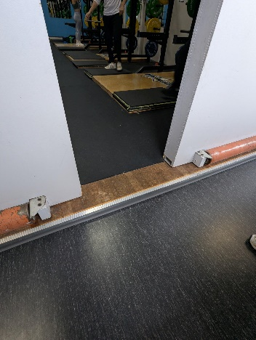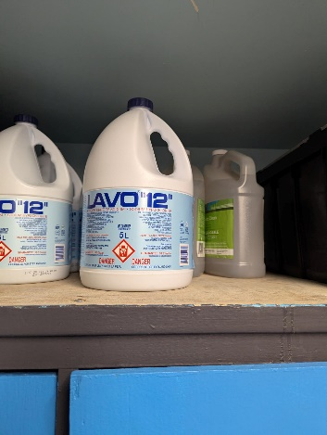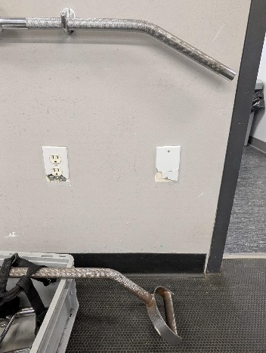
N.4 N.5
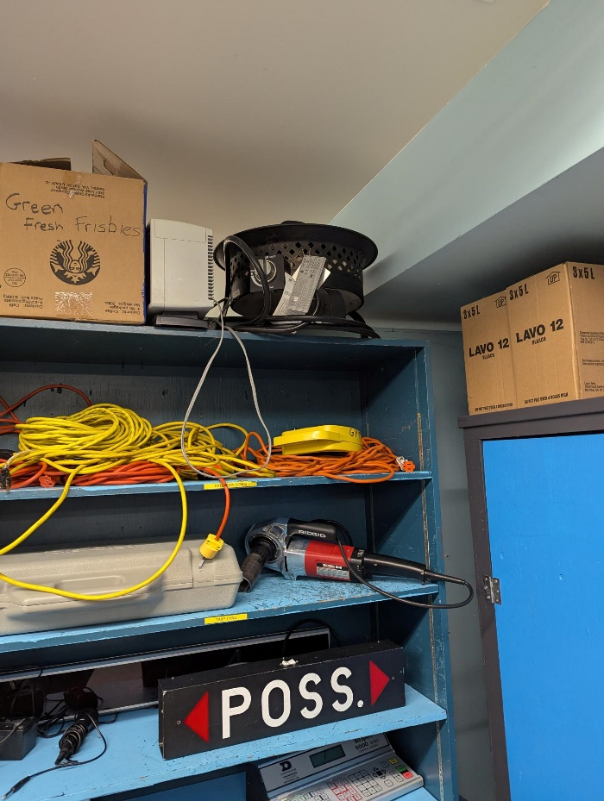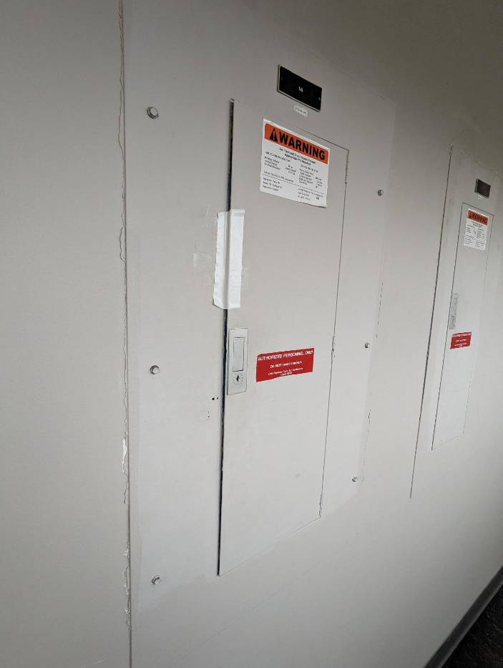

Building: 190 Exterior Date: March 4, 2025
Names of Inspectors: Kordell Bergen, Jannine Grant

 | Yes | No | N/A
 | Around the Building
A.1 | Is the address sign or number easily visible? | X
A.2 | Is waste stored in appropriate waste or recycling storage areas? | X
A.3 | Is the property kept clear of litter, combustibles, hazardous materials, etc.? |  | X
A.4 | If present, are smoking areas clean? Is an appropriate cigarette butt receptacle available? |  |  | X
 | Parking Lot
B.1 | Are appropriate signs posted (e.g., no parking in fire routes, etc.)? | X
B.2 | Are the parking areas free from trip hazards (e.g., no pot holes, cracks, etc.)? | X
B.3 | Is the lighting adequate in the area and walkways at night? | X
B.4 | Is the parking lot kept free of debris? | X
B.5 | In winter, is the parking lot free from ice and snow? |  |  | X
 | Stairs
C.1 | Are stairs, stairwells, and landings kept clear and unobstructed? | X
C.2 | In winter, are stairs, stairwells, and landings kept clear from ice and snow? | X
C.3 | Are stairways adequately lit? | X
C.4 | Are stairs, treads, hand rails, and any guards secure and in good condition? | X
C.5 | Do treads and landings have non-skid surfaces and they are in good condition? | X
 | Exits / Fire Safety
D.1 | Are all emergency exits, exit doors, landings, and steps from the building well marked, unblocked, and kept in good condition? | X
D.2 | In winter, are exits kept free from ice and snow? |  |  | X
D.3 | In winter, is the roof area over the exits free of falling ice and snow hazards? | X
D.4 | Are exit doors, landings, and steps well lit? Are the lights over the exit doors working and in good repair? | X
D.5 | In winter, is the access ramp clear of ice and snow, and is there good traction? | X
D.6 | Can the building be easily accessed by the fire department? Are fire lanes accessible and posted? | X
D.7 | Are the fire department hose connections kept clear, accessible and have caps? | X
D.8 | Is the electrical service entrance area clear of trees and branches? | X
D.9 | Are all electrical wires out of reach of the public? | X
 | Grounds
E.1 | Are walkways clear and in good condition? Are there any holes or trip hazards on grounds where workers/public may walk? | X
E.2 | In winter, are ice and snow cleared promptly from walkways? |  |  | X
E.3 | Is security lighting functioning properly? | X
E.4 | Are exit routes (from the grounds) well marked, and kept clear and unobstructed? | X
E.5 | Is fencing in good condition? | X
E.6 | Is any outdoor machinery in good repair? |  |  | X
 | Storage Shed
F.1 | Are hazardous products adequately stored and labelled? |  |  | X
F.2 | Are incompatible materials stored separately? |  |  | X
F.3 | Is the shed or area secured and access limited? |  |  | X
F.4 | Is there any sign of leaks or spills? |  |  | X
F.5 | Are “No Smoking” signs posted when flammable products are stored? |  |  | X
F.6 | Is the storage area protected from exposure to heat, moisture, vibration, flame, etc. as appropriate for the products stored? |  |  | X
F.7 | Is equipment and machinery in good condition? |  |  | X
 | Loading Areas
G.1 | If required, are pedestrian walkways clearly marked? |  |  | X
G.2 | Are vehicles and/or loads secured from accidental movement? |  |  | X
G.3 | Is the area kept free of obstructions or debris? |  |  | X
G.4 | Are any lifting devices, racking systems, etc. in good condition? |  |  | X
G.5 | If required, are machine guards in place? |  |  | X
 | Miscellaneous
H.1 | Bird Holes | X
H.2 | South wall (blue wall) | X
Corrective Action | Assigned To
A.3. Debris located at east emergency exit.  An old light pole is laying against the east wall.  H.1. New bird hole in the north wall. | Facility Services / Athletic and Recreation  Facility Services
H.2. A piece of the blue wall needs to be repaired. | Facility Services

A.3 A.3 H.1
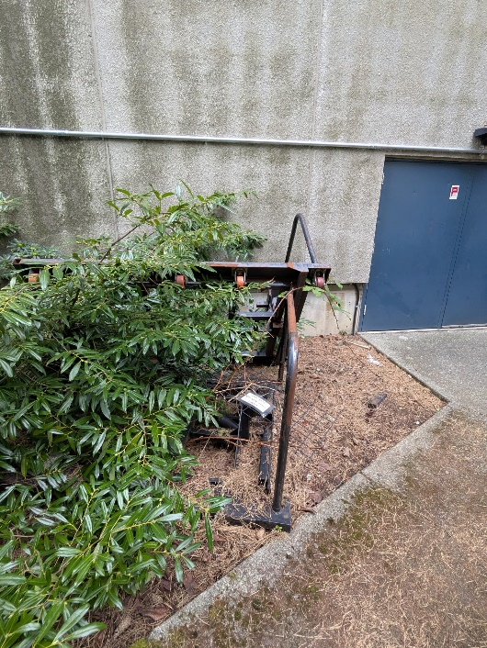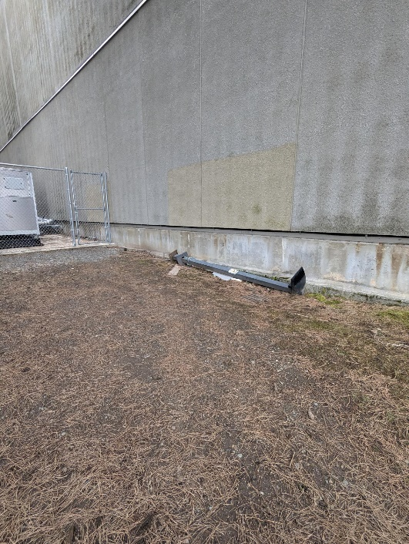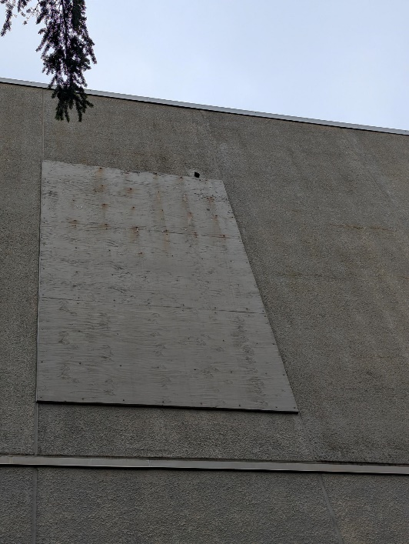

H.2
