Building: Milner House Date: November 6, 2024
Names of Inspectors: Kordell Bergen, Kim Sharpe, Ashley Faulkner, Derek Mann, Mathews Tharakan, Geoff Ball, Emily Weeks

 | Yes | No | N/A
 | Bulletin Boards and Signs
A.1 | Are they clean and readable? | X
A.2 | Is the material changed frequently? | X
A.3 | Do items interfere with people walking by? |  | X
 | Floors
B.1 | Is there loose material, debris, worn carpeting? |  | X
B.2 | Are the floors slippery, oily or wet? |  | X
 | Stairways and Aisles
C.1 | Are they clear and unblocked? | X
C.2 | Are stairways well lighted? |  |  | X
C.3 | Are handrails, handholds in place? |  |  | X
C.4 | Are the aisles marked and visible? |  |  | X
 | Equipment
D.1 | Are guards, screens and sound-dampening devices in place and effective? |  |  | X
D.2 | Is the furniture in good repair and safe to use? Look for:
D.3 | - chairs that are in poor repair |  | X
D.4 | - sharp edges on desks and cabinets |  | X
D.5 | - poor ergonomics (keyboard elevation, chair adjustment, desk height) |  | X
D.6 | - crowding | X
D.7 | Are ladders well-maintained and safe to use? |  |  | X
 | Emergency Equipment
E.1 | Is all fire control equipment regularly tested and certified? | X
E.2 | Is fire control equipment appropriate for the type of fire it must control? | X
E.3 | Are sprinkler heads guarded? Obstructed? |  |  | X
E.4 | Is emergency lighting in place and regularly tested? | X
 | Building
F.1 | Do buildings conform to standards with respect to use, occupancy, building services, and plumbing facilities? | X
F.2 | Check the following structures to ensure safety:
F.3 | - swinging doors | X
F.4 | - floor and wall openings | X
F.5 | - ladders, stairways and ramps | X
F.6 | - guardrails | X
F.7 | Are materials stored safely? | X
 | Air Handling System
G.1 | Does air exchange rate meet standard requirements? |  |  | X
G.2 | Is the system free of sources of contamination (e.g., asbestos, microorganisms, dust, fumes)? |  |  | X
G.3 | Is humidity within recommended range? | X
 | Hazardous Products
H.1 | Are there any hazardous products (e.g., products regulated by WHMIS)? | X
H.2 | - If yes, are the products properly labelled? | X
H.3 | - If yes, is there a corresponding safety data sheet (SDS) for each product? | X
H.4 | - If yes, are workers trained in how to work with or near these products safely? | X
 | Sanitation
I.1 | Are washrooms and food preparation areas clean? | X
I.2 | Are the following provided adequately?
I.3 | - toilets | X
I.4 | - showers | X
I.5 | - potable (drinkable) water | X
I.6 | - clothing storage | X
I.7 | - change rooms | X
I.8 | - field accommodations | X
I.9 | - lunchrooms | X
I.10 | Are measures in place to prevent the spread of disease? | X
 | Security
J.1 | Do entry and exit procedures provide workers personal security at night? |  |  | X
J.2 | Are emergency (evacuation, fire, bomb threat, hostile person) procedures in place? | X
 | Lighting
K.1 | Are lamp reflectors clean? | X
K.2 | Are bulbs missing? | X
K.3 | Are any areas dark? | X
 | Material Storage
L.1 | Are materials neatly and safely piled? | X
L.2 | Are there stepladders or stools to get to materials on higher shelves? |  |  | X
L.3 | Are storage shelves overloaded or beyond their rated capacity? |  | X
L.4 | Are large and heavy objects stored on lower shelves? | X
L.5 | Are passageways and work areas clear of obstructions? | X
 | General
M.1 | Are extension cords used extensively? (if so, consider installing permanent wiring) |  | X
M.2 | Are electrical or telephone cords exposed in areas where employees may become entangled? |  | X
M.3 | Is electrical wiring properly installed? | X
M.4 | Are machines properly guarded? | X
M.5 | Does any equipment have sharp metal projections? |  | X
M.6 | Are wall and ceiling fixtures fastened securely? | X
M.7 | Are paper and waste properly disposed of? | X
M.8 | Are desk and file drawers kept closed when not in use? | X
M.9 | Are office accessories stored appropriately? | X
M.10 | Are materials stacked on desks or cabinets? | X
M.11 | Are file cabinet drawers overloaded? |  | X
M.12 | Are file cabinets loaded with the heaviest items in the bottom drawers? | X
M.13 | Are filing stools or wastebaskets placed where they might be tripping hazards?
 | Miscellaneous
N.1 | Eye wash station | X
N.2 | Escape routes and muster points signed | X
N.3 | Door paint | X
N.4 | Bathroom light | X
Corrective Action | Assigned To
D.6. Understanding that the main building is 100 years old, the kitchen area is very crowded. Is there a possibility of expanding the kitchen space into one of the adjacent rooms? | Geoff Ball
F.4. The floor in the attic office in the northeast is badly deteriorated. | Geoff Ball
H.3. Are SDS records available for chemicals used inside the main house? | Geoff Ball
H.4. Are training / orientation records available for workers and volunteers? | Geoff Ball
K.2. One of the blubs in the attic is burnt out. | Geoff Ball
L.5. One of the exit doors is blocked (I do not remember which one). Please move items so that the door is usable. | Geoff Ball
M.10. Items stacked on prep room tables. Is there a dedicated storage area available for these items? Concerns were raised over the number of supplies stacked in this space during busy season use (MSI, falling objects). | Geoff Ball
N.1. Are there eyewash supplies available for kitchen staff? | Geoff Ball
N.2. Does Milner have designated muster points on site? | Geoff Ball
N.3. The paint on the door to the men’s washroom on the ground floor is peeling. Does this paint contain lead? | Geoff Ball
N.4. The light in the men’s washroom on the ground floor of the main house is flickering quite badly. | Geoff Ball

F.4 K.2 L.5
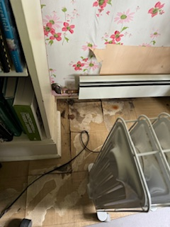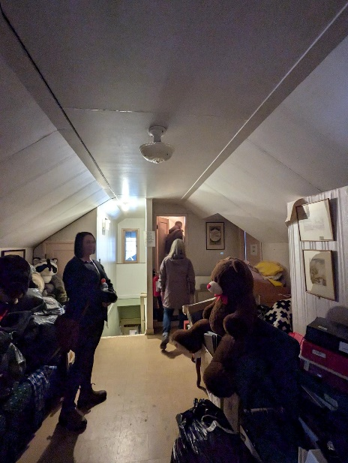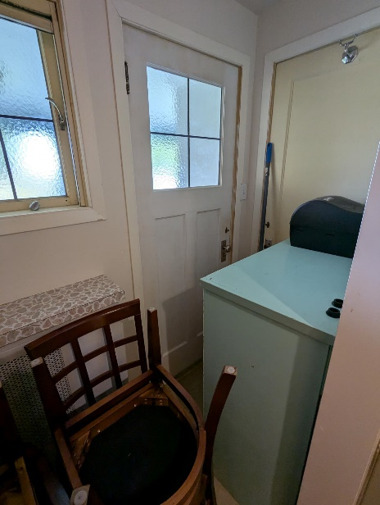

M.10 N.3
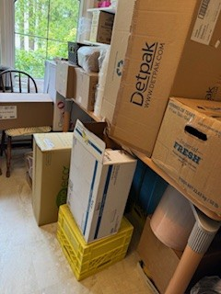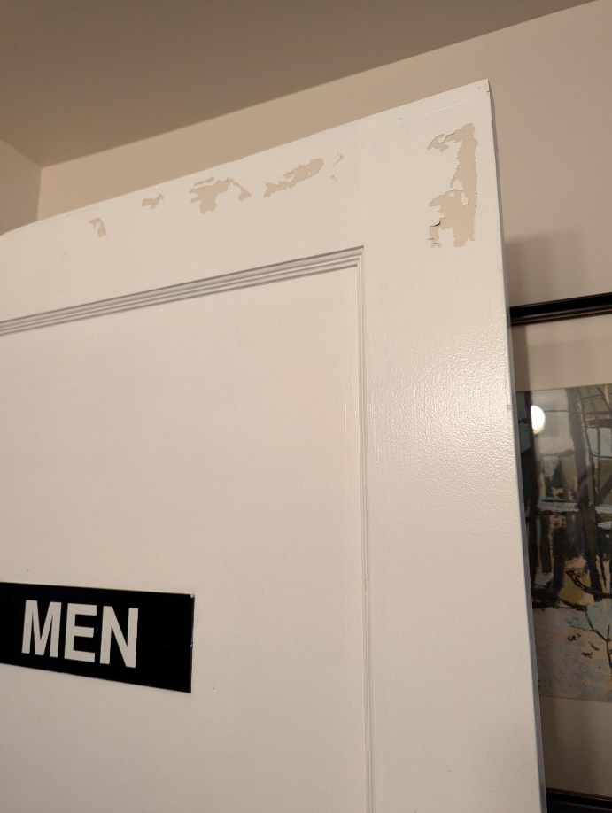

Building: Milner Gardens Date: November 6, 2024
Names of Inspectors: Kordell Bergen, Kim Sharpe, Ashley Faulkner, Derek Mann, Mathews Tharakan, Geoff Ball, Emily Weeks

 | Yes | No | N/A
 |  | Around the Building
 | A.1 | Is the address sign or number easily visible? | X
 | A.2 | Is waste stored in appropriate waste or recycling storage areas? | X
 | A.3 | Is the property kept clear of litter, combustibles, hazardous materials, etc.? | X
 | A.4 | If present, are smoking areas clean? Is an appropriate cigarette butt receptacle available? | X
 |  | Parking Lot
 | B.1 | Are appropriate signs posted (e.g., no parking in fire routes, etc.)? | X
 | B.2 | Are the parking areas free from trip hazards (e.g., no pot holes, cracks, etc.)? | X
 | B.3 | Is the lighting adequate in the area and walkways at night? |  |  | X
 | B.4 | Is the parking lot kept free of debris? | X
 | B.5 | In winter, is the parking lot free from ice and snow? | X
 |  | Stairs
 | C.1 | Are stairs, stairwells, and landings kept clear and unobstructed? | X
 | C.2 | In winter, are stairs, stairwells, and landings kept clear from ice and snow? |  |  | X
 | C.3 | Are stairways adequately lit? | X
 | C.4 | Are stairs, treads, hand rails, and any guards secure and in good condition? | X
 | C.5 | Do treads and landings have non-skid surfaces and are they in good condition? | X
 |  | Exits / Fire Safety
 | D.1 | Are all emergency exits, exit doors, landings, and steps from the building well marked, unblocked, and kept in good condition? | X
 | D.2 | In winter, are exits kept free from ice and snow? |  |  | X
 | D.3 | In winter, is the roof area over the exits free of falling ice and snow hazards? |  |  | X
 | D.4 | Are exit doors, landings, and steps well lit? Are the lights over the exit doors working and in good repair? | X
 | D.5 | In winter, is the access ramp clear of ice and snow, and is there good traction? |  |  | X
 | D.6 | Can the building be easily accessed by the fire department? Are fire lanes accessible and posted? | X
 | D.7 | Are the fire department hose connections kept clear, accessible and have caps? |  |  | X
 | D.8 | Is the electrical service entrance area clear of trees and branches? |  |  | X
 | D.9 | Are all electrical wires out of reach of the public? | X
 | D.10 | Are sprinkler heads guarded? Obstructed? |  |  | X
 | D.11 | Are extension cords in good condition? Being used excessively? | X
 |  | Grounds
 | E.1 | Are walkways clear and in good condition? Are there any holes or trip hazards on grounds where workers/public may walk? | X
 | E.2 | In winter, are ice and snow cleared promptly from walkways? |  |  | X
 | E.3 | Is security lighting functioning properly? |  |  | X
 | E.4 | Are exit routes (from the grounds) well marked, and kept clear and unobstructed? | X
 | E.5 | Is fencing in good condition? | X
 | E.6 | Is outdoor machinery in good condition? | X
 | E.7 | Are signs present and legible? |  | X
 |  | Tools and Equipment
F.1 |  | Maintenance log up-to-date | X
F.2 |  | Inspection log up-to-date | X
F.3 |  | Lockout procedures posted |  |  | X
F.4 |  | Equipment positioned to avoid endangering other workers | X
F.5 |  | Defective tools and equipment tagged and removed from service | X
F.6 |  | PPE is available as required for all workers | X
 |  | Ladders
G.1 |  | Ladders are appropriate for the work tasks | X
G.2 |  | Ladders are in good condition with no obvious signs of wear and tear | X
 |  | Work practices – general
H.1 |  | Workers trained for specific work tasks | X
H.2 |  | Workers supervised for work tasks | X
H.3 |  | Tools used for their designed purposes only | X
 |  | Personal protective equipment (PPE)
I.1 |  | Workers are trained in correct PPE use | X
I.2 |  | Used consistently and correctly | X
I.3 |  | Maintained in good working order | X
I.4 |  | Inspected and replaced on schedule | X
 |  | Storage Shed
 | J.1 | Are hazardous products adequately stored and labelled? |  | X
 | J.2 | Are incompatible materials stored separately? | X
 | J.3 | Is the shed or area secured and access limited? | X
 | J.4 | Is there any sign of leaks or spills? |  | X
 | J.5 | Are “No Smoking” signs posted when flammable products are stored? |  | X
 | J.6 | Is the storage area protected from exposure to heat, moisture, vibration, flame, etc. as appropriate for the products stored? | X
 | J.7 | Is equipment and machinery in good condition? | X
 | J.8 | SDS is available and less than three years old? | X
 |  | Miscellaneous
 | K.1 | Eye wash stations | X
 | K.2 | Muster Points | X
Corrective Action | Assigned To
A.4. This was not discussed during the inspection, is smoking allowed on the premises? If so, are designated smoking areas provided? Cigarette butt receptacles? | Geoff Ball
D.6. This was not discussed during the inspection, are full-size fire trucks able to access the structures on site? Is there a fire response plan for the grounds? | Geoff Ball
D.9. Some extension cords on site were running between trees, above paths, quite low. Geoff shared that these cords are temporary. | N/A
D.11. The power bars in the ‘Christmas Light Shed’ appear overloaded. Please remove some cords, or reroute additional power sources. | Geoff Ball
E.7. The warning sign for the water feature is blocked by a bush. Please trim it back so the sign is visible. | Geoff Ball
F1 & 2. Are maintenance and inspection logs available for tools used on the grounds? | Geoff Ball
F.6. Is PPE available for workers and volunteers? Gloves, safety glasses, Steel toe work boots? | Geoff Ball
G1 & 2. We did not see any ladders during the inspection, but I assume they must be used on the grounds. | Geoff Ball
H.1. Do volunteers receive an orientation? Are records of the orientation kept? | Geoff Ball
J.1. Flammable fuels on the grounds should be stored in a vented, metal cabinet, labeled to notify users of the occupants. | Geoff Ball
J.2 & 8. There is a storage rack in the tool shed with paint, stains, and solvents. Are all these items properly labeled? Compatible? Are SDS available for all the products? | Geoff Ball
J.5. “No Smoking” signs should be posted next to the fuel cabinet. | Geoff Ball
K.1. Are portable eye wash options available for grounds crew/volunteers? | Geoff Ball
K.2. Does Milner have designated muster points on site? | Geoff Ball

D.11 D.11 E.7
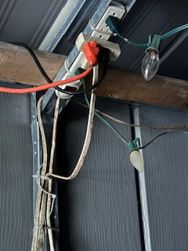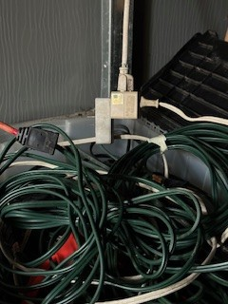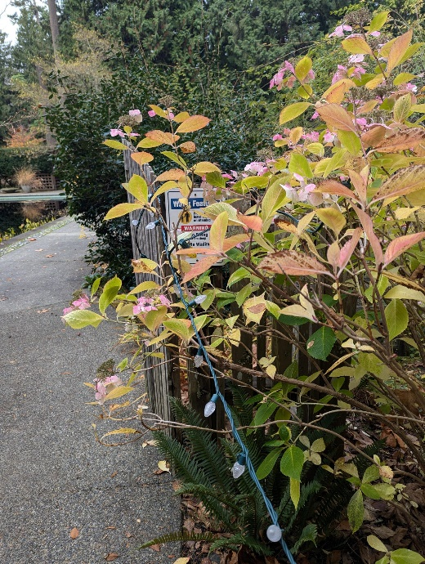

J.1 J.2 & 8
