Building: 120 Date: October 15, 2024
Names of Inspectors: Kordell Bergen, Rob Okashimo, Erin Bascom

 | Yes | No | N/A
 | Bulletin Boards and Signs
A.1 | Are they clean and readable? | X
A.2 | Is the material changed frequently? | X
A.3 | Do items interfere with people walking by? |  | X
 | Floors
B.1 | Is there loose material, debris, worn carpeting? |  | X
B.2 | Are the floors slippery, oily or wet? |  | X
 | Stairways and Aisles
C.1 | Are they clear and unblocked? | X
C.2 | Are stairways well lighted? | X
C.3 | Are handrails, handholds in place? | X
C.4 | Are the aisles marked and visible? |  |  | X
 | Equipment
D.1 | Are guards, screens and sound-dampening devices in place and effective? | X
D.2 | Is the furniture in good repair and safe to use? Look for:
D.3 | - chairs that are in poor repair |  | X
D.4 | - sharp edges on desks and cabinets |  | X
D.5 | - poor ergonomics (keyboard elevation, chair adjustment, desk height) |  | X
D.6 | - crowding |  | X
D.7 | Are ladders well maintained and safe to use? | X
 | Emergency Equipment
E.1 | Is all fire control equipment regularly tested and certified? | X
E.2 | Is fire control equipment appropriate for the type of fire it must control? | X
E.3 | Is emergency lighting in place and regularly tested? | X
 | Building
F.1 | Do buildings conform to standards with respect to use, occupancy, building services, and plumbing facilities? | X
F.2 | Check the following structures to ensure safety:
F.3 | - swinging doors | X
F.4 | - floor and wall openings | X
F.5 | - ladders, stairways and ramps | X
F.6 | - guardrails | X
F.7 | Are materials stored safely? | X
 | Air Handling System
G.1 | Does air exchange rate meet standard requirements? |  |  | X
G.2 | Is the system free of sources of contamination (e.g., asbestos, microorganisms, dust, fumes)? |  |  | X
G.3 | Is humidity within recommended range? |  |  | X
 | Hazardous Products
H.1 | Are there any hazardous products (e.g., products regulated by WHMIS)? | X
H.2 | - If yes, are the products properly labelled? | X
H.3 | - If yes, is there a corresponding safety data sheet (SDS) for each product? |  |  | X
H.4 | - If yes, are workers trained in how to work with or near these products safely? |  |  | X
 | Sanitation
I.1 | Are washrooms and food preparation areas clean? | X
I.2 | Are the following provided adequately?
I.3 | - toilets | X
I.4 | - showers |  |  | X
I.5 | - potable (drinkable) water | X
I.6 | - clothing storage | X
I.7 | - change rooms | X
I.8 | - field accommodations | X
I.9 | - lunchrooms | X
I.10 | Are measures in place to prevent the spread of disease? | X
 | Security
J.1 | Do entry and exit procedures provide workers personal security at night? | x
J.2 | Are emergency (evacuation, fire, bomb threat, hostile person) procedures in place? | X
 | Lighting
K.1 | Are lamp reflectors clean? | X
K.2 | Are bulbs missing? |  | X
K.3 | Are any areas dark? |  | X
 | Material Storage
L.1 | Are materials neatly and safely piled? | X
L.2 | Are there stepladders or stools to get to materials on higher shelves? |  |  | X
L.3 | Are storage shelves overloaded or beyond their rated capacity? |  | X
L.4 | Are large and heavy objects stored on lower shelves? | X
L.5 | Are passageways and work areas clear of obstructions? | X
 | General
M.1 | Are extension cords used extensively? (if so, consider installing permanent wiring) |  | X
M.2 | Are electrical or telephone cords exposed in areas where employees may become entangled? |  | X
M.3 | Is electrical wiring properly installed? | X
M.4 | Are machines properly guarded? | X
M.5 | Does any equipment have sharp metal projections? |  | X
M.6 | Are wall and ceiling fixtures fastened securely? | X
M.7 | Are paper and waste properly disposed of? | X
M.8 | Are desk and file drawers kept closed when not in use? | X
M.9 | Are office accessories stored appropriately? | X
M.10 | Are materials stacked on desks or cabinets? |  | X
M.11 | Are file cabinet drawers overloaded? |  | X
M.12 | Are file cabinets loaded with the heaviest items in the bottom drawers? | X
M.13 | Are shelves securely fastened to the wall when necessary? |  |  | X
M.14 | Are filing stools or wastebaskets placed where they might be tripping hazards? |  | X
Corrective Action | Assigned To
No corrective actions needed.

Building: 120 Date: October 15, 2024
Names of Inspectors: Kordell Bergen, Rob Okashimo, Erin Bascom

 | Yes | No | N/A
 | Emergency and Hazard Information
A.1 | Emergency phone numbers posted? Are phones available? | X
A.2 | Are exits clearly marked and accessible? | X
A.3 | Are evacuation maps posted? | X
A.4 | Are emergency evacuation drills conducted at least annually? | X
A.5 | Are first aid attendants available with kits fully stocked and inspected? | X
A.6 | Are Level 1 Attendant’s qualifications current? |  |  | X
A.7 | Do students know where and how to receive care for an injury |  |  | X
A.8 | Are signs present for emergency safety equipment (eyewash, exits etc.)? | X
A.9 | Are appropriate fire extinguishers available and inspected regularly? | X
A.10 | Are flammable materials stored in a flammable storage cabinet? | X
A.11 | Chemical inventories up to date |  |  | X
A.12 | MSDS sheets available and current |  |  | X
 | Floors
B.1 | Is there loose material, debris, worn carpeting? |  | X
B.2 | Are the floors slippery, oily or wet? |  | X
 | Stairways and Aisles
C.1 | Are they clear and unblocked? | X
C.2 | Are stairways well lighted? |  |  | X
C.3 | Are handrails, handholds in place? |  |  | X
C.4 | Are the aisles marked and visible? |  |  | X
 | Safety Administration
D.1 | Have all students received general orientation and safety training e.g. MSDS, PPE, evacuations, etc.? |  |  | X
D.2 | Have all students been trained on the equipment that they operate? |  |  | X
D.3 | Have students received other specialized training: Lockout/Tagout, Respirators, Tools (hand/power), PPE, ect |  |  | X
D.4 | Is orientation/safety training documented? |  |  | X
D.5 | Do students have access to the orientation information? |  |  | X
D.6 | Are regularly scheduled safety meetings conducted in the shop? |  |  | X
D.7 | Has a hazard assessment been done in order to select appropriate PPE? |  |  | X
D.8 | Is PPE provided and used whenever necessary? |  |  | X
D.9 | Are there chemicals or controlled substances in the shop? Is WHMIS training provided? Are SDS’s available? |  |  | X
 | Housekeeping, Ventilation, Illumination
E.1 | Are all work areas clean and orderly? | X
E.2 | Are waste containers kept clean and emptied daily? | X
E.3 | Is food kept in the designated area at all times? | X
E.4 | Are all cabinets and shelves secured or anchored? | X
E.5 | Are all machines/equipment secured or anchored? | X
E.6 | Are floors in good condition and kept dry? | X
E.7 | Are all light fixtures adequate and functioning properly? | X
E.8 | Dust extractors in good working order |  |  | X
E.9 | Exhaust fans functioning |  |  | X
E.10 | “No Eating/Drinking/Smoking” signs posted | X
 | Electrical Safety/Portable Tools
F.1 | Are all plugs, cords, and panels enclosed, and in good condition? | X
F.2 | Do all extension cords have grounding? | X
F.3 | Are extension cords used only temporarily? | X
F.4 | Are cords secured so they do not run across pathways, under doors or the walls? | X
F.5 | Is the breaker panel locked? |  |  | X
F.6 | Are ground fault circuit interrupters available for use in wet areas? |  |  | X
F.7 | Are hand-tools effectively grounded or Double insulated? | X
F.8 | Are hand/power tools inspected regularly? |  |  | X
 | Mechanical Safety
G.1 | Is defective equipment promptly reported, labeled, and replaced? |  |  | X
G.2 | Can equipment be locked out? |  |  | X
G.3 | Safeguards prevent workers’ hands, arms and other body parts from making contact with dangerous moving parts | X
G.4 | Safeguards have not been tampered with, altered or removed |  |  | X
G.5 | Powered machinery/equipment has start and stop controls located within easy reach of the operator has controls and switches whose functions are clearly identified |  |  | X
G.6 | Are machines regularly cleaned and maintained? |  |  | X
G.7 | Are maintenance records, calibrations, certifications of each machine kept on file? |  |  | X
G.8 | Do authorized people perform the repairs? |  |  | X
G.9 | Physical hazards are marked in a manner that clearly identifies the hazard | X
 | Spill Response
H.1 | Do personnel know the location of the closest First Aid Kit? | X
H.2 | Do personnel know the location of the closet Spill Kit? |  |  | X
H.3 | Are personnel familiar with Vancouver Island Universities Spill Procedures? |  |  | X
 | WHMIS
I.1 | Have all personnel received WHMIS training? |  |  | X
I.2 | Are all hazardous materials labeled according to the WHMIS Regulations? |  |  | X
I.3 | Is there a current inventory of all hazardous substances in the area? |  |  | X
I.4 | Do personnel know where to find current (<3 years) SDS for the materials being used? |  |  | X
 | Emergency Eyewash/Showers
J.1 | Are personnel familiar with the location of the nearest eyewash / shower? |  |  | X
J.2 | Is the eyewash station / shower clean and clear of debris? | X
J.3 | Have emergency shower(s) been tested in the last 12 months and have a tag indicating testing date? |  |  | X
 | Lighting
K.1 | Are lamp reflectors clean? | X
K.2 | Are bulbs missing? |  | X
K.3 | Are any areas dark? |  | X
 | Material Storage
L.1 | Are materials neatly and safely piled? | X
L.2 | Are there stepladders or stools to get to materials on higher shelves? |  |  | X
L.3 | Are storage shelves overloaded or beyond their rated capacity? |  | X
L.4 | Are large and heavy objects stored on lower shelves? | X
L.5 | Are passageways and work areas clear of obstructions? | X
 | General
M.1 | Is electrical wiring properly installed? | X
M.2 | Does any equipment have sharp metal projections? |  | X
M.3 | Are wall and ceiling fixtures fastened securely? | X
M.4 | Are paper and waste properly disposed of? | X
M.5 | Are desk and file drawers kept closed when not in use? | X
M.6 | Are office accessories stored appropriately? | X
M.7 | Are materials stacked on desks or cabinets? |  | X
M.8 | Are file cabinet drawers overloaded? |  | X
M.9 | Are file cabinets loaded with the heaviest items in the bottom drawers? | X
M.10 | Are shelves securely fastened to the wall when necessary? |  |  | X
Corrective Action | Assigned To
E.9. Are the exhaust fans functional in the painting room? Are the filters changed on a regular basis? The filters along the north wall appear to be very old and dusty (E.9.1). | Facility Services
J.2. Eyewash locations must be tested monthly. Please adjust and document your testing schedule to meet the compliance requirements.  https://www.worksafebc.com/en/law-policy/occupational-health-safety/searchable-ohs-regulation/ohs-regulation/part-05-chemical-and-biological-substances#SectionNumber:5.93 | Facility Services
Notes on deficiencies / other comments
E.9 E.9.1
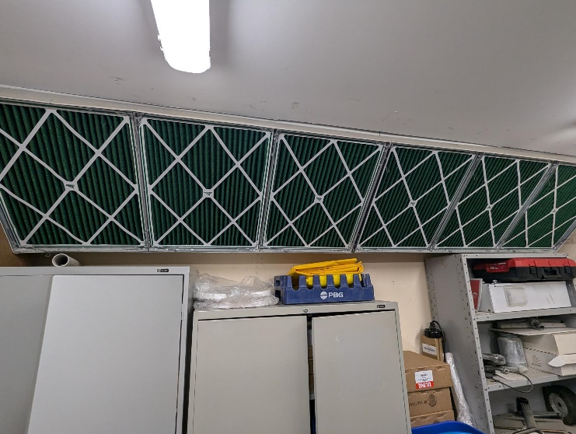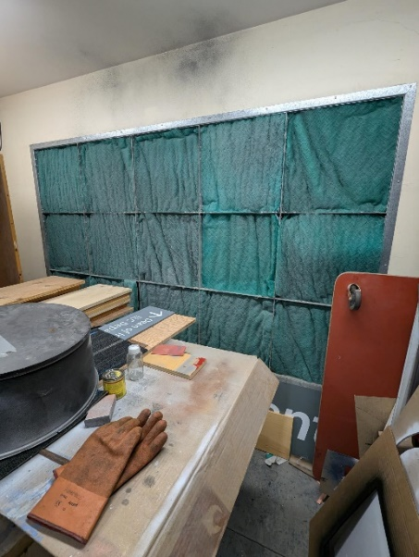
Building: 120 Date: October 15, 2024
Names of Inspectors: Kordell Bergen, Rob Okashimo, Erin Bascom

 | Yes | No | N/A
 | Around the Building
A.1 | Is the address sign or number easily visible? | X
A.2 | Is waste stored in appropriate waste or recycling storage areas? | X
A.3 | Is the property kept clear of litter, combustibles, hazardous materials, etc.? | X
A.4 | If present, are smoking areas clean? Is an appropriate cigarette butt receptacle available? |  |  | X
 | Parking Lot
B.1 | Are appropriate signs posted (e.g., no parking in fire routes, etc.)? | X
B.2 | Are the parking areas free from trip hazards (e.g., no pot holes, cracks, etc.)? | X
B.3 | Is the lighting adequate in the area and walkways at night? | X
B.4 | Is the parking lot kept free of debris? | X
B.5 | In winter, is the parking lot free from ice and snow? |  |  | X
 | Stairs
C.1 | Are stairs, stairwells, and landings kept clear and unobstructed? | X
C.2 | In winter, are stairs, stairwells, and landings kept clear from ice and snow? |  |  | X
C.3 | Are stairways adequately lit? |  |  | X
C.4 | Are stairs, treads, hand rails, and any guards secure and in good condition? |  |  | X
C.5 | Do treads and landings have non-skid surfaces and they are in good condition? |  |  | X
 | Exits / Fire Safety
D.1 | Are all emergency exits, exit doors, landings, and steps from the building well marked, unblocked, and kept in good condition? | X
D.2 | In winter, are exits kept free from ice and snow? |  |  | X
D.3 | In winter, is the roof area over the exits free of falling ice and snow hazards? |  |  | X
D.4 | Are exit doors, landings, and steps well lit? Are the lights over the exit doors working and in good repair? | X
D.5 | In winter, is the access ramp clear of ice and snow, and is there good traction? |  |  | X
D.6 | Can the building be easily accessed by the fire department? Are fire lanes accessible and posted? | X
D.7 | Are the fire department hose connections kept clear, accessible and have caps? | X
D.8 | Is the electrical service entrance area clear of trees and branches? | X
D.9 | Are all electrical wires out of reach of the public? | X
 | Grounds
E.1 | Are walkways clear and in good condition? Are there any holes or trip hazards on grounds where workers/public may walk? | X
E.2 | In winter, are ice and snow cleared promptly from walkways? |  |  | X
E.3 | Is security lighting functioning properly? |  |  | X
E.4 | Are exit routes (from the grounds) well marked, and kept clear and unobstructed? | X
E.5 | Is fencing in good condition? | X
E.6 | Is any outdoor machinery in good repair? | X
 | Storage Shed
F.1 | Are hazardous products adequately stored and labelled? | X
F.2 | Are incompatible materials stored separately? | X
F.3 | Is the shed or area secured and access limited? | X
F.4 | Is there any sign of leaks or spills? |  | X
F.5 | Are “No Smoking” signs posted when flammable products are stored? |  | X
F.6 | Is the storage area protected from exposure to heat, moisture, vibration, flame, etc. as appropriate for the products stored? | X
F.7 | Is equipment and machinery in good condition? | X
 | Loading Areas
G.1 | If required, are pedestrian walkways clearly marked? | X
G.2 | Are vehicles and/or loads secured from accidental movement? |  |  | X
G.3 | Is the area kept free of obstructions or debris? | X
G.4 | Are any lifting devices, racking systems, etc. in good condition? |  |  | X
G.5 | If required, are machine guards in place? |  |  | X
Corrective Action | Assigned To
F.5. This may be in place, I can’t remember at this point. Is there a No Smoking sign posted at the outdoor oil/fuel cabinet beside the loading zone? | Facility Services

