Self-Study Model and Outline
Key Dimensions of Quality
This guide provides an outline of key dimensions of Program Review and is intended to help you plan and organize your Self-Study. The outline includes five dimensions of quality informed by research: commitments, structures, community, practices, and outcomes. A sixth section provides an opportunity to summarize key learning and identify next steps. Core ideas and extending questions are provided within each of the six sections. These prompts are aligned with the key dimensions of quality and are intended to assist you in reflecting on a variety of aspects of your program. Given that Program Review at VIU is a faculty-driven, reflective process, you are encouraged to focus on areas most pertinent as identified by faculty, students, and other community members engaged with your department.
As you gather or review evidence and reflect on these five dimensions, you are encouraged to engage with those individuals and groups who directly and indirectly contribute to and are impacted through your program. This includes current and past students, as well as faculty members and staff. You may also choose to engage others who you believe will provide valuable insight into your program. For example, you may wish to connect with internal colleagues and external partners (e.g., internally – Centre for Experiential Learning, Office of Aboriginal Education and Engagement, Centre for Innovation and Excellence in Learning, International Education; externally – regional, national, or international colleagues, organizations, or discipline associations).
You are also encouraged to use approaches and information sources that are most relevant to your discipline, industry, or profession. Consider how you might use a combination of existing evidence, relevant literature, and new information to help you reflect on what is working well and areas for enhancement. This may include a combination of qualitative and quantitative evidence. There is a list of possible sources of evidence at the end of this guide. Please note that you may not have access to all of the evidence listed; however, please feel free to contact your program review support team to discuss existing sources and ideas on what additional evidence you may want to collect and how you might go about collecting this evidence.
Finally, as you plan your Self-Study and compile evidence, consider the ultimate purpose and your audience. The overarching purpose of your Self-Study is to reflect on the evidence gathered to identify strengths and areas for growth. The primary audience includes those individuals and groups directly or indirectly impacted through your program, as well as the External Review Team. As a result, your final product should include a combination of descriptive information and critical reflection. The descriptive components provide the necessary context for readers, as well as the evidence to support your reflections. The reflective aspect of your Self-Study is what sets it apart from other processes and existing products (e.g., program description on your website, course outlines, enrolment statistics, and program handbook). This is the crux of your Program Review and, together with the observations and recommendations from the external reviewers, provides the foundation for your action plan. The completed product, together with the report provided by the external reviewers and your action plan and follow-up reports are posted online following the completion of the review cycle.
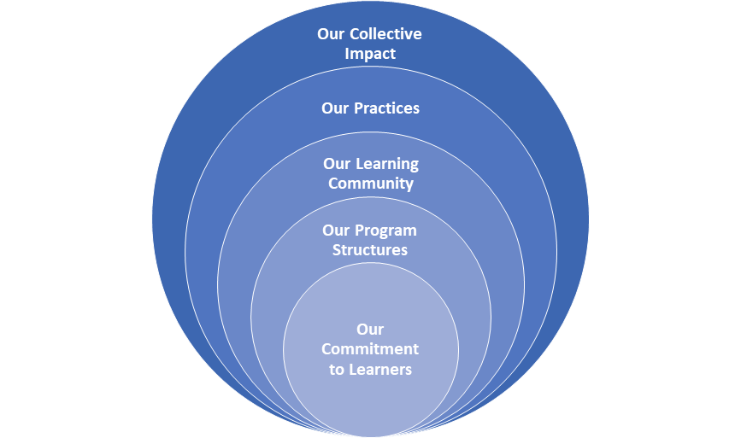
Overview of Sections
- Our Commitment to Learners
- Reflection on the values, philosophy and alignment components of program outlining the needs and expectations of students, the institution, and the discipline, industry or profession

- Our Program Structures
- Reflection on the development of the program, student learning journey through the program, how has program evolved and is currently delivered and scheduled

- Our Learning Community
- Reflection on the interactions and relationships between and among faculty and students within the program, as well as engagement with broader communities to establish a learning community

- Our Practices
- Reflection on teaching and learning practices; the methods or approaches to fulfil the stated commitments and engage in reflective practice

- Our Collective Impact
- Reflection on the accomplishments and contributions of faculty and students from the program including learning experiences, opportunities, and outcomes

- Our Key Learning and Next Steps
- Reflection on faculty learning experienced through the self-study process and an identification of areas for feedback from the external review team

Section 1: Our Commitment to Learners
The purpose of this section is to describe the program’s commitment to student learning by reflecting on the underlying values and philosophy of the program. This reflection includes highlighting the alignment of program commitments with the needs and expectations of students, the institution, and the broader discipline, industry, or profession.
Core Ideas
- Describe what you want students to experience, develop, and accomplish during their time in your program (e.g., mission, goals, program learning outcomes, learning intentions, attributes).
- Describe what key stakeholders will expect students to experience in your program. Key stakeholders may include: students, parents, family, discipline, profession, employers, and community partners.
- In reference to your responses to question 2, reflect on similarities and differences in expected outcomes among stakeholder groups.
- Provide details on the extent to which your program’s mission and goals align with the standards and expectations of the credential (e.g., articulation, accreditation, association or industry standards).
- Identify opportunities and experiences for students to develop breadth and depth of many of VIU’s Graduate Attributes.
- Reflect on the alignment to and contribution of your program to the mission and objectives of VIU’s Academic Plan: Access to Excellence.

Extending Prompts
- What are your key takeaways about current program commitments?
- How might what you have learned about current commitments and expectations affect your program moving forward (e.g., curriculum, pedagogy, recruitment, retention)?
- What are some possible next steps to enhance the development and/or alignment of your commitments?

Section 2: Our Program Structures
The purpose of this section is to describe the roots and design of the program, as well as how, and why, the program has evolved over time. You are encouraged to reflect on the evolution itself, as well as the mechanisms in place for identifying and responding to emerging needs and changing realities.
Core Ideas
- Describe and reflect on how and why your program came to be. Identify changes that have occurred since your program was first developed. Reflect on some of the reasons for these changes including internal and external factors.
- Describe the anticipated learning journey for students as they progress through your program. Identify and describe the milestones and key learning opportunities students may experience through your program.
- Describe how your program is currently delivered and scheduled. Reflect on how well the methods of delivery and scheduling meet student needs and whether or not there are any barriers to accessing learning opportunities for current or future students.
- Outline how learning experiences and opportunities are designed to meet the needs of the program. Reflect upon the ways and methods through which faculty develop curriculum, courses, and classes. Describe how the program ensures students have optimal opportunities for core concepts are being introduced, reinforced, practiced, and evaluated throughout the program to build learning skills, knowledge, and applications.
- Highlight what resources are currently available to support student learning (e.g., specialized facilities, equipment, community partnerships). Consider what resources are essential to student learning, as well as additional resources to enhance the learning experience. Reflect on whether gaps exist in essential and/or non-essential resources.
- Think about what sets your program apart from similar programs across the region, province and beyond. Describe how you convey your program purpose and unique characteristics to internal and external stakeholders.

Extending Prompts
- What are your key takeaways about current program structures?
- How might what you have learned about current structures and design affect your program moving forward (e.g., curriculum, pedagogy, recruitment, retention)?
- What are some possible next steps to enhance existing structures including identifying and responding to emerging needs?

Section 3: Our Learning Community
The purpose of this section is to describe and reflect on your program as a learning community. This includes identifying interactions and relationships between and among faculty and students within the program, as well as engagement with broader communities (e.g., institutional, regional, discipline, industry, or profession specific relationships).
Core Ideas
- Describe and reflect on the composition of faculty and students within your program. Consider characteristics of members, as well as the experience and expertise they contribute to the learning community.
- Highlight previous and current partnerships and collaborations with members outside of your program. Reflect on how these relationships were developed and are nurtured, as well as how these partnerships contribute to student learning and development.
- Consider how faculty and students build and nurture a sense of community within your program (e.g., classroom activities, clubs and study groups, program events, outreach activities). Describe current levels of morale and sense of belonging and reflect on how this might impact both the learning environment and learning outcomes.
- Describe program-level supports or mechanisms currently in place to assist students with their academic and non-academic needs as well as assistance in developing networks, communities of practice and opportunities to enhance classroom learning (e.g., program advising, program clubs, peer mentorship, referral process). Reflect on the extent to which current supports and mechanisms exist, can be sustained by the program, and meet the needs of students.
- Identify and reflect on the perceived benefits to being a member of your program’s learning community.

Extending Prompts
- What are your key takeaways about your program as a learning community?
- How might what you have learned about your current learning community affect your program moving forward (e.g., curriculum, pedagogy, recruitment, retention)?
- What are some possible next steps to enhance the sense of community within your program?
- How might you enhance or develop community engagement?

Section 4: Our Practices
The purpose of this section is to describe and reflect upon teaching and learning practices. More specifically, this section is a description of the methods or approaches members of the department engage in to fulfil the stated commitments while engaging in reflective practice.
Core Ideas
- Describe the ways in which student needs and goals are identified. Outline the approaches used to support students in reaching their personal goals, as well as course and program level goals. Reflect on the extent to which these supports or strategies enhance student learning and development.
- Outline and provide details on the methods and approaches used to engage students and facilitate learning opportunities. Explain how these approaches align with best practices identified in the literature, including approaches for accommodating learners with diverse and varied needs.
- Describe the methods and approaches used to assess and evaluate student learning and growth. Consider how these align with best practices identified in the literature and the extent to which they provide you with the information needed to both support learning and evaluate progression.
- Reflect on the degree your methods and approaches provide you with the information needed to determine the extent to which your program’s mission and goals are being achieved.
- Describe how program staff and instructors engage in ongoing reflective practices.

Extending Prompts
- What are your key takeaways about current practices?
- How might what you have learned about current practices affect your program moving forward (e.g., pedagogy, assessment, evaluation)?
- What are some possible next steps to enhance practices?

Section 5: Our Collective Impact
The purpose of this section is to describe and reflect on the accomplishments and contributions of faculty and students from your program. This includes a range of measures to describe learning experiences, opportunities, and outcomes related to your program. This also includes mechanisms in place to help faculty and students reflect upon and recognize accomplishments.
Core Ideas
- Reflect on what you and your students consider success. Describe the different accomplishments achieved by students, current and past, and faculty over the past several years. Consider how these accomplishments contribute to those directly involved and the broader learning community.
- Describe how students have progressed and achieved in their learning and development based on identified goals (e.g., personal, program, institutional, discipline, industry, or profession). Reflect on whether or not there are discrepancies by type of goal, student characteristics, and/or year. Consider possible reasons for discrepancies if they exist.
- Reflect on specific knowledge, skills, attributes, and/or values that students have developed or enhanced through your program. Consider how these align with program mission and goals, as well as how growth is tracked and measured.
- Describe how students, current and past, and faculty are contributing to the institution, broader community, discipline, industry, or profession (e.g., leadership and volunteer opportunities, employment, research). Reflect on ways in which students and faculty are encouraged and supported to pursue these opportunities.
- Consider the diverse strengths and contributions of students and faculty. Reflect on how various accomplishments are acknowledged and celebrated.

Extending Prompts
- What are your key takeaways about the collective impact of your program?
- How might what you have learned about your collective impact affect your program moving forward (e.g., pedagogy, assessment, evaluation, ways of defining and recognizing accomplishments)?
- What are some possible next steps to enhance outcomes? Monitoring and measuring outcomes?

Section 6: Our Key Learning and Next Steps
The purpose of this section is to highlight your key learning through the self-study process. Based on the evidence reviewed - conversations, observations, and review of data - describe the strengths of the program and areas for enhancement, including future direction of your program. This section also provides you with the opportunity to specify areas in which you would like feedback from the external review team.
Core Ideas
- Describe the strengths of your program using feedback from stakeholders and other evidence reviewed.
- Outline gaps and areas of concern. Reflect on how you might utilize identified strengths to enhance other areas of your program.
- Highlight any questions you still have or new questions arising from the self-study. Reflect on how you might further explore these questions. For example, through the external review process, with assistance from other departments, and/or with help from students and colleagues.
- Outline some key next steps that you are considering for inclusion within your action plan.
- Highlight specific questions or feedback you are seeking from the external review team to help inform your next steps.

Possible Sources of Evidence
- Program proposal (new program development documents)
- Program handbook for students
- Program website
- Program map (of courses and connections)
- Department meeting minutes
- Previous Program Reviews or accreditation reports
- Summative Program Assessment (SPA) (2012 and 2015 versions)
- Survey data (e.g., Student Outcomes surveys from BC Stats, NSSE, CUSC, Student Experience Survey)
- Perceptual data from alumni, students, faculty, other community members (e.g., gathered through focus groups, interviews, surveys, arts-based methods)
- Enrolment statistics, including demographic details
- Retention statistics
- Graduation rates
- Meeting minutes from Program Advisory Council or other community groups
- Employer feedback about students engaged in experiential learning opportunities
- Feedback on students attending graduate studies - grants/scholarships attained, research activity
- Curriculum mapping results (aligning program outcomes to courses, graduate attributes)
- Course outlines from across the program
- Assessment and evaluation strategies and tools
- Student work: Portfolios, capstone activities and projects, culminating displays of learning, undergrad research projects etc.

