Building: tiwšɛmawtxw Campus exterior Date: October 20, 2025
Names of Inspectors: Kim Sharpe

 | Yes | No | N/A
 | Around the Building
A.1 | Is the address sign or number easily visible? | X
A.2 | Is waste stored in appropriate waste or recycling storage areas? | X
A.3 | Is the property kept clear of litter, combustibles, hazardous materials, etc.? |  | X (tire storage)
A.4 | If present, are smoking areas clean? Is an appropriate cigarette butt receptacle available? |  |  | X
 | Parking Lot
B.1 | Are appropriate signs posted (e.g., no parking in fire routes, etc.)? | X
B.2 | Are the parking areas free from trip hazards (e.g., no pot holes, cracks, etc.)? | X
B.3 | Is the lighting adequate in the area and walkways at night? |  |  | X
B.4 | Is the parking lot kept free of debris? | X
B.5 | In winter, is the parking lot free from ice and snow? |  |  | X
 | Stairs
C.1 | Are stairs, stairwells, and landings kept clear and unobstructed? | X
C.2 | In winter, are stairs, stairwells, and landings kept clear from ice and snow? |  |  | X
C.3 | Are stairways adequately lit? | X
C.4 | Are stairs, treads, hand rails, and any guards secure and in good condition? | X
C.5 | Do treads and landings have non-skid surfaces and they are in good condition? | X
 | Exits / Fire Safety
D.1 | Are all emergency exits, exit doors, landings, and steps from the building well marked, unblocked, and kept in good condition? | X
D.2 | In winter, are exits kept free from ice and snow? |  |  | X
D.3 | In winter, is the roof area over the exits free of falling ice and snow hazards? |  |  | X
D.4 | Are exit doors, landings, and steps well lit? Are the lights over the exit doors working and in good repair? | X
D.5 | In winter, is the access ramp clear of ice and snow, and is there good traction? |  |  | X
D.6 | Can the building be easily accessed by the fire department? Are fire lanes accessible and posted? | X
D.7 | Are the fire department hose connections kept clear, accessible and have caps? | X
D.8 | Is the electrical service entrance area clear of trees and branches? |  |  | X
D.9 | Are all electrical wires out of reach of the public? | X
D.10 | Are sprinkler heads guarded? Obstructed? |  |  | X
 | Grounds
E.1 | Are walkways clear and in good condition? Are there any holes or trip hazards on grounds where workers/public may walk? |  | X (trip hazards on some paths)
E.2 | In winter, are ice and snow cleared promptly from walkways? |  |  | X (steep path leading to/from carpentry shop)
E.3 | Is security lighting functioning properly? | X
E.4 | Are exit routes (from the grounds) well marked, and kept clear and unobstructed? | X
E.5 | Is fencing in good condition? |  |  | X
E.6 | Is any outdoor machinery in good repair? |  |  | X
 | Loading Areas
F.1 | If required, are pedestrian walkways clearly marked? | X
F.2 | Are vehicles and/or loads secured from accidental movement? |  |  | X
F.3 | Is the area kept free of obstructions or debris? | X
F.4 | Are any lifting devices, racking systems, etc. in good condition? |  |  | X
F.5 | If required, are machine guards in place? |  |  | X
 | Miscellaneous
G.1 | Stairway leading from parking lot to nowhere/forested area | X
Corrective Action | Assigned To
A.3 Tire storage behind Automotive shop – close to forest and waste oil storage. Presents a fire hazard.  Recommendation: Identify alternate tire storage that is compliant with BC Fire Code | Faculty of Trades/Facilities Management and Development
E.1. Some walkways are uneven and are trip hazards. Highlight uneven areas with high-vis paint or alternate means to inform people of the hazard. | Facilities Management and Development
E.2. Steep path is very slippery in Winter months when there is ice and snow. | Facilities Management and Development
G.1. What is the purpose of this stairway?

A.3
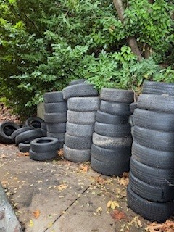

E.1
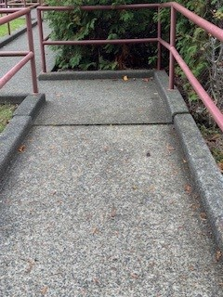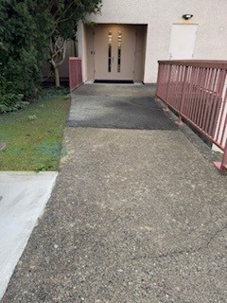

E.2
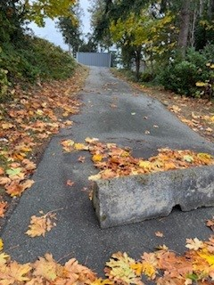

G.1

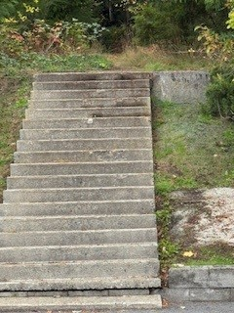

Building: Tiwšɛmawtxʷ campus Date: October 20, 2025
Names of Inspectors: Kim Sharpe (conversations with Paul Franske (Facilities Maintenance contractor), Elyse Freeborn, Jonathan Bretseth, Brody Jacob (Carpentry), Ron DePape (Automotive)

 | Yes | No | N/A
 | Bulletin Boards and Signs
A.1 | Are they clean and readable? | X
A.2 | Is the material changed frequently? | X
A.3 | Do items interfere with people walking by? |  | X
 | Floors
B.1 | Is there loose material, debris, worn carpeting? | X
B.2 | Are the floors slippery, oily or wet? |  | X
 | Stairways and Aisles
C.1 | Are they clear and unblocked? | X
C.2 | Are stairways well lighted? | X
C.3 | Are handrails, handholds in place? | X
C.4 | Are the aisles marked and visible? | X
 | Equipment
D.1 | Are guards, screens and sound-dampening devices in place and effective? |  |  | X
D.2 | Is the furniture in good repair and safe to use? Look for:
D.3 | - chairs that are in poor repair |  | X
D.4 | - sharp edges on desks and cabinets |  | X
D.5 | - poor ergonomics (keyboard elevation, chair adjustment, desk height) |  | X
D.6 | - crowding |  | X
D.7 | Are ladders well maintained and safe to use? |  |  | X
 | Emergency Equipment
E.1 | Is all fire control equipment regularly tested and certified? |  |  | X (did not review)
E.2 | Is fire control equipment appropriate for the type of fire it must control? | X
E.3 | Is emergency lighting in place and regularly tested? | X
 | Building
F.1 | Do buildings conform to standards with respect to use, occupancy, building services, and plumbing facilities? | X
F.2 | Check the following structures to ensure safety:
F.3 | - swinging doors | X
F.4 | - floor and wall openings | X
F.5 | - ladders, stairways and ramps | X
F.6 | - guardrails | X
F.7 | Are materials stored safely? | X
 | Air Handling System
G.1 | Does air exchange rate meet standard requirements? | X
G.2 | Is the system free of sources of contamination (e.g., asbestos, microorganisms, dust, fumes)? | X
G.3 | Is humidity within recommended range? | X
 | Hazardous Products
H.1 | Are there any hazardous products (e.g., products regulated by WHMIS)? | X
 | Incompatible chemicals stored together (leach and vinegar)
H.2 | - If yes, are the products properly labelled? |  | X
H.3 | - If yes, is there a corresponding safety data sheet (SDS) for each product? |  | X
H.4 | - If yes, are workers trained in how to work with or near these products safely? |  |  | X (did not ask – janitors not present)
 | Sanitation
I.1 | Are washrooms and food preparation areas clean? | X
I.2 | Are the following provided adequately?
I.3 | - toilets | X
I.4 | - showers | X
I.5 | - potable (drinkable) water | X
I.6 | - clothing storage | X
I.7 | - change rooms | X
I.8 | - field accommodations |  |  | X
I.9 | - lunchrooms | X
I.10 | Are measures in place to prevent the spread of disease? | X (janitorial services are available but did not verify Food Safe)
 | Security
J.1 | Do entry and exit procedures provide workers personal security at night? |  | X (concerns about opening and closing when working alone)
J.2 | Are emergency (evacuation, fire, bomb threat, hostile person) procedures in place? | X
 | Lighting
K.1 | Are lamp reflectors clean? | X
K.2 | Are bulbs missing? |  | X
K.3 | Are any areas dark? |  | X
 | Material Storage
L.1 | Are materials neatly and safely piled? | X
L.2 | Are there stepladders or stools to get to materials on higher shelves? |  |  | X
L.3 | Are storage shelves overloaded or beyond their rated capacity? |  | X
L.4 | Are large and heavy objects stored on lower shelves? | X
L.5 | Are passageways and work areas clear of obstructions? | X
 | General
M.1 | Are extension cords used extensively? (if so, consider installing permanent wiring) |  | X
M.2 | Are electrical or telephone cords exposed in areas where employees may become entangled? |  | X
M.3 | Is electrical wiring properly installed? | X (assumed so)
M.4 | Are machines properly guarded? | X
M.5 | Does any equipment have sharp metal projections? |  | X
M.6 | Are wall and ceiling fixtures fastened securely? | X
M.7 | Are paper and waste properly disposed of? | X
M.8 | Are desk and file drawers kept closed when not in use? | X
M.9 | Are office accessories stored appropriately? | X
M.10 | Are materials stacked on desks or cabinets? |  | X
M.11 | Are file cabinet drawers overloaded? |  | X
M.12 | Are file cabinets loaded with the heaviest items in the bottom drawers? | X
M.13 | Are shelves securely fastened to the wall when necessary? | X
M.14 | Are filing stools or wastebaskets placed where they might be tripping hazards? |  | X
 | Miscellaneous
N.1 | Asbestos-containing floor tires | X
N.2 | Desks in WEST classroom (bottom Floor) not suitable for COVER during earthquake due to bar located underneath | X
N.3 | VIU IT “Need Assistance” stickers on telephones are not campus-specific | X
Corrective Actions | Assigned To | Date to be completed by
B.1. This was identified in the June 2024 inspection as well  The carpeting on the main level, south side of the building is worn causing it to ripple in most rooms. This presents a tripping hazard. Asked Facilities contractor if the carpet can be stretched, but it is too old. The backing will disintegrate when stretched, and the carpet will rip as a result. This carpeting needs to be replaced to rectify the safety hazard. | Facilities Management and Development | March 31, 2026
B.1. This was identified in the June 2024 inspection as well  The tiles in R116 (Janitorial Room) are broken and deteriorating. These tiles are asbestos containing and will either need to be remediated (removed and replaced), or sealed with an appropriate sealant that will prevent further deterioration of the tiles.  IAQ is recommended as well to ensure that asbestos fibres are not in the air or HVAC system. | Facilities Management and Development | March 31, 2026
E.1. From 2024 Inspection - Unsure if this was resolved  The fire extinguisher in the crawl space in R148/149 is expired. | Facilities Management and Development
H.1. – H.4 Chemicals in Janitorial Room are not stored safely  - incompatible chemicals are stored together  - there are unlabeled containers (chemical unknown)  - no Safety Data Sheets available – SDSs contain all needed chemical safety information needed to determine how to store and use chemicals safely  Recommendation: Confirm that janitors have been trained on WHMIS 2015 and ask contractor to train/retrain if needed.  Chemical Storage needs to be fixed | Facilities Management and Development | March 31, 2026
J.1 From 2024 Inspection – Unsure if this was resolved in 2024  An employee raised concerns regarding working alone or in isolation from 8 - 8:30 am. The doors at the tiwšɛmawtxʷ campus automatically unlock at 8 am. Most staff do not arrive on campus until 8:30 am. One staff member and One contractor arrive at work before 8:30.  Possible solutions include changing the door schedule to unlock at 8:30 am, changing the one-staff members start time to 8:30 am, creating an opening procedure where all staff open and close in pairs, and reviewing VIU’s Working Alone Program. | Liam Haggarty/Trina Isaksen/Department Managers (if not tiwšɛmawtxʷ campus administration) | March 31, 2026
N.2. From 2024 Inspection  Broken and worn asbestos-containing floor tiles were noted in the janitorial room (116). These tiles must be replaced or sealed. | Facilities Management and Development | March 31, 2026
N.3 IT “Need Assistance” stickers need to be updated to reflect the campus emergency contact information. 6600 does not apply at tiwšɛmawtxw campus. | IT Services | March 31, 2026

B.1
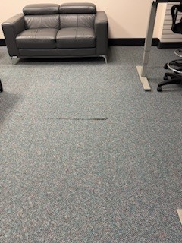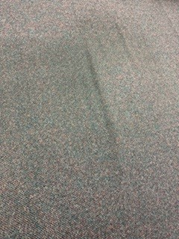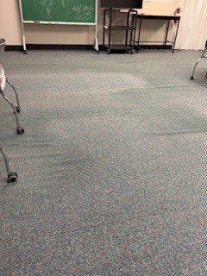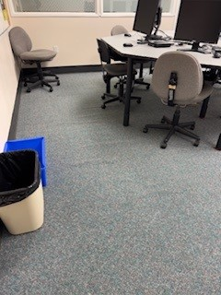

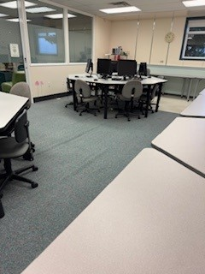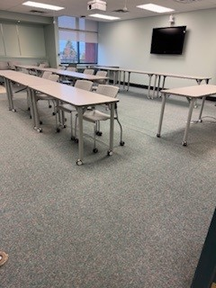

H1. Room 116 – Janitorial Room: Incompatible chemical storage – refer to VIU Chemical Safety Procedures for details

Chemical Segregation for Storage
Each chemical must be evaluated to determine where and how it should be stored. Manufacturers’ recommendations should be followed at a minimum but you will also find specific information on the (M)SDS. As a general rule, flammable or combustible liquids, toxic chemicals, explosive chemicals, oxidizing agents, corrosive chemicals, water-sensitive chemicals, and compressed gases should be segregated from each other. As such, they must be stored in such a way that they will not mix with each other if a container leaks or breaks. It is important to segregate chemicals for storage in a compatible manner.

Storage segregation based on the WHMIS Hazard Classes
- Sort according to the categories described below.
- Prioritize the separation process in the following order:
1. FLAMMABLE & COMBUSTIBLE MATERIALS
2. OXIDIZING MATERIALS
3. CORROSIVE MATERIALS
4. GASES UNDER PRESSURE
5. TOXIC MATERIALS

Incompatible Chemicals
For a detailed list of incompatible chemicals see Page 30, Table 7 in the WorkSafeBC Laboratory Health
and Safety Handbook. Also check your SDS for additional information. Contact Health and Safety
Services at 250-740-6283 for advice as required

If incompatible chemicals must be stored on the same shelf together, place chemicals in secondary containment that large enough to hold the total volume of each container (e.g. a Rubbermaid bin can be used as a secondary container for each chemical type)

Bleach (oxidizer) stored with Vinegar (acid) – if there is a spill and they combine, chlorine gas will be produced, which is a toxic gas.
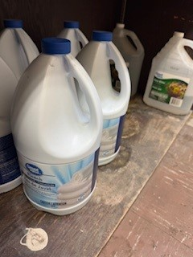

Formula 50 (corrosive) and bleach (oxidizer) being stored together on same shelf
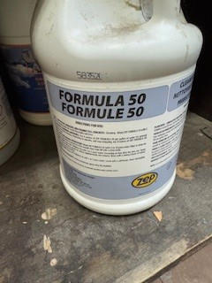

H.2 Room 116 – Janitorial Room
Unlabeled chemical
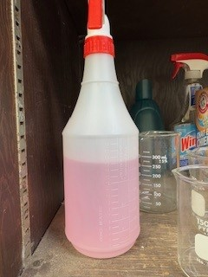

N.1 Deteriorating Asbestos-containing floor tiles

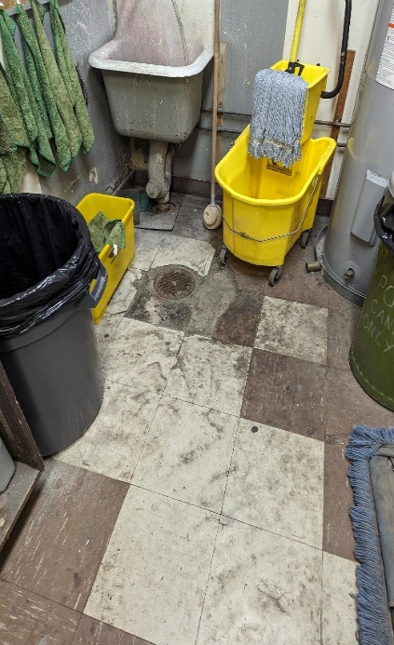

N.2 Bar of desk hindering earthquake response
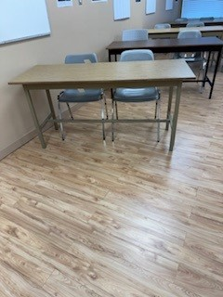

N.3 IT “Need Assistance” stickers on phones are for Nanaimo and Cowichan Campuses
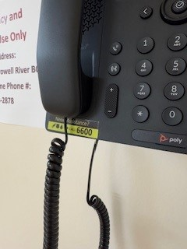

Building: Automotive & Carpentry Tiwšɛmawtxʷ campus Date: October 20, 2025
Names of Inspectors: Kim Sharpe, Ron DePape, Jonathan Bratseth, Brody Jacob

 | Yes | No | N/A
 | Emergency and Hazard Information
A.1 | Emergency phone numbers posted? Are phones available? | X
A.2 | Are exits clearly marked and accessible? | X
A.3 | Are evacuation maps posted? | Unknown
A.4 | Are emergency evacuation drills conducted at least annually? | X
A.5 | Are first aid attendants available with kits fully stocked and inspected? | Unknown
A.6 | Are Level 1 Attendant’s qualifications current? | Unknown
A.7 | Do students know where and how to receive care for an injury | Unknown
A.8 | Are signs present for emergency safety equipment (eyewash, exits etc.)? | X
A.9 | Are appropriate fire extinguishers available and inspected regularly? | X
A.10 | Are flammable materials stored in a flammable storage cabinet? | X
A.11 | Chemical inventories up to date | Unknown
A.12 | MSDS sheets available and current | Unknown
 | Floors
B.1 | Is there loose material, debris, worn carpeting? |  | X
B.2 | Are the floors slippery, oily or wet? |  | X
 | Stairways and Aisles
C.1 | Are they clear and unblocked? | X
C.2 | Are stairways well lighted? | X
C.3 | Are handrails, handholds in place? | X
C.4 | Are the aisles marked and visible? | X
 | Safety Administration
D.1 | Have all students received general orientation and safety training e.g. MSDS, PPE, evacuations, etc.? | X (Automotive confirmed safety is the first two weeks of class)
D.2 | Have all students been trained on the equipment that they operate? | X
D.3 | Have students received other specialized training: Lockout/Tagout, Respirators, Tools (hand/power), PPE, ect | Unknown
D.4 | Is orientation/safety training documented? | X
D.5 | Do students have access to the orientation information? | Unknown
D.6 | Are regularly scheduled safety meetings conducted in the shop? | Unknown
D.7 | Has a hazard assessment been done in order to select appropriate PPE? | X
D.8 | Is PPE provided and used whenever necessary? | Unknown
D.9 | Are there chemicals or controlled substances in the shop? Is WHMIS training provided? Are SDS’s available? | Unknown
 | Housekeeping, Ventilation, Illumination
E.1 | Are all work areas clean and orderly? | X
E.2 | Are waste containers kept clean and emptied daily? | X
E.3 | Is food kept in the designated area at all times? | X
E.4 | Are all cabinets and shelves secured or anchored? | X
E.5 | Are all machines/equipment secured or anchored? | X
E.6 | Are floors in good condition and kept dry? | X
E.7 | Are all light fixtures adequate and functioning properly? | X
E.8 | Dust extractors in good working order | X
E.9 | Exhaust fans functioning | X
E.10 | “No Eating/Drinking/Smoking” signs posted | X
E.11 | Is illumination adequate? |  | X
 | Electrical Safety/Portable Tools
F.1 | Are all plugs, cords, and panels enclosed, and in good condition? | X
F.2 | Do all extension cords have grounding? | X
F.3 | Are extension cords used only temporarily? | X
F.4 | Are cords secured so they do not run across pathways, under doors or the walls? | X
F.5 | Is the breaker panel locked? | X
F.6 | Are ground fault circuit interrupters available for use in wet areas? | Unknown
F.7 | Are hand-tools effectively grounded or Double insulated? | Unknown
F.8 | Are hand/power tools inspected regularly? | Unknown
F.9. | Are electrical shut offs accessible? |  | X
 | Mechanical Safety
G.1 | Is defective equipment promptly reported, labeled, and replaced? | Unknown
G.2 | Can equipment be locked out? | Unknown
G.3 | Safeguards prevent workers’ hands, arms and other body parts from making contact with dangerous moving parts | X
G.4 | Safeguards have not been tampered with, altered or removed |  |  | X
G.5 | Powered machinery/equipment has start and stop controls located within easy reach of the operator has controls and switches whose functions are clearly identified | X
G.6 | Are machines regularly cleaned and maintained? | Unknown
G.7 | Are maintenance records, calibrations, certifications of each machine kept on file? | Unknown
G.8 | Do authorized people perform the repairs? | Unknown
G.9 | Physical hazards are marked in a manner that clearly identifies the hazard | X
 | Spill Response
H.1 | Do personnel know the location of the closest First Aid Kit? | Unknown
H.2 | Do personnel know the location of the closet Chemcial Spill Kit? | Unknown
H.3 | Are personnel familiar with Vancouver Island Universities Spill Procedures? | Unknown
H.4 | Is spill containment adequate? |  | TBD
 | WHMIS
I.1 | Have all personnel received WHMIS training? | Unknown
I.2 | Are all hazardous materials labeled according to the WHMIS Regulations? | Unknown
I.3 | Is there a current inventory of all hazardous substances in the area? | Unknown
I.4 | Do personnel know where to find current (<3 years) SDS for the materials being used? | Unknown
 | Emergency Eyewash/Showers
J.1 | Are personnel familiar with the location of the nearest eyewash / shower? | X
J.2 | Is the eyewash station / shower clean and clear of debris? | X
J.3 | Have emergency shower(s) been tested in the last 12 months and have a tag indicating testing date? |  |  | X
 | Lighting
K.1 | Are lamp reflectors clean? | X
K.2 | Are bulbs missing? |  | X
K.3 | Are any areas dark? | X
 | Material Storage
L.1 | Are materials neatly and safely piled? | X
L.2 | Are there stepladders or stools to get to materials on higher shelves? | X
L.3 | Are storage shelves overloaded or beyond their rated capacity? |  | X
L.4 | Are large and heavy objects stored on lower shelves? | X
L.5 | Are passageways and work areas clear of obstructions? | X
 | General
M.1 | Is electrical wiring properly installed? | X
M.2 | Does any equipment have sharp metal projections? |  | X
M.3 | Are wall and ceiling fixtures fastened securely? | X
M.4 | Are paper and waste properly disposed of? | X
M.5 | Are desk and file drawers kept closed when not in use? | X
M.6 | Are office accessories stored appropriately? | X
M.7 | Are materials stacked on desks or cabinets? |  | X
M.8 | Are file cabinet drawers overloaded? |  | X
M.9 | Are file cabinets loaded with the heaviest items in the bottom drawers? | X
M.10 | Are shelves securely fastened to the wall when necessary? | X
 | Miscellaneous
N.1 | Automotive Shop Heater – taken out of service by Facilities Management (faulty) |  | X
N.2 | Lockout/Tagout discussed with Carpentry Instructor and Carpentry Technical Trades Assistant | X
N.3. | Vehicle parked in front of exit door to automotive shop | X
Corrective Action | Assigned To | Date to be complete
E.11/K.3 No lighting in storage shed beside automotive shop. | Facilities Management and Development | March 31, 2026
F.9 Vehicle parked in front of electrical shut off outside Automotive shop – Access to emergency power shut off must not be blocked. Do not park cars in this area. | Faculty of trades/Automotive Department | October 31, 2026
H.4 Spill Containment for Waste Oil – Needs to be determined if the spill pallets in use are sufficient to absorb the total potential volume of waste oil that can be stored in each drum/container in the waste storage area in the event of a spill event. | Faculty of trades/Automotive Department | March 31, 2026
N.1. Due to a near miss incident related to one of the overhead heaters in the Automotive Shop, all overhead heaters were taken out of services by Facilities Management as the heaters are faulty.  Replaced with space heaters throughout the shop. | Facilities Management and Development | Complete
N.2. Lockout/Tagout discussed with Carpentry Instructor and Carpentry Technical Trades Assistant.  Training on new VIU Lockout/Tagout procedures will be provided by Health and Safety Services on completion of updating the Program | Health and Safety Services | March 31, 2026
N.3 Vehicle parked in front of exit door to automotive shop.  BC Fire Code 3.4.6.11. Doors  6) Where an exit door leading directly to the outside is subject to being obstructed by parked vehicles or storage because of its location, a visible sign or a physical barrier prohibiting such obstructions shall be installed on the exterior side of the door. | tiwšɛmawtxw campus Administration/Facilities Management and Development | March 31, 2026
E.11
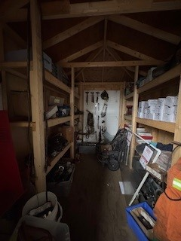
F.9
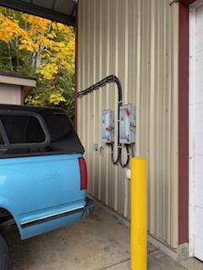

H.4
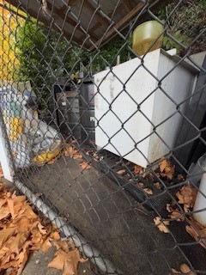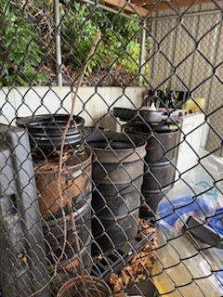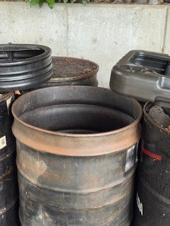

N.3
